Geography Department



IGCSE Geography Revision Book

Edexcel IGCSE (9-1) Specification

It’s in your hands…

Contents
Structure of the Exam Papers 4
Paper 1: Physical Geography 4GE1/01 (40% of total IGCSE marks) 4
Paper 2: Human Geography 4GE1/02 (60% of the total IGCSE marks) 4
Glossary of Terms 5
Command Words 5
General Terms for the Whole Paper: 6
Paper 1: Coastal Environments 9
Coasts: Specification: 10
Glossary of Terms: Coastal Environments 11
Coasts: Revision Materials 14
Coasts: Practice Questions: 26
Coasts: Source Question Examples 28
Coasts: Model Answers 29
Paper 1: Hazardous Environments 33
Hazards: Specification 34
Glossary of Terms: Hazardous Environments 35
Hazards: Revision Materials 37
Hazards: Practice Questions 47
Hazards: Source Question Examples: 50
Hazards: Model Answers 54
Paper 1: Fieldwork Questions 58
Principles of Fieldwork Units 58
Glossary of Terms: Physical Geography Fieldwork 62
Fieldwork Practice Questions 64
Physical Fieldwork: Model Answers 65
Paper 2: Economic Activity and Energy 69
Economic Activity & Energy: Specification 70
Glossary of Terms: Economic Activity & Energy 71
Economic Activity & Energy: Revision Materials 73
Economic Activity & Energy: Practice Questions 87
Economic Activity & Energy: Source Question Examples 89
Economic Activity & Energy: Model Answers 92
Paper 2: Urban Environments 95
Urban: Specification 96
Glossary of Terms: Urban Environments 97
Urban: Revision Materials 100
Urban: Practice Questions 113
Urban: Source Question Examples 115
Urban: Model Answers 120
Paper 2: Fieldwork Questions 125
Principles of Fieldwork 125
Glossary of Terms: Fieldwork 129
Fieldwork Practice Questions 131
Human Fieldwork: Model Answers 133
Paper 2: Globalisation & Migration 137
Globalisation & Migration: Specification 138
Glossary of Terms: Globalisation & Migration 139
Globalisation & Migration: Revision Materials 141
Globalisation & Migration: Practice Questions 154
Globalisation & Migration: Source Question Examples: 156
Globalisation & Migration: Model Answers 159
Revision and Preparation: 165

Our thanks to the GCSE students of 2019, who have so graciously permitted their work to be shared as model examples. Well done to them – learn from their hard work and effort!

Last Update: October 2019, DJP

Structure of the Exam Papers

Paper 1: Physical Geography 4GE1/01 (40% of total IGCSE marks)
This examination is 1 hour and 10 minutes (plus relevant extra time). The questions are a mixture of multiple-choice, short-answer, data-response and open-ended questions.
Section A:
Candidates are asked to complete two out of three questions based on the three topics. Each topic is worth 25 marks:
- River environments
- Coastal environments
- Hazardous environments.
Section B:
Candidates choose one out of three fieldwork-related questions on: river environments, coastal environments, hazardous environments. This section is worth 20 marks.

Paper 2: Human Geography 4GE1/02 (60% of the total IGCSE marks)
This examination is 1 hour and 45 minutes (plus relevant extra time). The questions are a mixture of multiple-choice, short-answer, data-response and open-ended questions.
Section A:
Candidates asked to complete two out of three questions based on the three topics. Each topic is worth 25 marks.
- Economic activity and energy
- Ecosystems and rural environments
- Urban environments.
Section B:
Candidates choose one out of three fieldwork-related questions on: economic activity and energy, rural environments or urban environments. This section is worth 20 marks.
Section C:
Candidates asked to complete one question drawn from one of the three topics:
- Fragile environments
- Globalisation and migration
- Development and human welfare.

Points to Note:
- Edexcel use electronic marking, scanning in your answers to send to examiners. DO NOT write outside of the boxes – they will not see them. Use additional paper instead.
- If you do not answer the right questions, they will not be marked. Spend a moment picking your questions at the start of the exam when you are fresh.

Glossary of Terms

Command Words
Command word Definition
These are the command words identified by the exam board. You should be clear on their meaning, and how to respond to each of them. They are listed in order of tariff – the first ones are likely to be simple questions, while the later ones are likely to be longer/open answer questions.

Identify/state/name: Recall or select one or more pieces of information.
Define: State the meaning of a term.
Calculate: Produce a numerical answer, showing relevant working.
Label: Add a label/labels to a given resource, graphic or image.
Draw/plot: Create a graphical representation of geographical information.
Compare: Find the similarities and differences of two elements given in a question. Each response must relate to both elements and must include a statement of their similarity/difference.
Describe: Give an account of the main characteristics of something or the steps in a process. Statements in the response should be developed but do not need to include a justification or reason.
Explain: Provide a reasoned explanation of how or why something occurs, showing a step by step sequence of process. An explanation requires a justification/exemplification of a point. Some questions will require the use of annotated diagrams to support the explanation.
Suggest: Apply understanding to provide a reasoned explanation of how or why something may occur. A suggested explanation requires a justification/exemplification of a point.
Examine: Break something down into individual components/processes and say how each one individually contributes to the question’s theme/topic and how the components/processes work together and interrelate.
Assess: Use evidence to determine the relative significance of something. Give consideration to all factors and identify which are the most important.
Evaluate: Measure the value or success of something and ultimately provide a substantiated judgement/conclusion. Review information and then bring it together to form a conclusion, drawing on evidence such as strengths, weaknesses, alternatives and relevant data.
Discuss: Explore the strengths and weaknesses of different sides of an issue/question. Investigate the issue by reasoning or argument.
Analyse: Investigate an issue by breaking it down into individual components and making logical, evidence-based connections about the causes and effects or interrelationships between the components.

General Terms for the Whole Paper:
Core: the most important economic, political and social area of a country or global region - a centre of power.
Circulation: the movement of such things as ocean currents, air masses, transport and people.
Distribution: the occurrence of a particular thing, such as volcanoes or people, within a given area.
Conflict: a clash between different people, land uses, etc.
Frequency: the number of times something happens in a given period of time
High-income country (HIC): a developed country in which there is high per capita income
Less economically-developed country (LEDC): no longer used: see LIC
Low-income country (LIC): a country still in the early stages of development and where per capita income is low
More economically-developed country (MEDC): no longer used: see HIC
Middle-income country (MIC): a country which is enjoying economic growth and making its way along the development pathway that runs from least to most-developed
Multiplier effect: the consequences, intended and unintended, of a particular action or decision.
Per capita: per person
Prediction: forecasting future events or changes
Recently industrialising country (RIC): a country, such as Brazil, China and India, experiencing increased economic growth due to the expansion of manufacturing.
Sustainability: the long-term maintenance of the well-being of people and the natural world through the responsible use of natural resources.
Sustainable: a term used to describe actions that minimise negative impacts on the environment and promote human well-being.
System: a set of interrelated components (stores) and processes (transfers). There are two types of system: an open system has inputs and outputs; a closed system has none.

Source Analysis Questions (8 markers)
One of the keys to being a successful geographer is the ability to draw together and connect ideas, and use a range of sources to say something useful and interesting about a topic. This is one of the new styles of question in the new 9-1 syllabus compared to the older A*-G specification. In old past papers (pre-2018), you will see “9 mark” essay-style questions – these are not something you are required to prepare for.
Although each question is different, there are common things that you can do for each one that will help you to access the top levels of marks.
You need to remember IDEAL
This is a set of steps that you can take, when presented with a range of unfamiliar material:
- Identify:
  - What are we looking at? Table, picture, some kind of source (e.g. quote, interview), graph or something else?
  - What do you need to know to figure out what it shows? (Title, Scale, Key)
- Describe:
  - Simple statements of what you can see in the source
  - You should be able to give clues as to what is happening, and what it relates to. Don’t make huge assumptions or inferences – simply state what the source shows.
  - Speak like a geographer! Should you say “left side of the map” or “on the west of the continent”? What about “looks rubbish” or “appears to be in an LIC”? Keep your language technical.
- Evidence:
  - You have to show that you are referring specifically to the figure, text, data etc. that is presented in the question
  - This means taking some evidence from it – quoting a number, referring to a particular element of it, or showing that you’ve clearly used the information there
  - Think: how do I show I didn’t just KNOW this?
- Analyse:
  - Analysis involves showing that you’re able to judge how important or realistic this is.
  - In order to analyse, you’ve got to be able to put the information in CONTEXT
  - Where does it fit with what you know?
  - Where does it fit with what you’d expect from theory or the way it normally happens?
  - Where does it fit with other case studies or examples?
  - Or – it doesn’t fit! It’s weird, it’s unusual, it’s an anomaly of some kind…
- Link
  - How do the sources and ideas connect together?
  - How do you connect them up, how do you put them in order of importance? Does one source explain something specific, that you can then prove with another source?

Common mistakes:
- “Capped” - not explicitly referring to the sources, and showing EVIDENCE of what you are talking about.
- 5-6 marks – not showing sufficient ANALYSIS or LINKS – you are likely to have just described the source
Practice this skill and technique:
Doing well in source questions is not just a ‘natural talent’ – it will take time, and plenty of practice. Your teacher should have shown you many examples over the course of the IGCSE, and you need to explore how to keep improving.

Paper 1: Coastal Environments

Coasts: Specification:

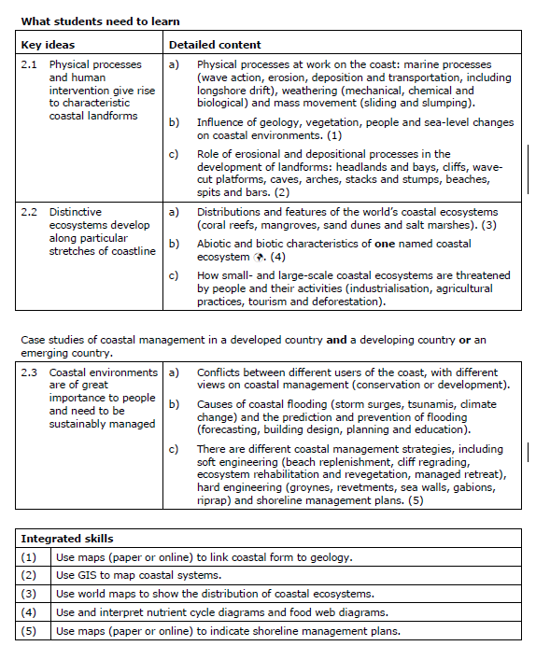

Glossary of Terms: Coastal Environments
Abrasion: the grinding away of bedrock by fragments of rock being carried by rivers, glaciers, the sea or wind.
Arch: a coastal feature formed by the meeting of two caves cut into either side of a headland
Attrition: the gradual wearing down of particles by erosion as they collide with each other, making them smaller and rounder.
Backwash: water from a breaking wave which flows under gravity down a beach and returns to the sea.
Bar: a ridge-like accumulation of coastal sediments exposed at low tide
Bay: a wide, coastal inlet that is open to the sea.
Beach replenishment: dredging or pumping sand and shingle from the seabed to replace material that has been eroded from a beach.
Beach: an accumulation of coastal sediments, most often occurring in sheltered areas along the coast, such as bays.
Berm: a ridge of sand or shingle towards the top of a beach with a steep seaward slope
Cave: a hollow cut by the sea into the base of a cliff.
Cliff regrading: the deliberate lowering of the angle of a cliff face to make it safer, i.e. reduce the likelihood of landslides or collapse.
Cliff: a steep rock slope, usually facing the sea.
Coastal cell: a segment of coastline which is self-contained in terms of the movement of sand and shingle
Coastal management: looking after the coast and resolving any conflicts between users of the coast
Coastline: the actual border between the land and the sea
Concordant coast: a coastline created when alternating hard and soft rocks occur parallel to the coast and are eroded at different rates
Corrosion: the chemical erosion of rock surfaces as by water flowing over limestone
Cuspate foreland: a triangular mass of sand and shingle deposited on the coast where waves converge from opposite directions
Deposition: the dropping of material that was being carried by a moving force, such as running water.
Discordant coast: a coastline created when alternating bands of hard and soft rock occur at right angles to the coast and are eroded at different rates
Emergent coast: a coastline that is experiencing either uplift of the land or a fall in sea level
Erosion: the wearing away and removal of material by a moving force, such as running water.
Estuary: the mouth of a river as it enters the sea
Fetch: the distance a wave has travelled from its origins to the coast where it breaks
Fjord: a long, narrow arm of the sea which is the result of the 'drowning' of a glaciated valley.
Hard engineering: protecting the coast by building such structures as sea walls and groynes
Headland: an area of land jutting out into the sea
Hold the line: a coastal management strategy aimed at protecting the coast and maintaining the coastline as it is
Hydraulic action: erosion caused by the force of moving water
Lagoon: a bay totally or partially shut off from the sea by a bar or reef running across the entrance
Longshore drift: the movement of sediments along the coast by wave action
Managed retreat: a coastal management strategy of deliberately allowing the coastline to retreat but in such a way as to minimise possible damage
Marine reserve: an area of the sea with some special or rare features (plant and animal life, coastal scenery, etc.) thought to be worth protection from human exploitation.
Mass movement: the movement of weathered material down a slope or cliff due to the force of gravity
Raised beach: a former beach now standing above sea level and some metres inland
Relict cliff: a cliff that now lies above the reach of the sea due to a fall in sea level or a rise in the land.
Ria: the seaward end of a river valley that has been flooded as a result of a rise in sea level
Sediment: any material ranging in size from fine silt to large boulders which has been transported and deposited, as for example by the sea or a river.
Slumping: a form of mass movement in which material slides downslope and rotates backwards as it does so.
Soft engineering: protecting the coast by working with nature.
Soil creep: a type of mass movement involving the slow downslope movement of soil under the influence of gravity.
Soil erosion: the washing or blowing away of topsoil so that the fertility of the remaining soil is greatly reduced.
Spit: material deposited by the sea that grows across a bay or estuary.
Stack: a detached column of rock located just off-shore and usually caused by the collapse of an arch.
Storm beach or ridge: a prominent ridge of coarse shingle and sand thrown up at the top of a beach by powerful waves during a storm.
Stump: a collapsed stack.
Sub-aerial: occurring on land, as opposed to underwater or underground.
Submergent coastline: a coastline that has been drowned by a rise in sea level.
Sustainable management: controlling and planning developments in such a way as to minimise the use of resources and impacts on the environment.
Swash: the forward movement of water up a beach after a wave has broken.
Tombolo: a coastal feature produced by the deposition of sand and shingle which joins an island to the mainland.
Tsunami: a tidal wave caused by the shock waves originating from a submarine earthquake or volcanic eruption.
Wave action: the work that waves do: erode, transport and deposit.
Wave: a ridge of water formed by the circular movement of water near the surface of the sea.
Wave-cut notch: a hollowed out area at the base of a retreating cliff and marking where a wave-cut platform begins.
Wave-cut platform: a gently sloping area left at the base of a cliff as it retreats.
Weathering: the breakdown and decay of rock by natural processes, without the involvement of any moving force.

Coasts: Revision Materials
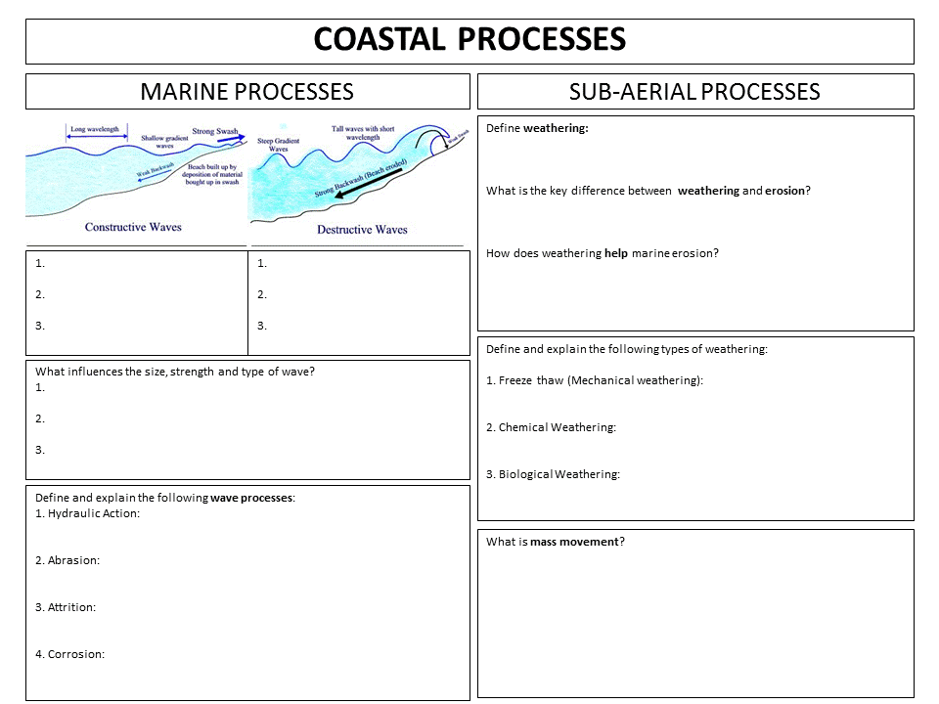
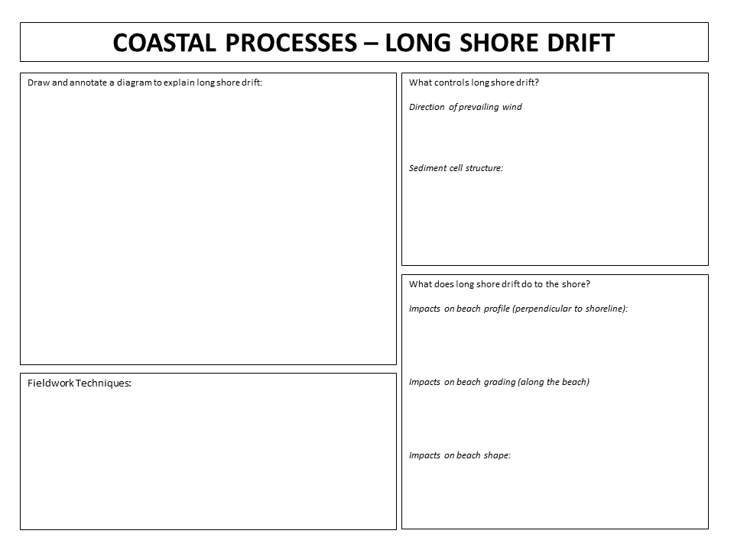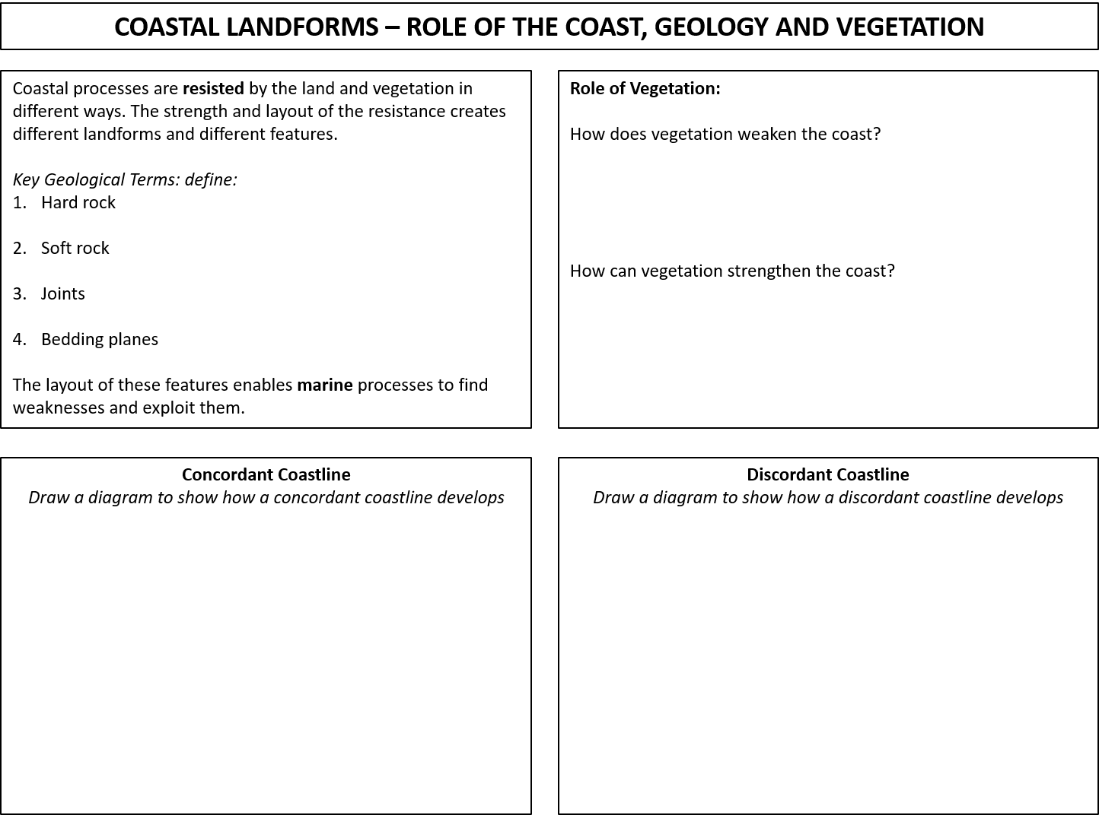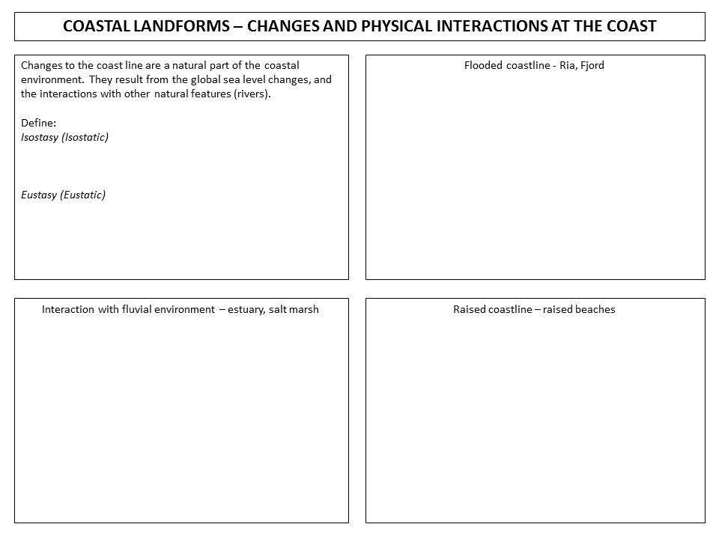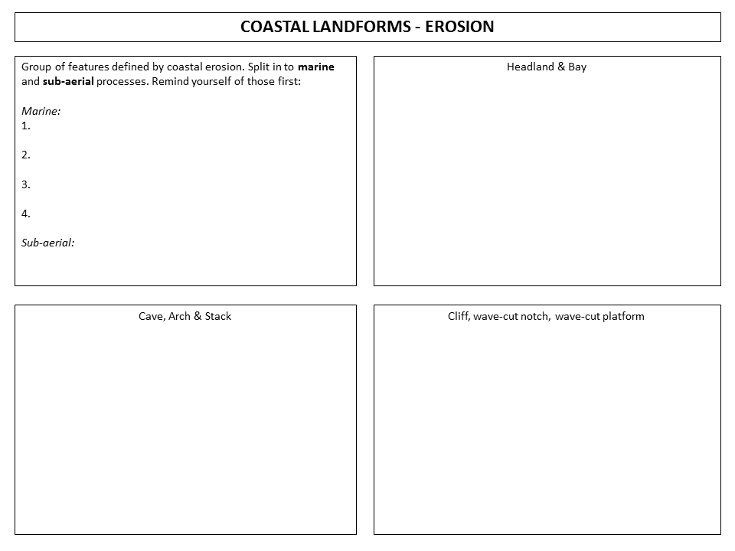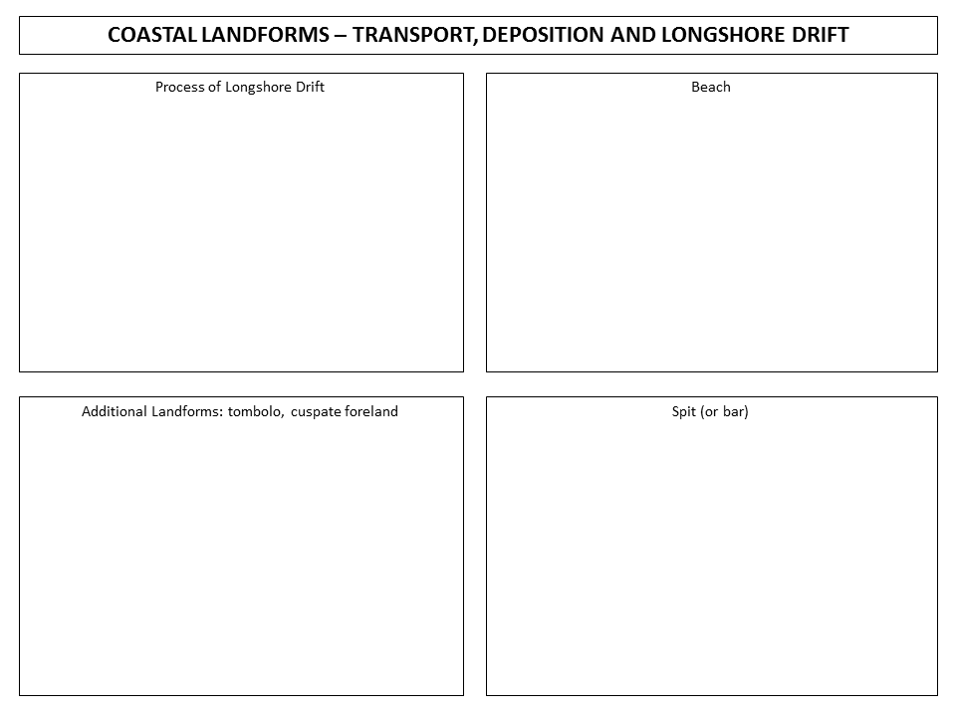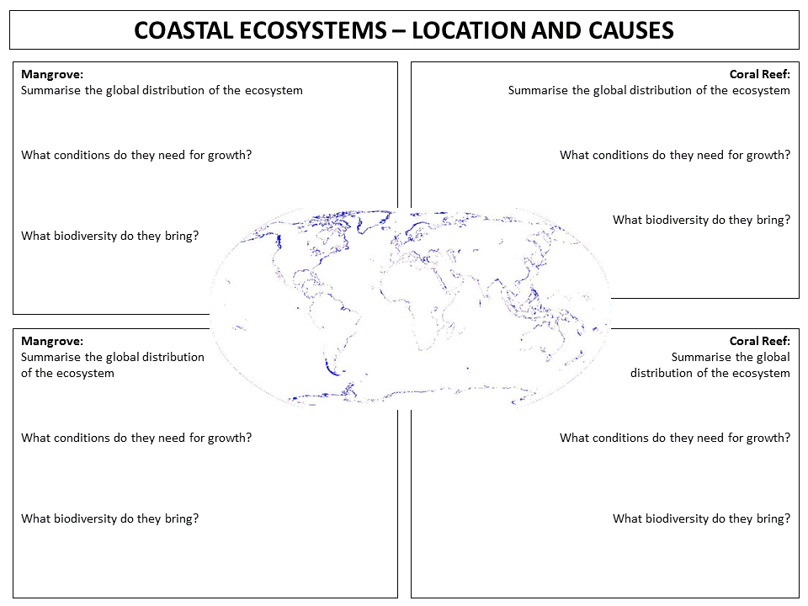
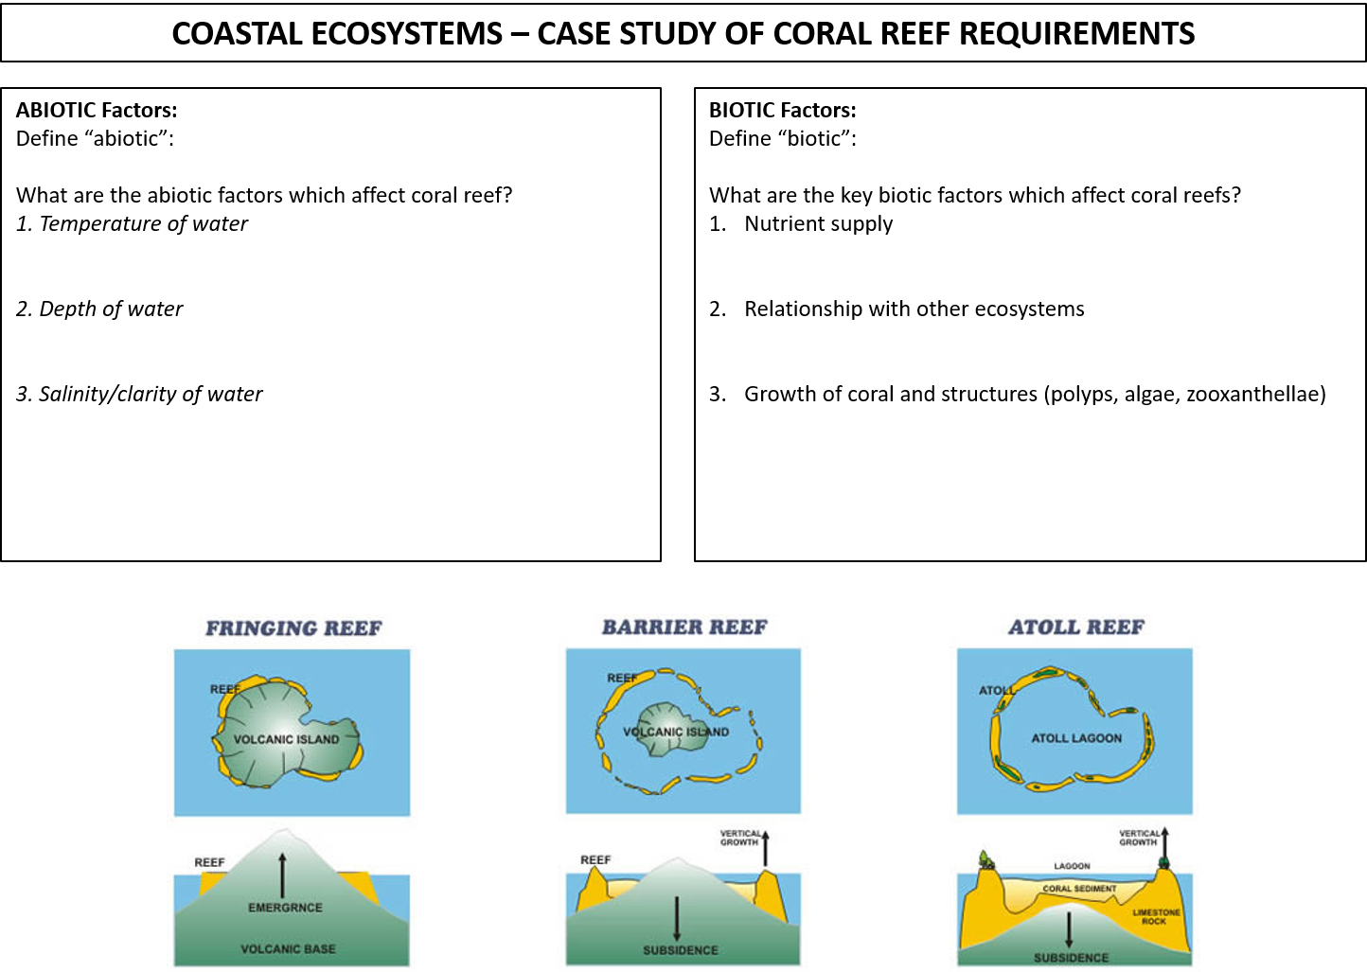
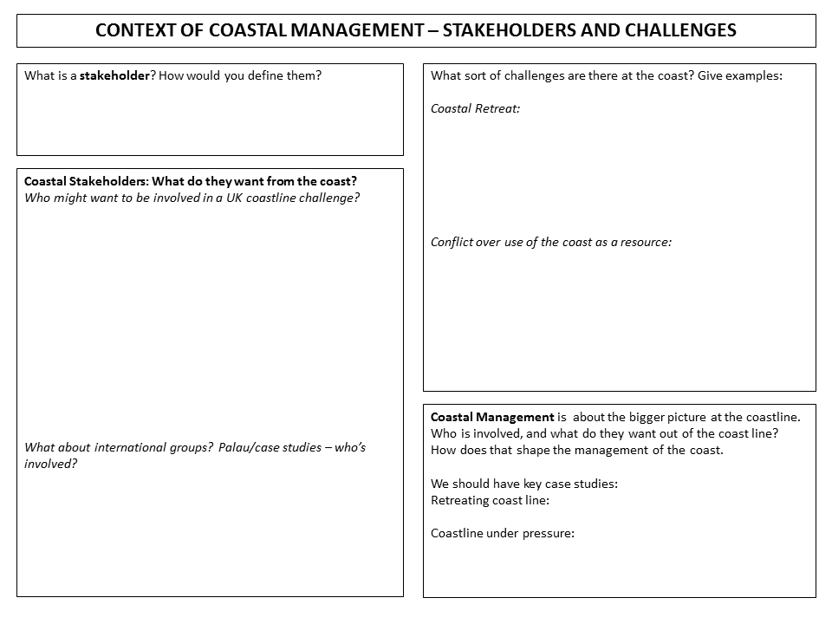
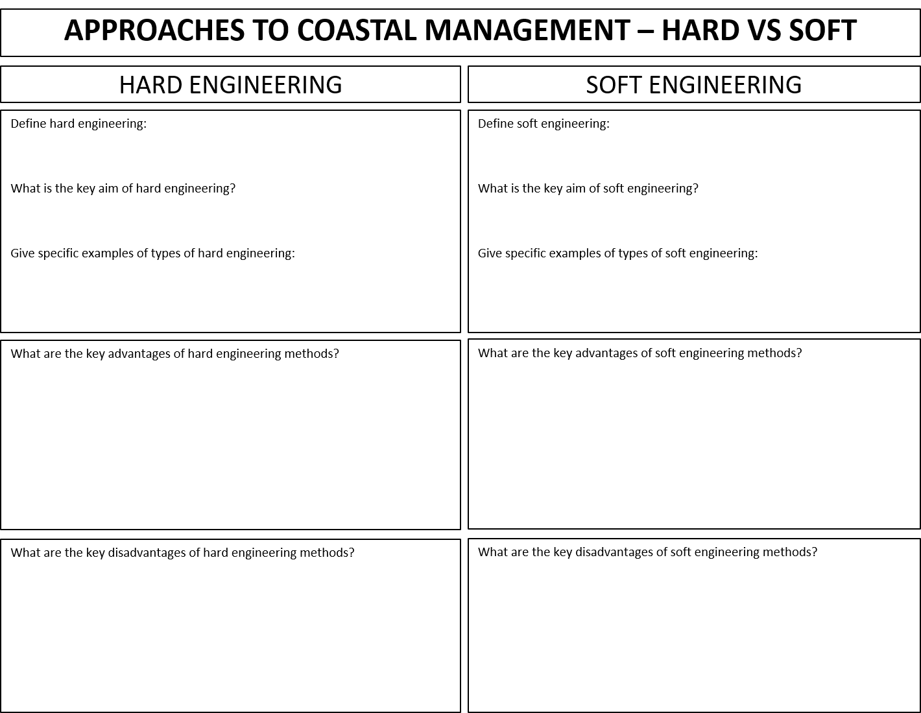
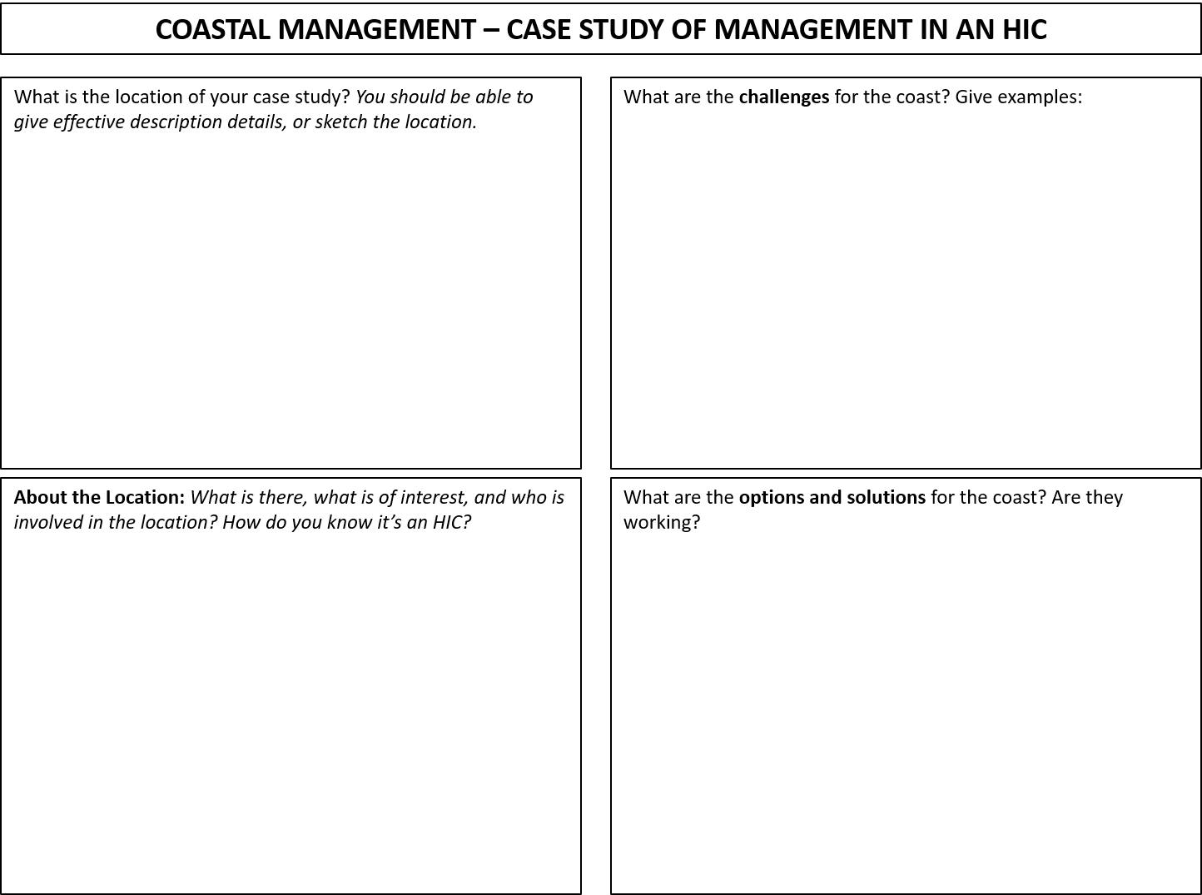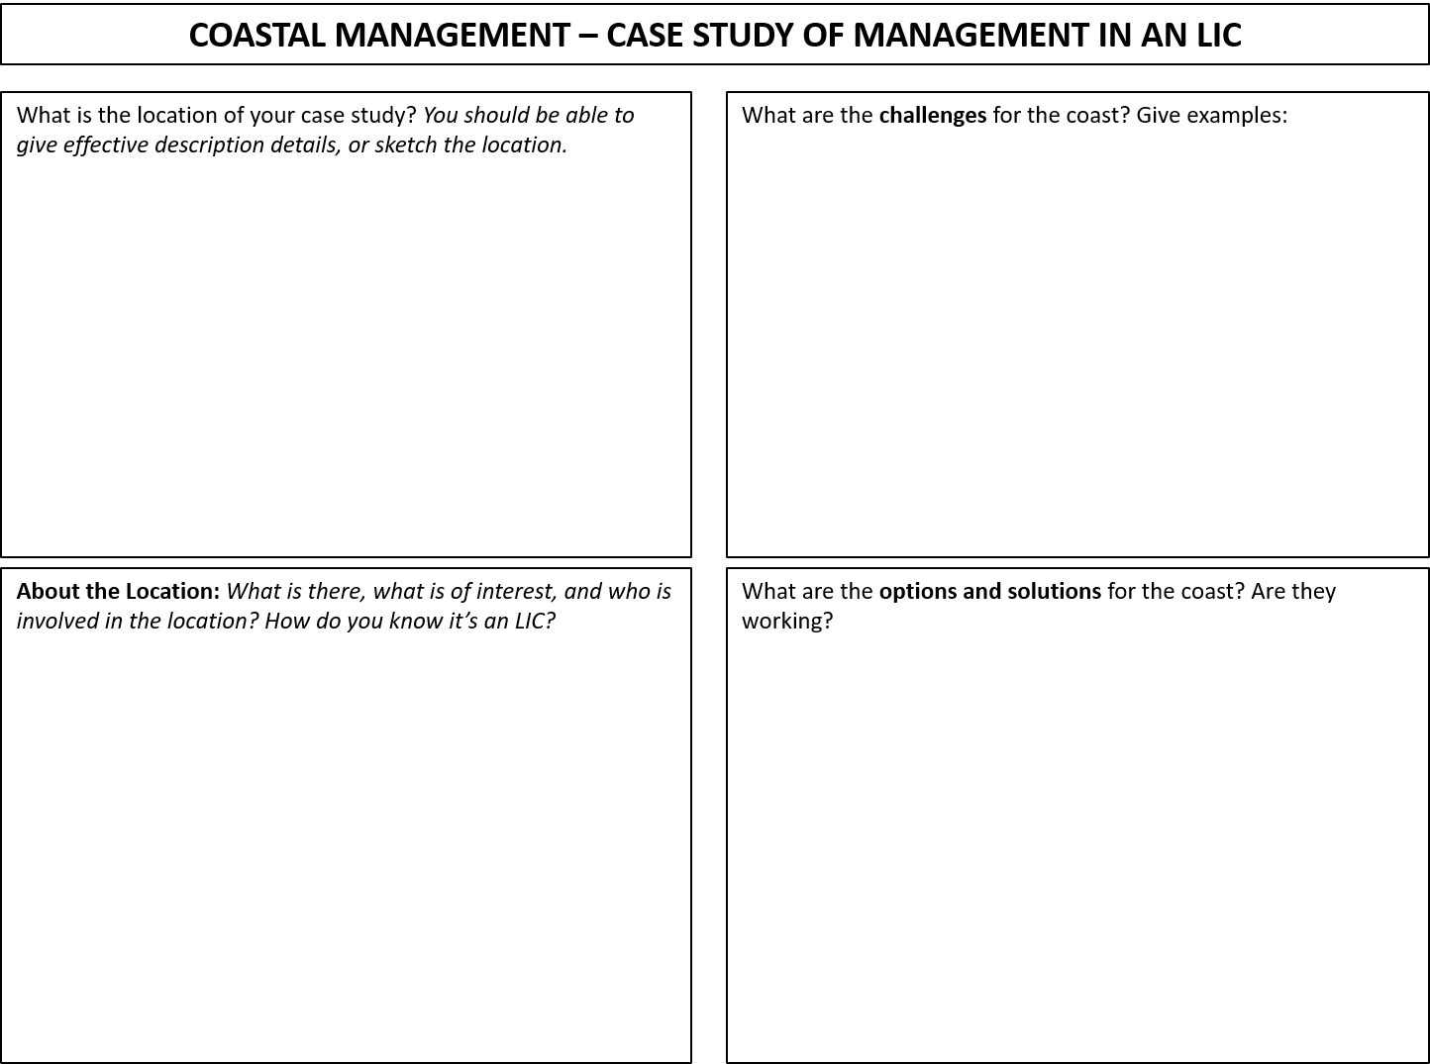

Coasts: Practice Questions:
CE1: What is longshore drift? (1 mark)
CE1: What is the name given to a coastline that has experienced a rise in sea level? (1 mark)
CE1: Which one of the following is a major influence on the distribution of coastal ecosystems: A rainfall; B sediment supply; C deep-sea fishing (1 mark)
CE1: Which one of the following is the purpose of hard engineering along a retreating coastline? (1 mark) [Multiple choice; from “advance”, “retreat”, “hold the line” and “improve appearance”]
CE1: With reference to [table of costs per km], what advantage does the table suggest groynes have over the other methods of defending the coastline? (1 mark)
CE2: Describe the characteristics of the beach shown in Figure 2 [shows wave cut platform and stone beach with vertical cliff face] (2 marks)
CE2: Give an example of a method of (i) soft defence (ii) hard defence (2 marks)
CE2: Give one reason why soft engineering schemes are generally preferred at present (2 marks)
CE2: Give two reasons why managed retreat is increasingly used in coastal areas (2 marks)
CE2: Identify one difference between hard and soft engineering in terms of: cost and environmental impact (2 marks)
CE2: Identify two features from a coastal area image (2 marks)
CE2: Identify two impacts that a fall in sea level has on the coastal area (2 marks)
CE2: Name a type of coastal landform shown on Figure 2b that was formed by: i) erosion, ii) deposition
CE2: Name an example of each of the following that could be used to manage a coastline: i) Soft Engineering; ii) Hard engineering (2 marks)
CE2: Name the landform which is made of: 1. sand or shingle; 2. hard rock (2 marks)
CE2: Name two coastal ecosystems (2 marks)
CE2: Name two methods of coastal protection being used along the coastline (2 marks)
CE2: Name two zones of the coast (2 marks)
CE2: The coast is a natural system. What is meant by a natural system? (2 marks)
CE2: What are sub-aerial processes?
CE2: What is an estuary? (2 marks)
CE2: What is long shore drift? (2 marks)
CE2: What is meant by the term “intertidal”? (2 marks)
CE2: What is meant by the term coastal deposition? (2 marks)
CE2: What is meant by the term ecosystem? (2 marks)
CE3: Describe the main features of the global distribution of coral reefs (3 marks)
CE3: Name three physical factors controlling the growth and distribution of coral (3 marks)
CE3: What is a coastal cell in the UK? (3 marks)
CE3: Why is it important to distinguish between constructive and destructive waves? (3 marks)
CE3: With the aid of a sketch, describe the process of longshore drift (3 marks)
CE3: With the help of an annotated diagram, explain how spits are formed. (4 marks)
CE4: Describe the four main marine processes (4 marks)
CE4: Describe the main coastal features produced by changes in sea level (4 marks)
CE4: Describe the process that leads to the formation of a spit. (4 marks)
CE4: Describe the swash and backwash of a wave. You may use a diagram or diagrams in your answer. (4 marks)
CE4: Explain how wave erosion causes cliff face changes (4 marks)
CE4: Explain the formation of a beach. A diagram may help your answer. (4 marks)
CE4: Explain what is meant by ‘managed retreat’ (4 marks)
CE4: Explain why cliffs are found along some coastlines. Annotated diagrams may help your answer (4 marks)
CE4: For one coastal protection method, explain how it reduces coastal erosion. (4 marks)
CE4: Give two ways in which coastal ecosystems are threatened by economic development. (4 marks)
CE4: In what ways does tourism threaten the coast? (4 marks)
CE4: Name one process, other than hydraulic action, that helps cliff erosion. (1 marks) Explain how this process helps cliff erosion (3 marks)
CE4: Outline two physical factors affecting the distribution of coastal ecosystems (4 marks)
CE4: Outline two physical processes that affect the coast (4 marks)
CE4: Outline two ways in which sub-aerial processes can affect the rate of cliff retreat
CE4: Suggest two conflicts which might occur between developers and conservationists in coastal areas (4 marks)
CE4: What part does longshore drift play in the development of coastal landforms? (4 marks)
CE4: With the help of examples, distinguish between hard and soft coastal engineering (4 marks)
CE6: Explain how geology affects two different coastal landforms. (6 marks)
CE6: Explain the threats to one named coastal ecosystem (6 marks)
CE6: Explain why conflict can occur between development and conservation on a coastline (6 marks)
CE6: Explain why the following features occur on the present coastline: i) a wave cut platform; a steep shingle beach (6 marks)
CE6: For a named coastal ecosystem, explain the ways in which it is valuable to people (6 marks)
Any reference to 9 mark questions are not valid for the new specification of paper.

Coasts: Source Question Examples
- Using Figure 1 and Figure 1, analyse the scale of the threat to coral reef ecosystems around the world (8 marks)
- Using Figure 3-5, analyse the causes of the threat to coral reef ecosystems (8 marks)
- Using Figure 1-5, and your own knowledge, explain why coral reef ecosystems are threatened (8 marks)
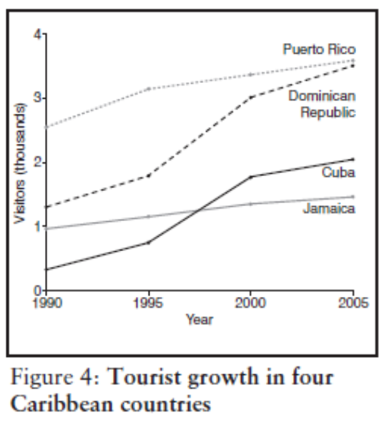
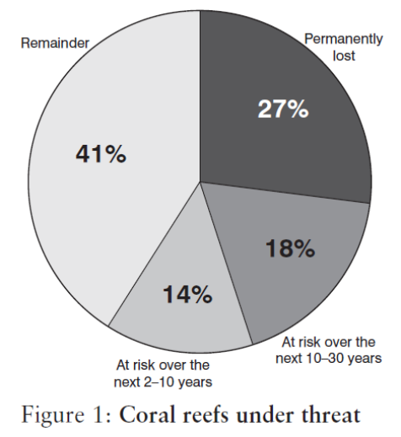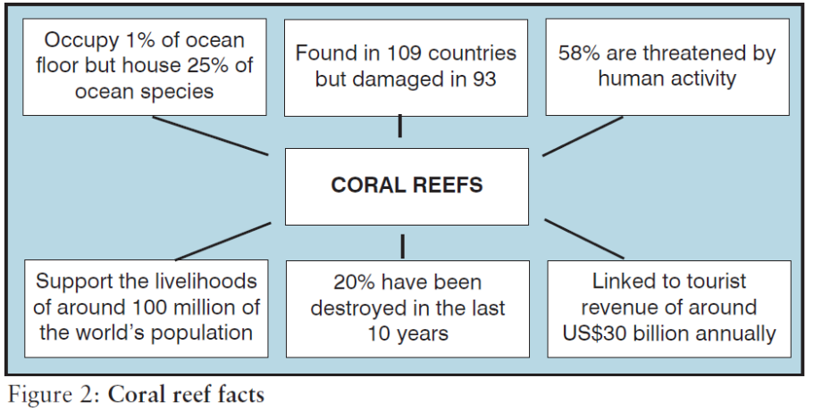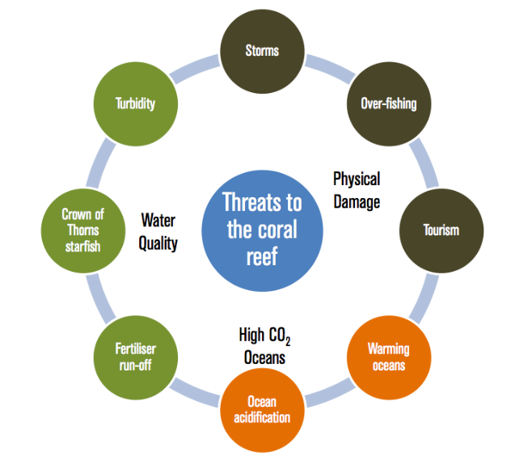
Figure 3: Physical Threats to the Reef Ecosystem
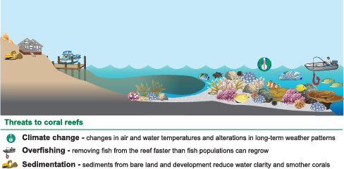
Figure 5: Human Threats to the Reef Ecosystem

Coasts: Model Answers

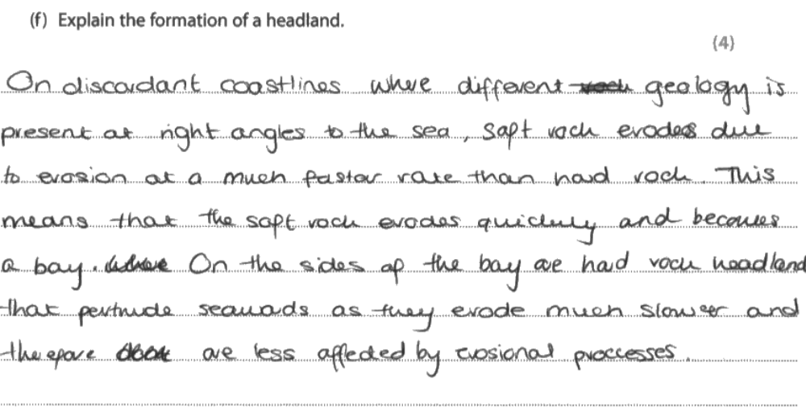
Examiner Comment: lots of technical language, well sequenced, clear use of ‘discordant’ terminology. Worth 4 marks

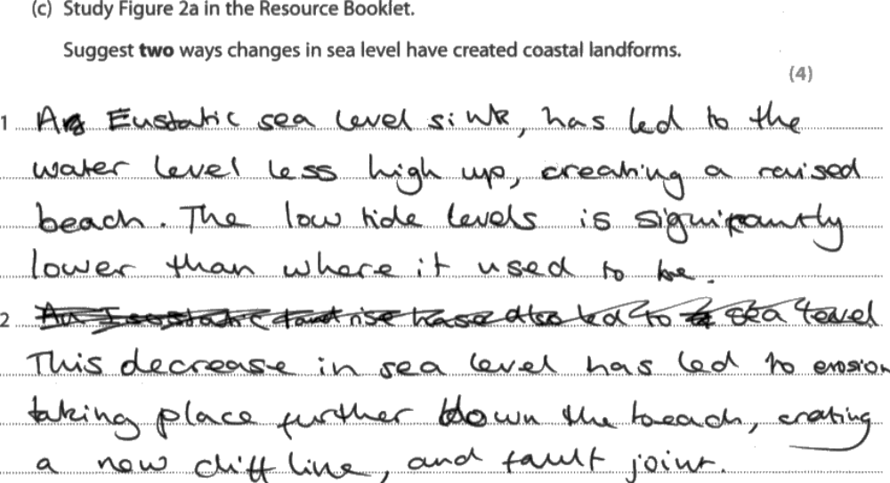

Examiner comment: look at the quality of technical language (eustatic, isostatic) and terminology, showing clear sense of what’s going on. Geology and further mentions in 2nd idea. 4 marks
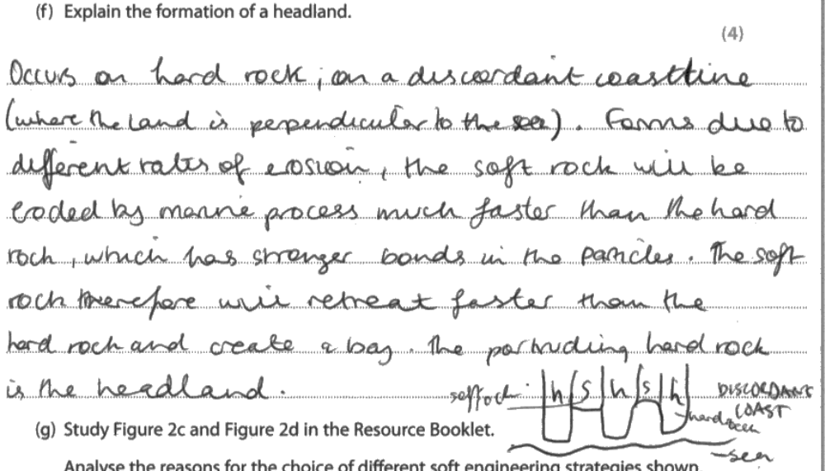

Examiner Comment: clear use of ‘discordant’ coast, credit also given for diagram, even though it wasn’t specifically requested in the question. Again, clearly sequenced knowledge and logical progression of answer. 4 marks.

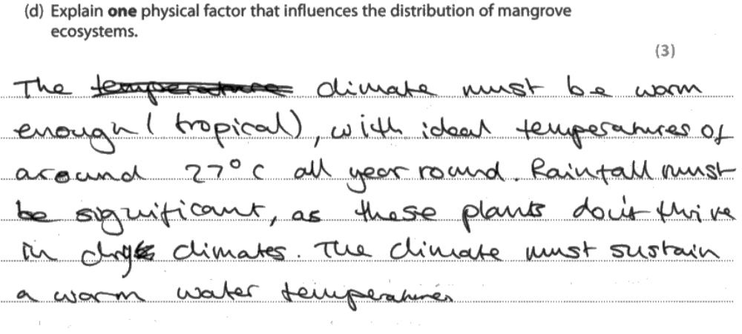
Examiner Comment: Three clearly linked points, showing technical understanding and precision of detail. An easy three marks for a well-revised factor question
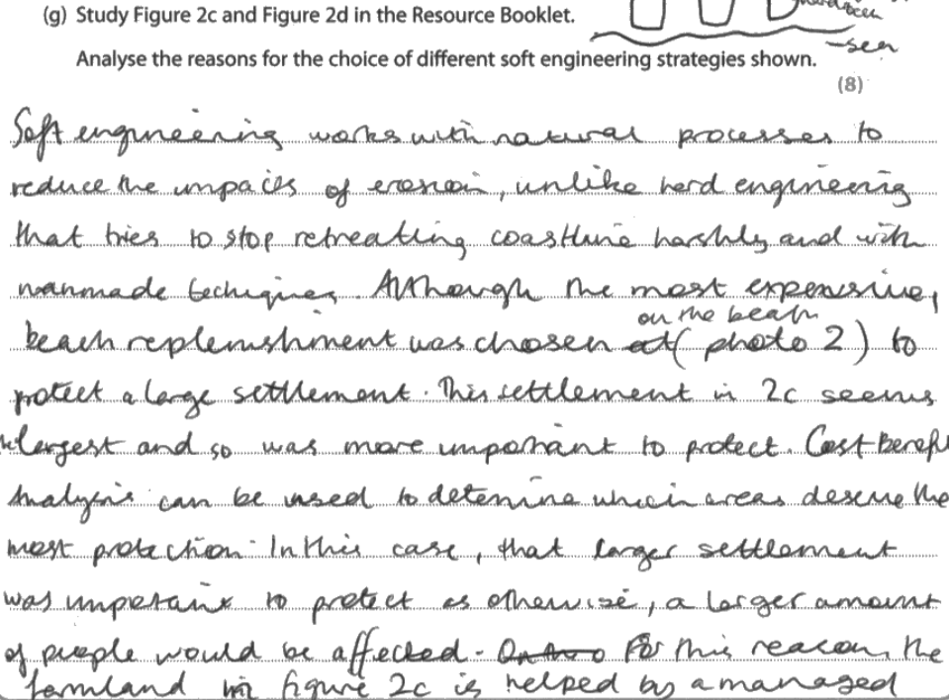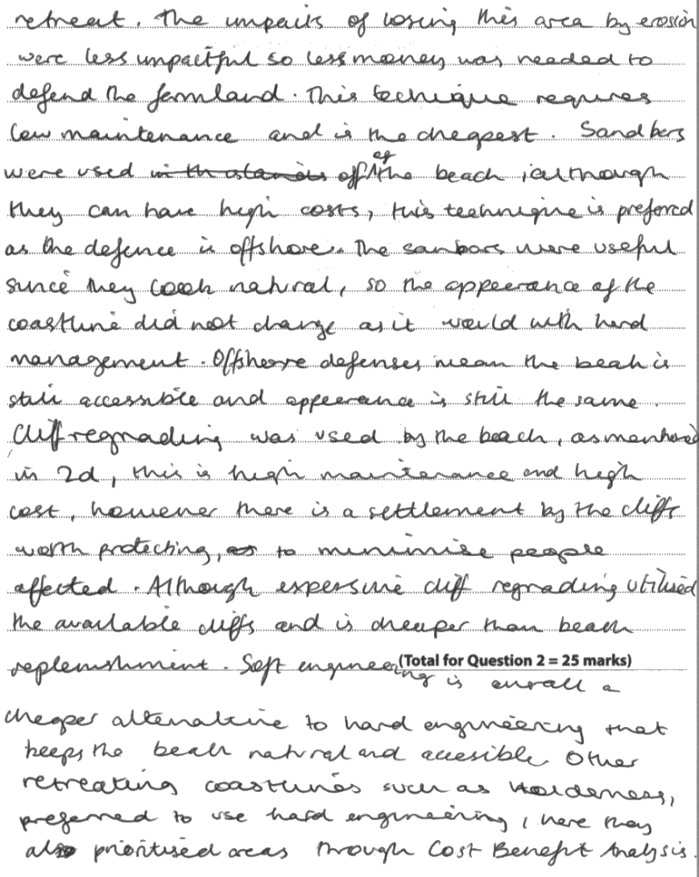
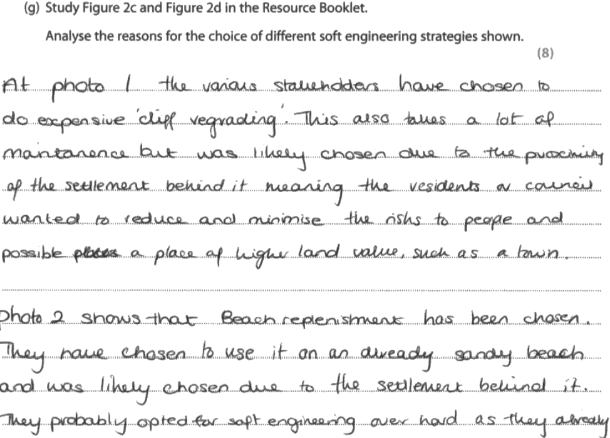

Examiner Comment: These responses both scored 8 marks. You can see how the sources are explicitly referred to throughout, and how the candidate links them together to draw out key conclusions. The response works methodically through the IDEAL structure, showing clear analysis

Paper 1: Hazardous Environments

Hazards: Specification

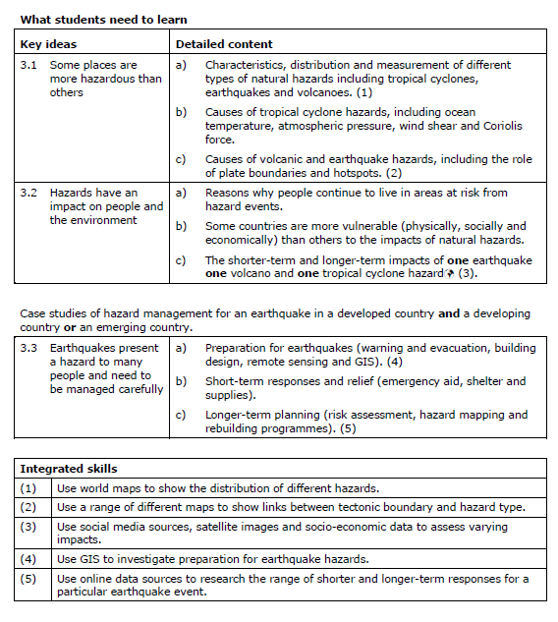

Glossary of Terms: Hazardous Environments
Aid: help in various forms given by a country or organisation to a relatively poor country
Ash: fine dust and cinders thrown out by an eruptive volcano
Convergent plate margin: see Collision plate margin
Collision plate margin: where two tectonic plates meet, with one plate overriding the other.
Conservative plate margin: where two tectonic plates are sliding past each other
Constructive plate margin: where two tectonic plates are moving apart and the space between them is filled with magma
Destructive plate margin: see Collision plate margin
Divergent plate margin: see Constructive plate margin
Earthquake: a violent shaking of the Earth’s crust
Emergency aid or response: the immediate help offered by relief and aid organisations immediately after a natural disaster. It usually takes the form of food, water, medical care and temporary housing.
Epicentre: the point on the Earth's surface that is directly above the focus of an earthquake
Focus: the point of origin of an earthquake
Hazard: an event which threatens the well-being of people and their property
Lahar: a flow of wet material down the side of a volcano's ash cone which can become a serious hazard
Lava flow: molten magma moving over the land usually in a downslope direction
Mitigation: the process of making something less severe
Natural disaster: a natural event or natural hazard causing damage and destruction to property, as well as personal injuries and death.
Natural event: something happening in the physical environment, such as a storm, volcanic eruption or earthquake.
Natural hazard: a natural event, such as an earthquake or tropical storm, which poses a threat to people and their property.
Plate movement: mainly the coming together and the moving apart of tectonic plates
Pyroclastic flow: a devastating eruption of extremely hot gas, ash and rocks during a period of explosive volcanic activity; the downslope flow for this mixture is capable of reaching speeds of up to 200kph.
Recovery: getting back to normal after an event such as a natural disaster or slump in business
Risk assessment: judging the degree of damage and destruction that an area might experience as a result of a natural event
Risk: the chances of a specific event or action happening
Subduction: the pushing down of one tectonic plate under another at a collision plate margin. Pressure and heat convert the plate into magma.
Tectonic plate: a block of the Earth's crust which 'floats like a raft' on the underlying mantle.
Tropical revolving storm: a weather system of very low pressure formed over tropical seas and involving strong winds and heavy rainfall (also known as a cyclone, hurricane or typhoon).
Volcanic activity or eruption: the eruption of molten rock, ash or gases from a volcano.
Voluntary aid: aid provided by non-government organisations that rely on the services of volunteers.

Hazards: Revision Materials
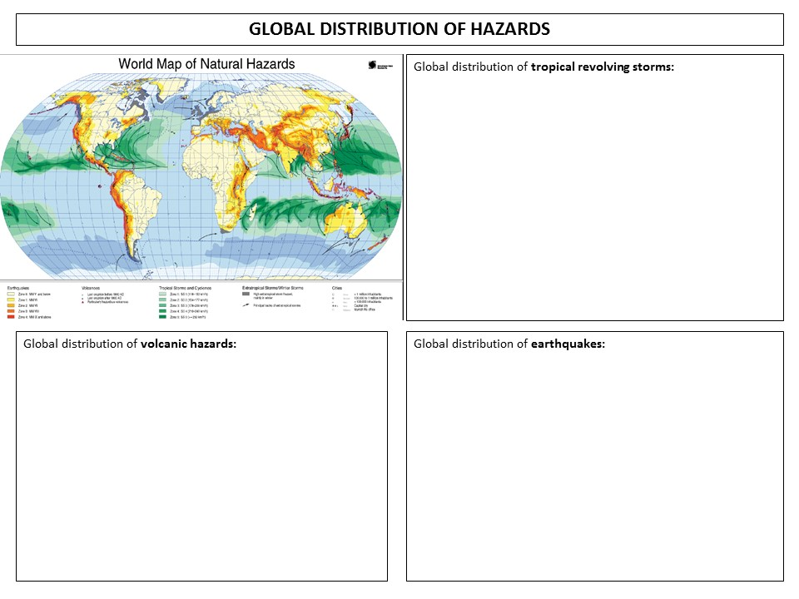
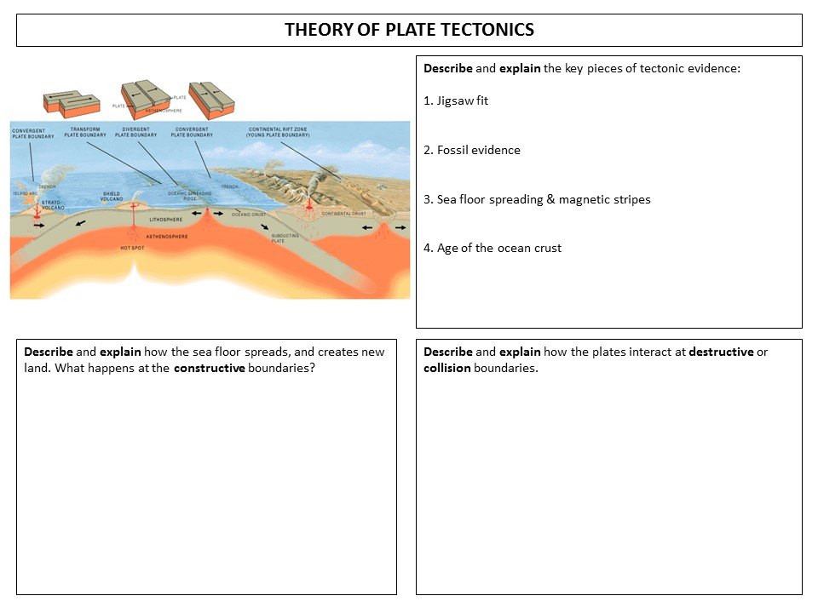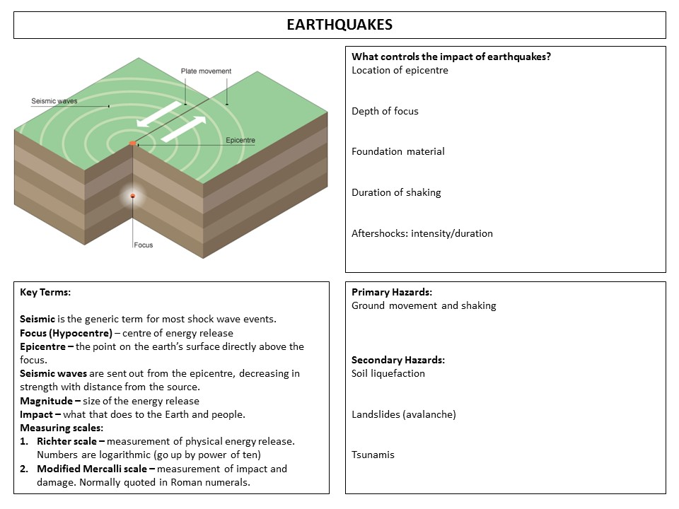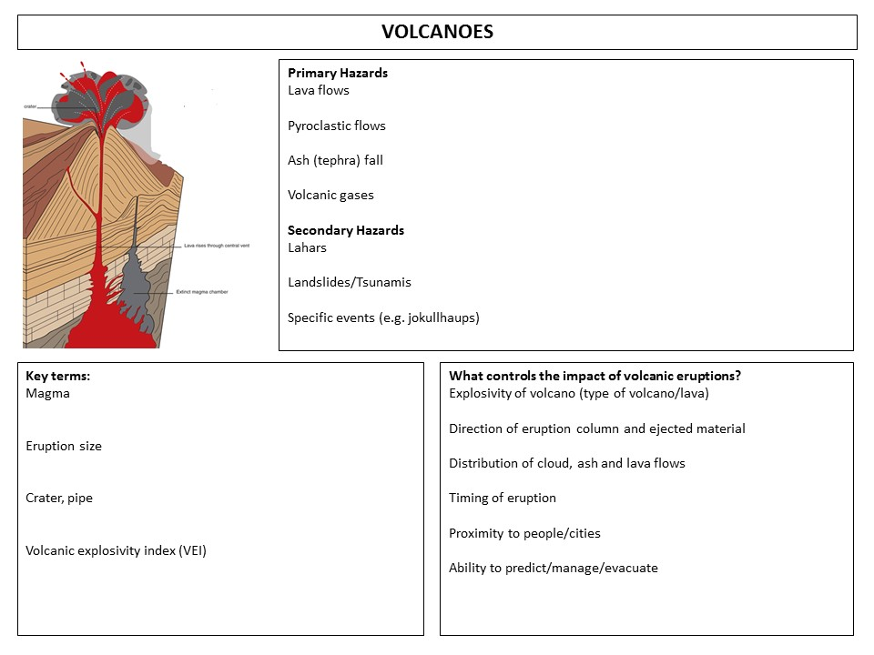
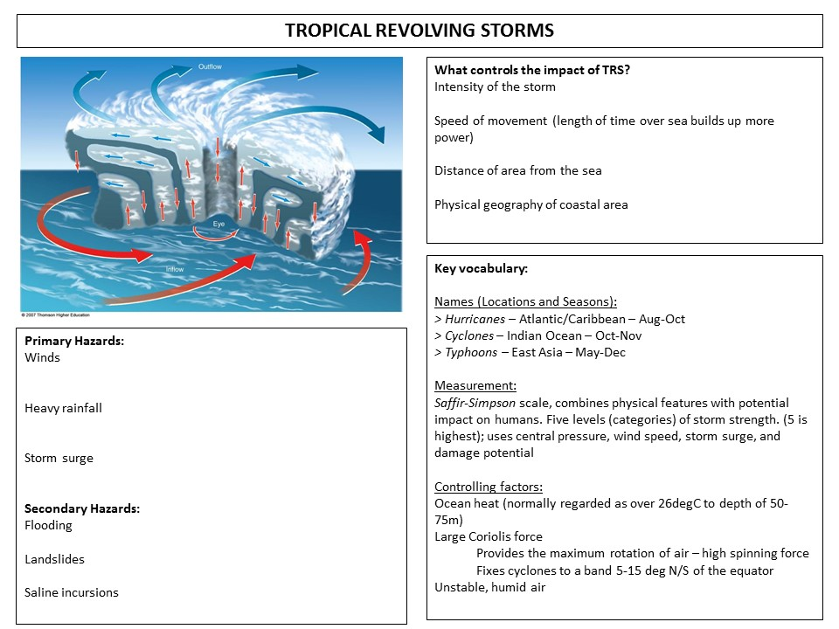

THE HAZARD MANAGEMENT CYCLE

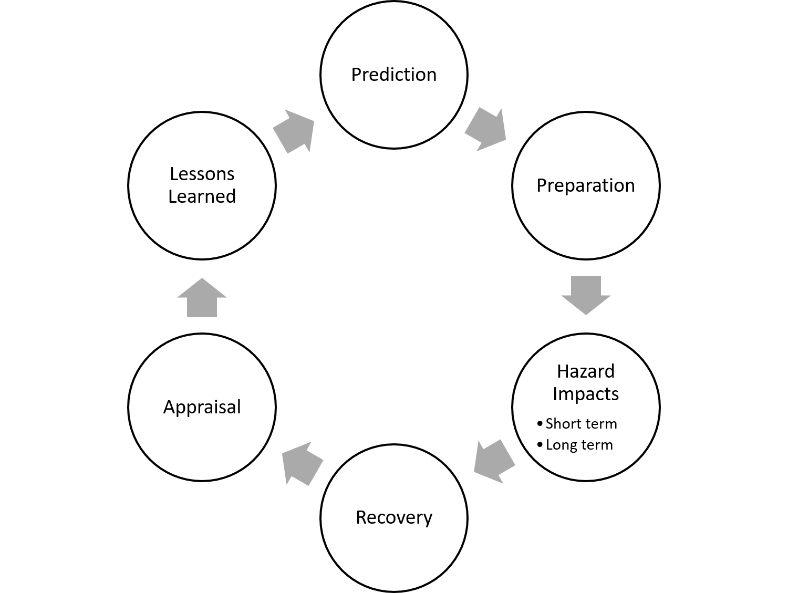
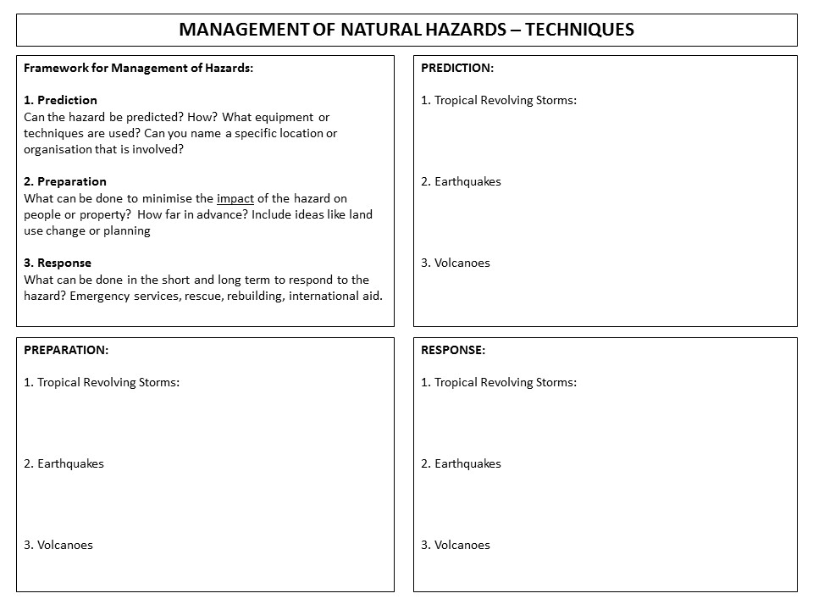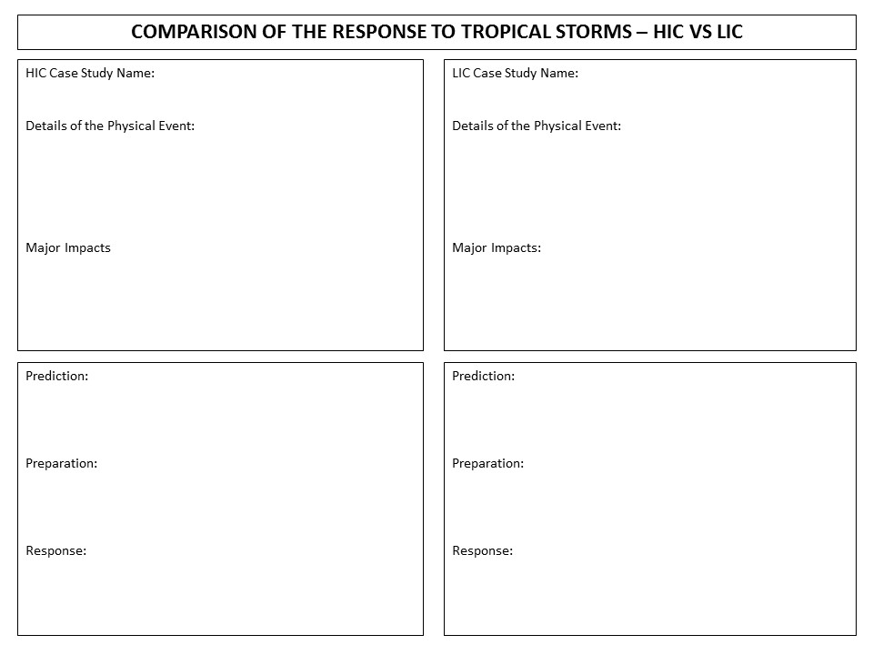
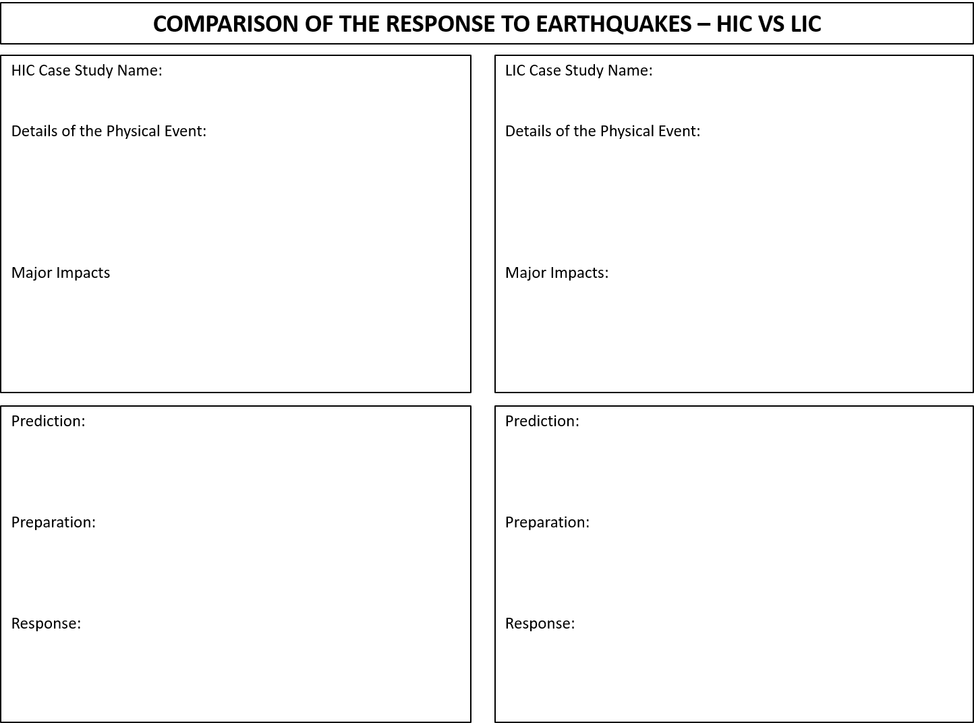
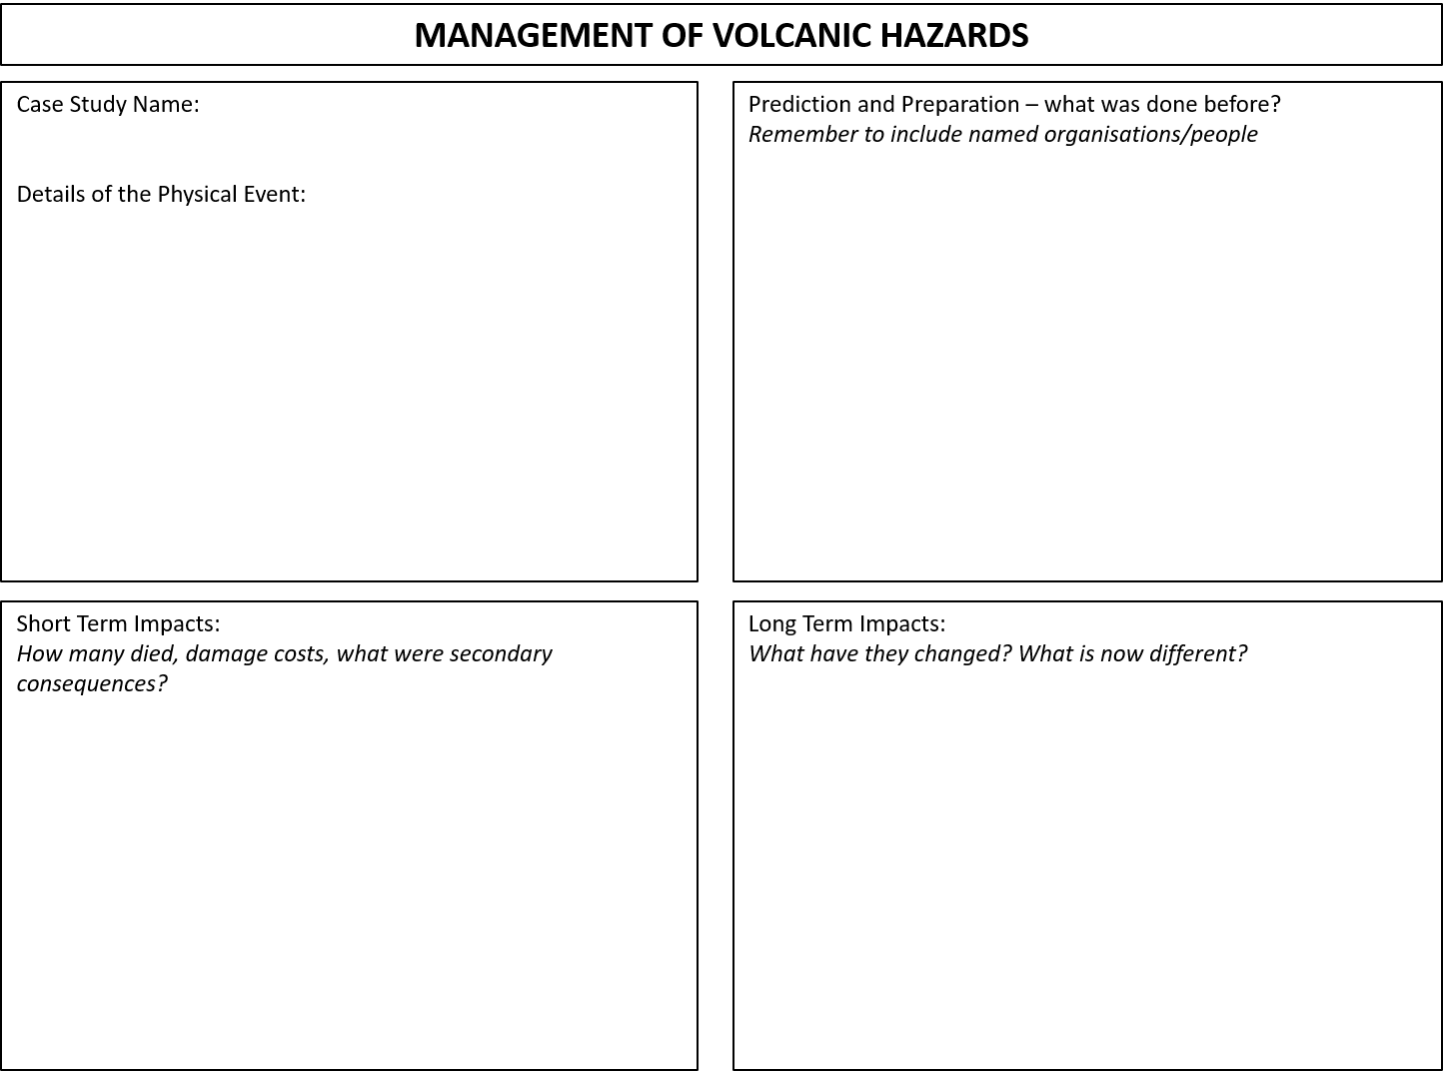

Hazards: Practice Questions
HE1: How might the number of deaths been affected by the time of the earthquake? (1 mark)
HE1: Name an area of the world prone to great and major earthquakes (1 mark)
HE1: Name an area severely affected by tropical storms. (1 marks)
HE1: Suggest one reason why people live in hazardous environments (1 mark)
HE1: What is an active volcano? (1 marks)
HE1: What is the epicentre of an earthquake? (1 mark)
HE1: What term describes the place on the earth’s surface directly above where the earthquakes started (1 mark)
HE1: What term is given to the giant slabs of crust that make up the Earth’s surface? (1 mark)
HE1: What type of volcano is formed by the eruption of different types of material (1 mark)
HE1: Which of the following best describes the pressure at the centre of the tropical storm system? (1 mark)
HE1: Which of the following is the greatest hazard to people during the passage of a hurricane? (1 mark) [Multiple Choice, from: high pressure, high wind, low visibility, low rainfall]
HE2: Complete the sentences by filling in the gaps The weather system shown in Figure 3 is known in this part of the world as a ............................................. Area A is known as the ............................. of the storm (2 marks)
HE2: Describe the characteristics of a volcanic landscape [Reference to Figure] (2 marks)
HE2: Give two actions, other than building standards, that can be taken to minimise the impact of an earthquake (2 marks)
HE2: Identify one way in which the following change with pressure: visibility, rainfall & windspeed (2 marks)
HE2: Identify two ways in which volcanoes differ in shape (2 marks)
HE2: Outline the main features of seismic waves (2 marks)
HE2: Outline why Japan is a hazardous place? Use information from the Figure in your answer (2 marks)
HE2: Suggest how people in LICs might be affected by a weather system such as that shown in Figure 3 (2 marks).
HE2: Suggest why stronger earthquakes generally cause more damage (2 marks)
HE2: What is a ‘hazard’? (2 marks)
HE2: What is a ‘tectonic plate’? (2 marks)
HE2: What is a natural disaster? (2 marks)
HE2: What is a plate? (2 marks)
HE2: What is meant by a hazard risk assessment? (2 marks)
HE2: What is meant by the term earthquake? (2 marks)
HE2: What is meant by the term natural disaster? (2 marks)
HE2: What is meant by the term natural disaster? (2 marks)
HE2: What is the ‘Saffir-Simpson’ scale? (2 marks)
HE2: What is the difference between the ‘focus’ and ‘epicentre’ of an earthquake? (2 marks)
HE2: When are tropical storms most common in the Northern Hemisphere, and why (2 marks)
HE3: Give three reasons, other than time, why the 2011 earthquake in Christchurch was more destructive than the 2010 earthquake [data table provided] (3 marks)
HE3: Identify the source of tropical revolving storms and the general path they take (3 marks)
HE3: What organisations provide emergency aid (3 marks)
HE3: Why are earthquakes a hazard in coastal regions? (3 marks)
HE4: Describe how tropical storms are tracked and predicted (4 marks)
HE4: Describe the characteristics of a tropical storm. Diagrams may help your answer. (4 marks)
HE4: Describe the main effects of volcanic eruptions: 1. in the short-term, 2. in the long-term. (4 marks)
HE4: Describe the physical features or landforms associated with the type of boundary where plates A and B meet. [destructive boundary] (4 marks)
HE4: Describe the short and long term impacts of an earthquake or volcanic event (4 marks)
HE4: Describe ways in which people try to reduce the harmful effects of volcanic eruptions (4 marks)
HE4: Explain why coastal areas are more hazardous than inland areas during the passage of a tropical storm (4 marks)
HE4: Explain why there are active volcanoes in Iceland. A diagram may help your answer. (4 marks)
HE4: Give three reasons why some people live close to volcanoes (3 marks)
HE4: Give two reasons why people continue to live in areas at risk from hazard events? (4 marks)
HE4: Give two reasons why people continue to live in volcanic areas. (4 marks)
HE4: Name the four main types of hazard (4 marks)
HE4: Outline the long-term impacts of a hazard event such as the Christchurch earthquake (4 marks)
HE4: Outline two reasons why people continue to live in areas at risk from natural disasters (4 marks)
HE4: Outline two ways in which earthquake damage can be mitigated (4 marks)
HE4: What are the principal impacts of a tropical storm (4 marks)
HE4: What conditions are necessary for the formation of tropical storms (4 marks)
HE4: What evidence is there that a volcano is active? (3 marks)
HE4: What is the difference between a destructive and collision plate margin? (4 marks)
HE4: With the use of examples, explain what is meant by ‘emergency aid’? (4 marks)
HE5: Suggest how the weather in Haiti changed as this weather system passed over the island. (5 marks)
HE5: Why do tropical storms generally cause more damage in LICs? (5 marks)
HE6: Explain how the methods of monitoring weather conditions have changed (6 marks)
HE6: Explain the causes of volcanoes (6 marks)
HE6: Explain the global distribution of earthquakes (6 marks)
HE6: Explain two characteristics of a tropical storm. Diagrams may help your answer. (6 marks)
HE6: How do people prepare for earthquakes? (6 marks)

Hazards: Source Question Examples:
Using Figure 1, and your own knowledge, analyse the reasons why earthquakes have different impacts in different parts of the world (8 marks)
Using Figure 2, and your own knowledge, analyse the differences between these three earthquakes (8 marks)
Using Figures 3 and 4, and your own knowledge, analyse the reasons for the distribution of earthquake azards around the world (8 marks)
Using Figures 3 and 4, and your own knowledge, analyse the reasons for the distribution of volcanic hazards around the world (8 marks)
Using Figures 3 and 4, and your own knowledge, explain why destructive boundaries tend to be a greater hazard to human life than other boundary types (8 marks)

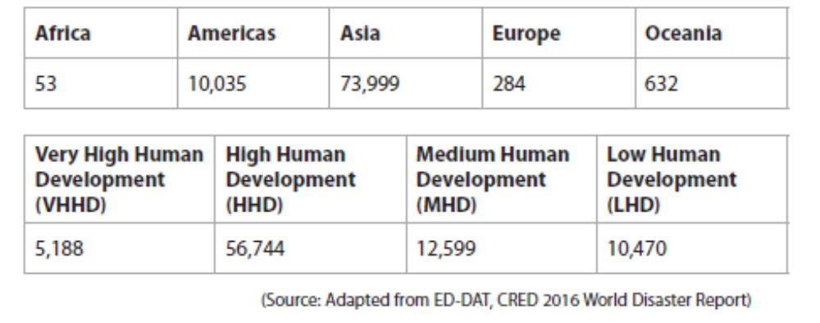
Figure 1: Number of people affected by earthquakes, in thousands (2006-2015) by region and level of development
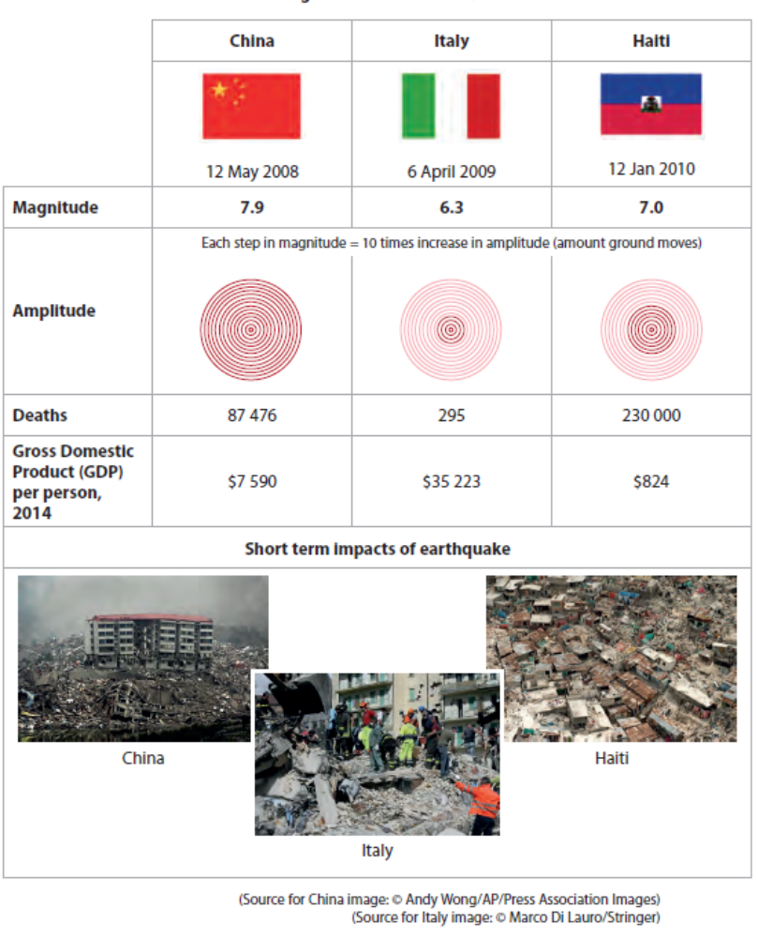
Figure 2: Information about three different earthquakes
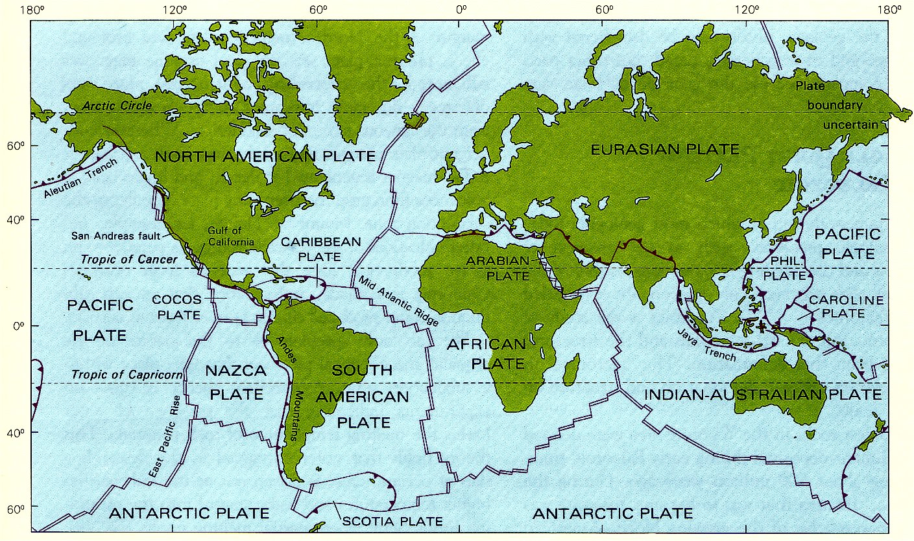
Figure 3: A global map of plates, showing the main features and distribution of different boundaries
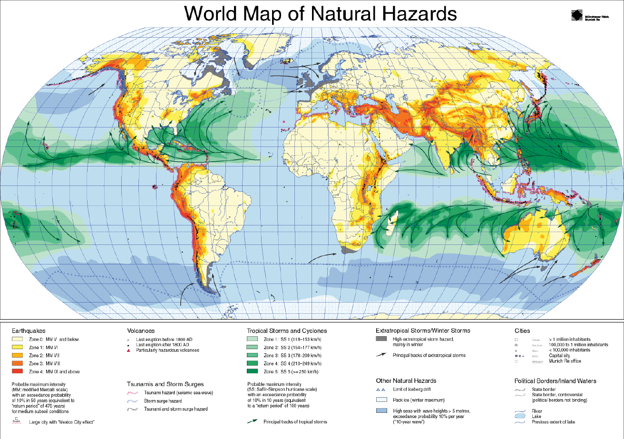
Figure 4: A World Map of the Distribution of Different Natural Hazards

Hazards: Model Answers

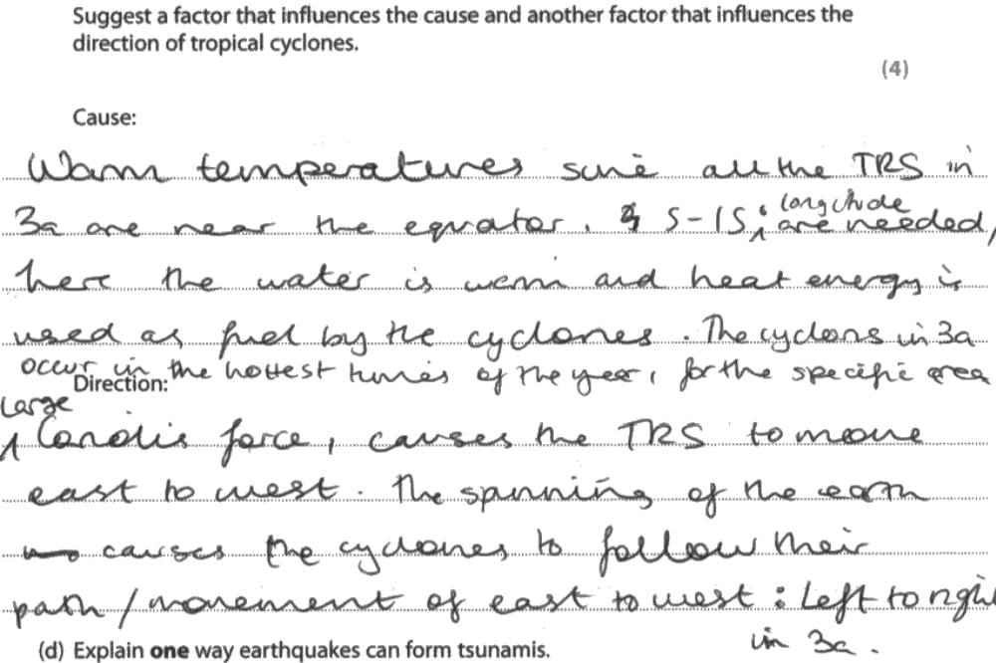

Examiner Comment: clear technical understanding and precise detail are key to this answer scoring full marks. The explanation is developed and extends the factor to a second point.

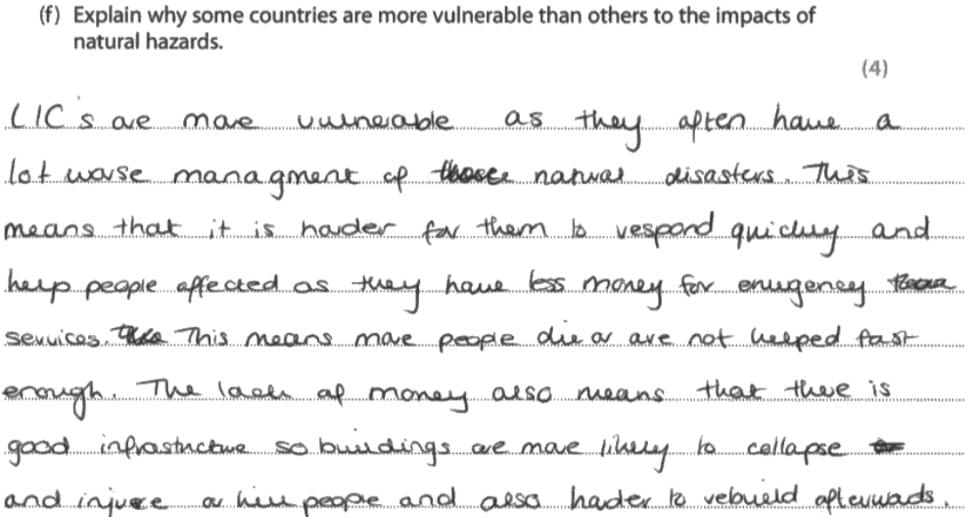

Examiner Comment: clear conceptual understanding. No examples are referred to – but the question doesn’t ask for them. The sequence of ideas is logical, and goes from point, to point. Four marks.
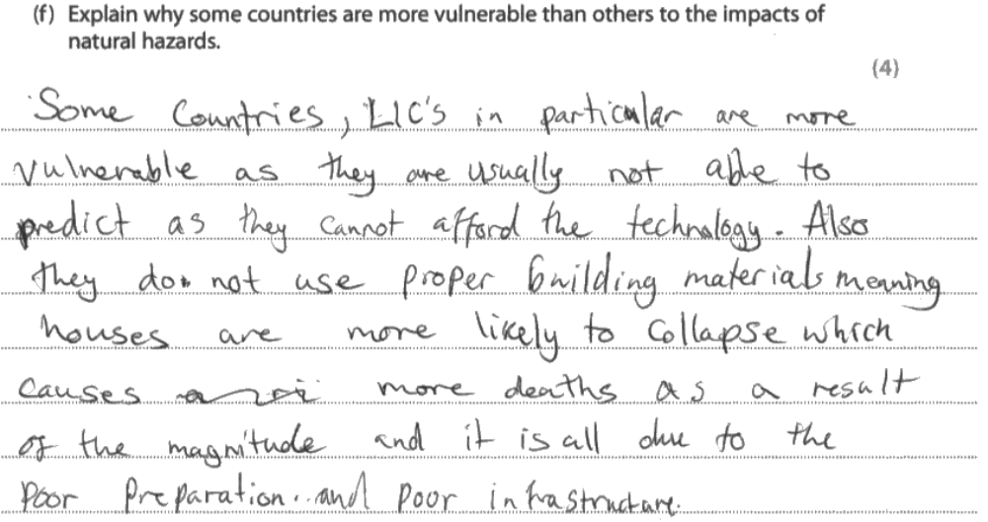

Examiner Comment: links some big ideas together, and even though I’d prefer not to see the word “also” in the text, it does make a range of good points that score full marks.

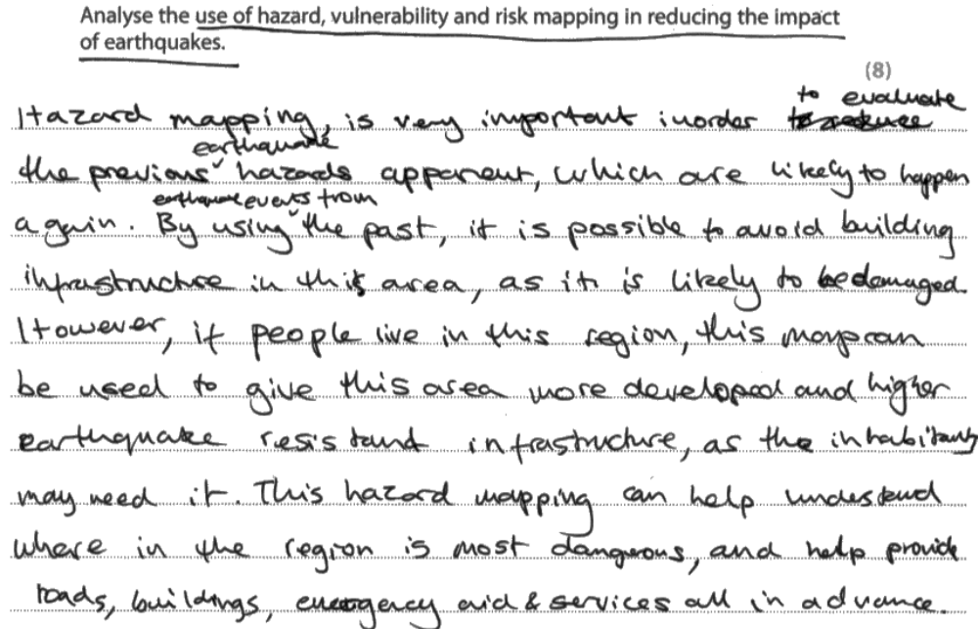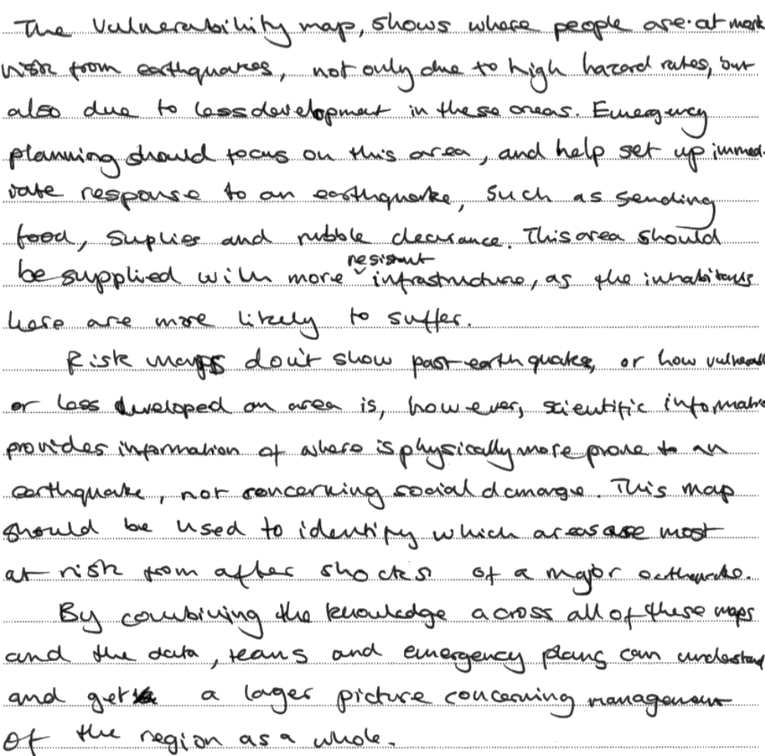

Examiner Comment: clear use of all of the sources, and explicit evidence from them. Creates a logical structure, and brings it to a reasonable assessment as a conclusion. Full marks.
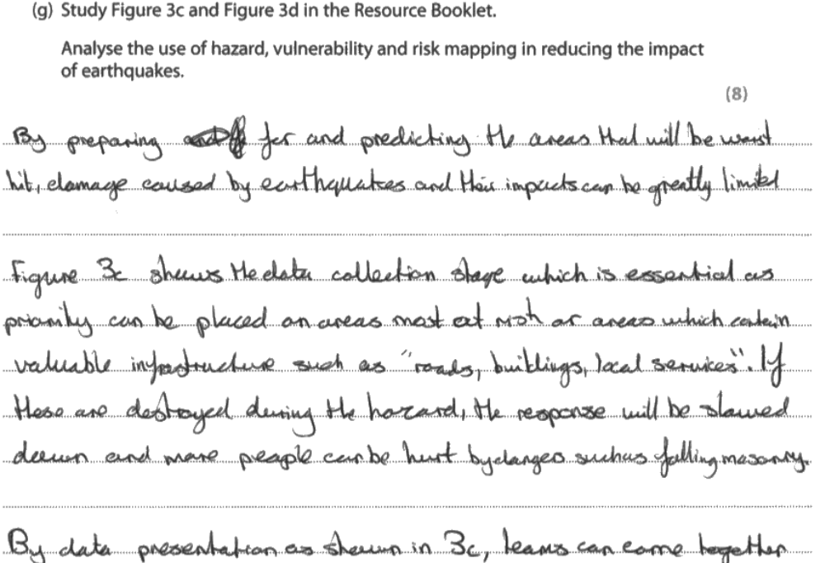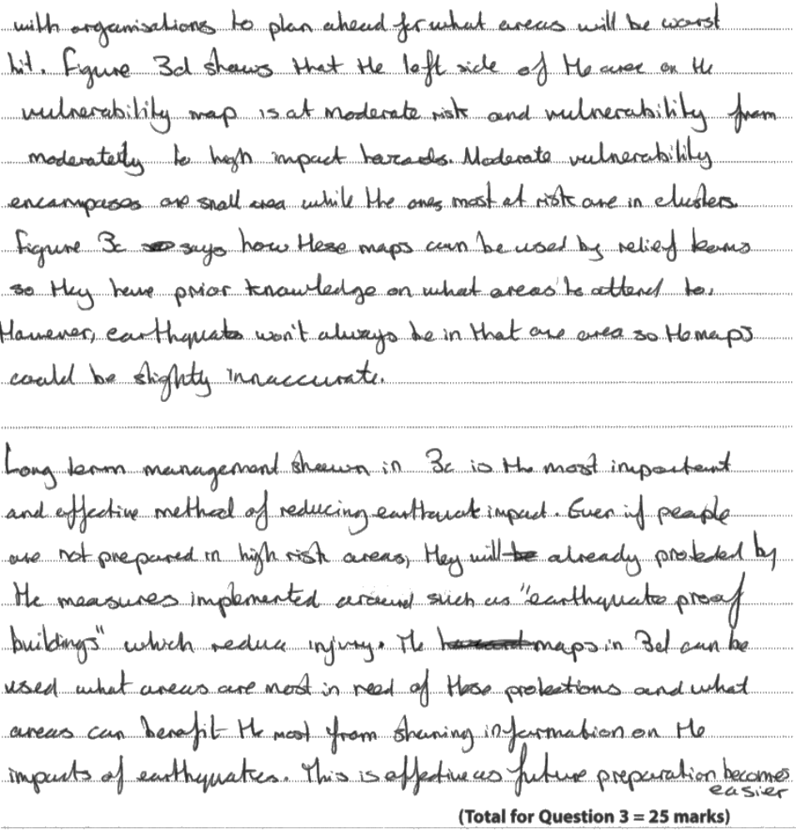
Examiner Comments: what’s excellent about this response is the clarity with which it’s written. There is an obvious separation between ideas, and each of them are explicitly linked to the data and sources. There is judgement “management shown in 3c is most important and effective” and explicit quotes from the text. Excellent. 8 marks

Paper 1: Fieldwork Questions

Principles of Fieldwork Units
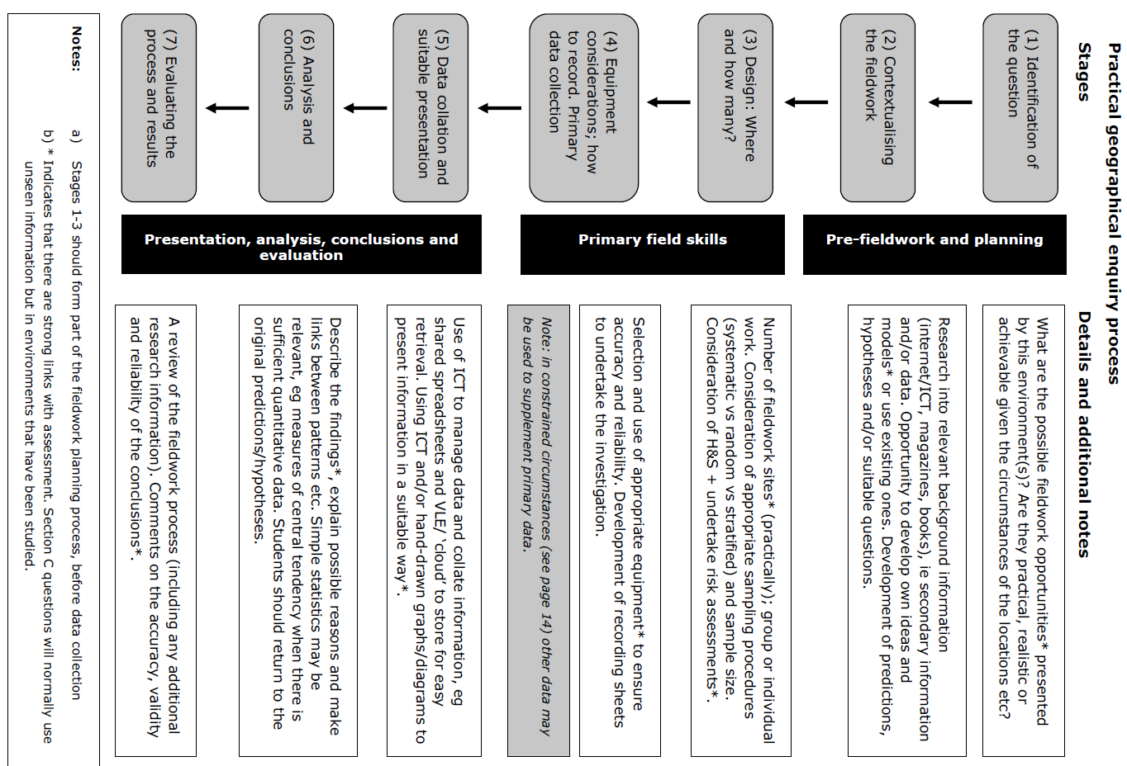
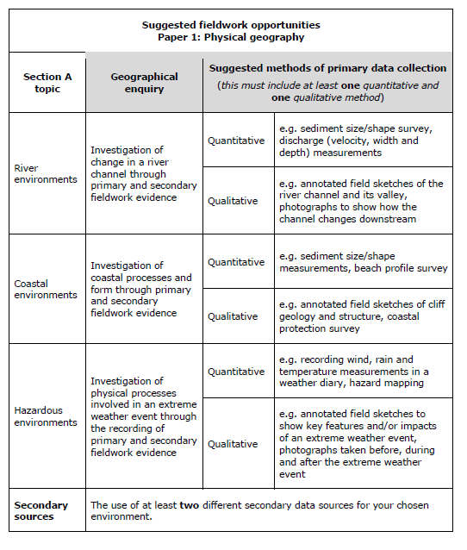

COASTAL FIELDWORK – Jurassic Coast, Lulworth Cove, Dorset, UK
What do we want to know?
- What would we expect to happen? Why? [Theory/Context]

- What do we want to find out? [Aim]

- What specific questions do we want to answer? [Research Question]

How do we find our information? [Methods]
- What kind of data do we want to collect? (Primary/Secondary/Quantitative/Qualitative)
Primary: Secondary:

Quantitative: Qualitative:

- How do we collect data? (Equipment, Techniques)

- How do we know where/how much to measure? (Sampling)

- How do we stay safe? (Risk Assessment)

What did we find out? [Results & Conclusions]
- Presentation of results

- Statement of conclusions/key findings

- Statement of any anomalies or unexplained results

Did we do it right? [Evaluation]
- Did we collect enough data in terms of places visited or people asked? How do we know?

- Did we collect data for long enough in time? How do we know?

- Did we use the most effective techniques of data collection? How do we know?

- How could we improve our study in any of these areas?

Glossary of Terms: Physical Geography Fieldwork
Accurate data is as close to the real data as possible. It represents the target population precisely and shows the real world as it is. Accuracy is usually improved by better techniques and sampling techniques.
Aim: an aim is a big and broad idea, which covers lots of smaller research questions. For example, in physical geography, an aim might be “to investigate beach processes”, or “to investigate the CBD of Catford” in human geography. These are big ideas, and give rise to lots of smaller research questions and hypotheses that you can test.
Anemometer: device used to measure wind speed. Normally must be placed up high, to avoid ground effects.
Barometer: instrument used to measure surface pressure. Normally placed inside a Stevenson Screen (raised white box, 1.5m above the ground for fairness)
Bias: an interpretation or approach which suits a particular set of facts. This is a negative idea, and we want to create unbiased approaches wherever possible.
Calipers: pinch-instrument, used in coastal fieldwork to measure the size of sediment
Clinometer: instrument used to estimate angles and gradients. Used in coasts to assess slope.
Fair: a technique that can be produced without personal interpretation and reflects the real world.
Hypothesis: a hypothesis (plural: hypotheses) is a testable question, that you should be able to answer “yes” or “no” to at the end of your fieldwork using statistical evidence. For example: “does longshore drift occur on the beach at Swanage?”, or “does land use follow the Burgess model in Catford?”. Think about what type of data this might need to collect. This is different to a research question.
Okta: unit of measuring cloud cover
Primary data is collected personally by an investigator or their team.
Qualitative data provides people’s opinions and perceptions. This needs to be described and interpreted by the investigator, and brought together to understand it.
Quantitative data provides numerical information that can easily be shown on graphs and charts.
Questionnaire: a range of questions, asked as a template, to establish people’s opinions. Designing a questionnaire needs careful consideration of aim, research needs and data collection. Practically completing a questionnaire needs careful planning of a sampling strategy and risk assessment.
Rain gauge: instrument used to measure rainfall. A tipping bucket gauge might also measure rainfall rate (rainfall per hour). Needs to be placed in open ground, away from obstacles.
Random sampling involves using a random number generator (calculator/phone) to produce a completely unbiased choice. The generator identifies the interval (e.g. how many people to wait before your next questionnaire or how many metres before your next measurement).
Ranging pole: large 2 metre stick that is used as part of coastal investigation to provide framework for study.
Reliable data is the output of the scientific method. It is repeatable, based on a clear and evidence driven approach, and you can get similar results again and again by doing the same technique. Reliability is usually improved by repetition and taking averages to show consistency.
Research Question: a research question offers a more evaluative question that has no single answer. For example: “has the regeneration of Catford been successful?”. There is no single piece of data you can collect to prove that: it’s about opinion and evaluation of results! What data does it need?
Risk assessment is a core part of fieldwork. You need to identify realistic problems, and consider potential solutions. You should normally think about personal risks, environmental risks and specific risks for the area of study (e.g. coastal, urban).
Sample: a representative section from a target population. May be drawn using different techniques
Secondary data has been collected by someone else. It can be official (e.g. a government census, a satellite map of an area, the weather records for an area) or comparative (someone else’s questionnaire data, another group’s comparison study). The key is that you have not collected it yourself.
Stevenson Screen: white slatted box, raised 1.5m above the ground, which contains weather instruments. Designed to reduce the impact of sun/shade and ground albedo and surface heat effects. This technique creates fair and comparable results.
Stratified sampling involves having a clear knowledge of your target population, and then sampling according to that pre-determined ratio. So for example if you’re asking a questionnaire, and you know 70% of the people you want to talk to are female, you’d make sure 70% of your sample are female too.
Systematic sampling involves having a clear and pre-planned interval for your samples. You may decide you’ll measure every 100m, or ask every third person. A transect is a specific type of systematic sampling technique.
Tape measure: instrument designed to measure the length of a sample size.
Target population: the whole context for a fieldwork study. A sample will draw some elements from this whole context as part of a sampling technique.
Thermometer: instrument used to measure temperature. May be a max/min thermometer, which records highest and lowest temperatures. Normally placed inside a Stevenson Screen (raised white box, 1.5m above the ground for fairness)
Transect: a linear sampling technique, that takes a cross section across a target population space to produce a fair representation. They are excellent for showing change over space (e.g. distance from the CBD, or coastal beach profile), and follow a pre-existing line or approach.
Wind vane: instrument used to measure wind direction. Normally placed up high to avoid ground effects.

Fieldwork Practice Questions
FW1: Identify one advantage of putting data near a map of where it was collected (1 mark)
FW1: What piece of equipment are students using? [picture of a beach profile with measurement of distance] (1 mark)
FW2: [Source shows a temperature/weather collection table] Suggest a possible aim for this investigation (2 marks)
FW2: Describe how this piece of equipment [coastal data] may be used in the collection of data (2 marks)
FW2: Describe one advantage of using the type of diagram you have drawn in Figure [line graph] (2 marks)
FW2: Describe one health and safety risk to be aware of when carrying out this type of fieldwork investigation (2 marks)
FW3: Describe how a clinometer is used to measure a beach profile (3 marks)
FW3: Describe how a Stevenson screen is used in collecting weather data (3 marks)
FW3: Explain how ICT could be used in this investigation (3 marks)
FW3: Outline how one named quantitative technique might have been used to analyse the fieldwork technique (3 marks)
FW3: Outline how one named simple statistical technique could help you analyse data (3 marks)
FW3: Outline how you would attempt to ensure that the data collected (by questionnaire) was as accurate as possible (3 marks)
FW4: [Figure] Shows a temperature table for seven days. Draw a labelled diagram below to present the results for temperature (4 marks)
FW4: Comment on how you might try to ensure the beach data collected is as accurate and reliable as possible (4 marks)
FW4: Describe two sources of secondary information that might have been useful as part of the pre-fieldwork and planning stage (4 marks)
FW4: Draw a diagram to represent the data for [chosen site] (4 marks)
FW4: Fig 8 shows data collected along a beach transect (Distance, height, slope, sediment size). Draw a labelled graph to present data for sediment size and distance from the cliff (4 marks). Justify your choice of data presentation technique (3 marks)
FW4: Other than health and safety, what factors might you consider when carrying out an investigation on weather? (4 marks)
FW4: Outline two factors that should be considered when choosing a suitable site to collect beach data (4 marks)
FW4: Outline two sources of secondary data that could be researched before collecting fieldwork data for this investigation (4 marks)
FW4: Suggest how you might evaluate the accuracy of conclusions reached in an investigation such as this (4 marks)
FW4: Suggest how you might evaluate the conclusion reached in an investigation (4 marks)
FW4: Suggest the type of information you would need to collect for the aim of your study (4 marks)
FW4: Suggest two factors that might be considered when choosing a site for a beach profile (4 marks)
FW4: Suggest two factors that should be considered when choosing a suitable site at which to locate weather equipment (4 marks)
FW4: Suggest two ways ICT might have been used in this investigation (4 marks)
FW4: What additional information may be collected to improve the investigation? (4 marks)
FW5: Outline what you need to consider when evaluating the fieldwork process and conclusions of a geographical investigation (5 marks)
FW6: Describe how you would collect and record data about the weather in your local area.(6 marks)
FW6: Describe how you would collect and record data in the field to investigate wind and temperature conditions. (6 marks)
FW6: Describe how you would collect data in the field to investigate a beach. Diagrams may help your answer. (6 marks)
FW6: Describe the fieldwork you would carry out to investigate sediment on a beach. Diagrams may help your answer (6 marks)
FW6: What conclusions can be reached about changes in weather up the hill slope? [data plotted as part of the question] (6 marks)
Physical Fieldwork: Model Answers
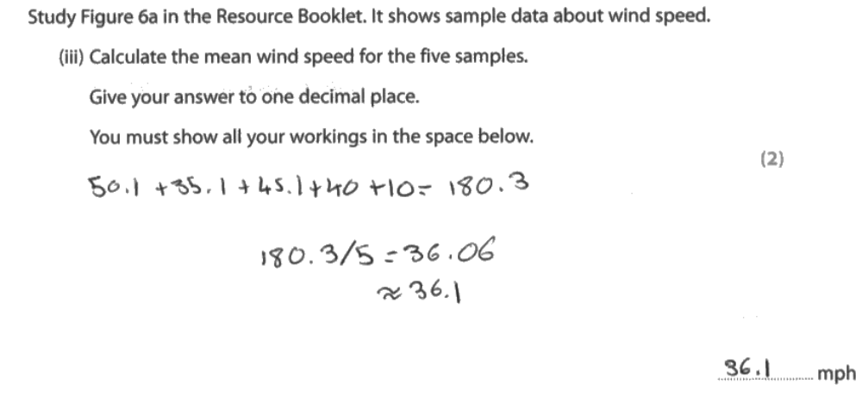

Examiner Comment: Simple addition, accurate working out, and a clear answer. Easy two marks. You should always aim for full marks on the small, short answer questions – they are the easy targets.
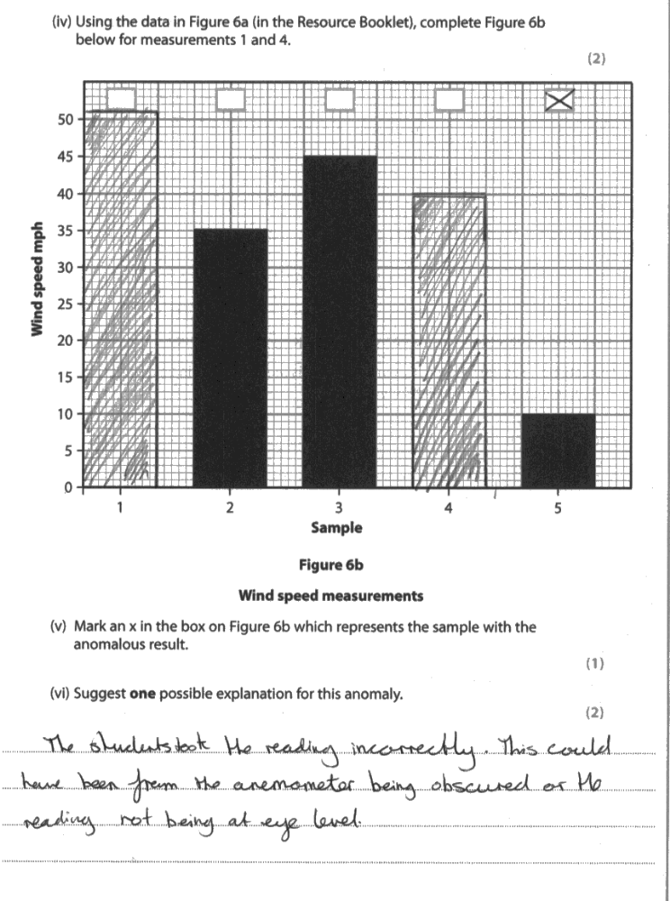

Examiner Comment: An excellent example here of how important data skills are. A simple bar chart plot, and logical answers score full marks. While this isn’t difficult, it means easy marks are being secured, and allowing you to build your score higher! It’s important you practice these skills.
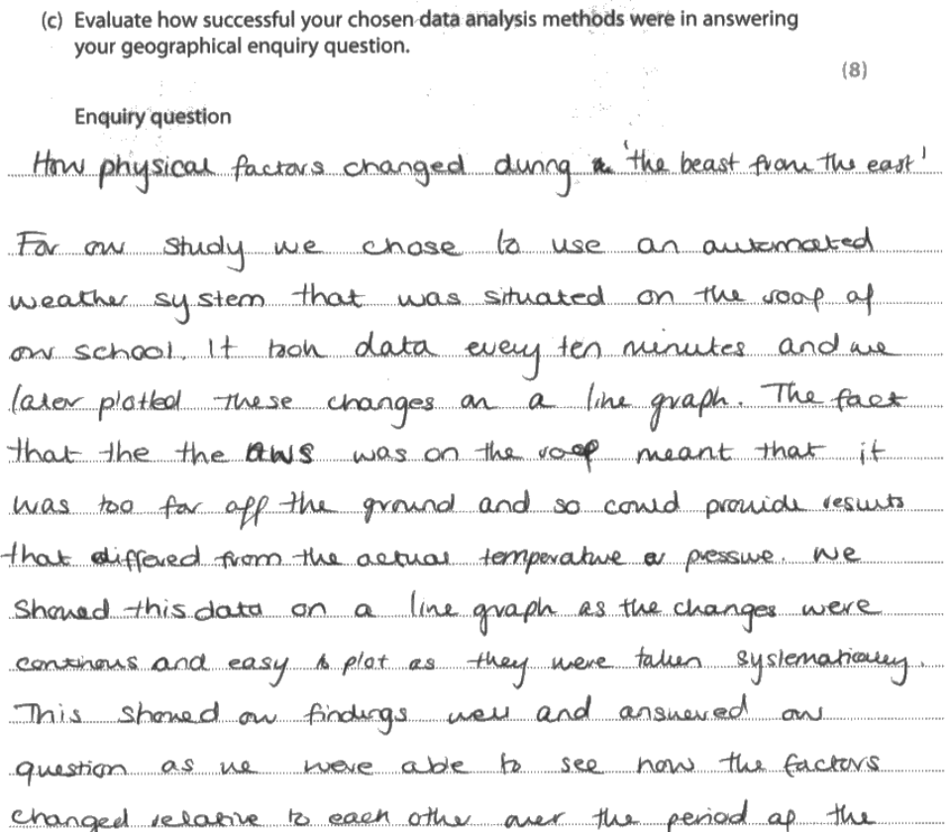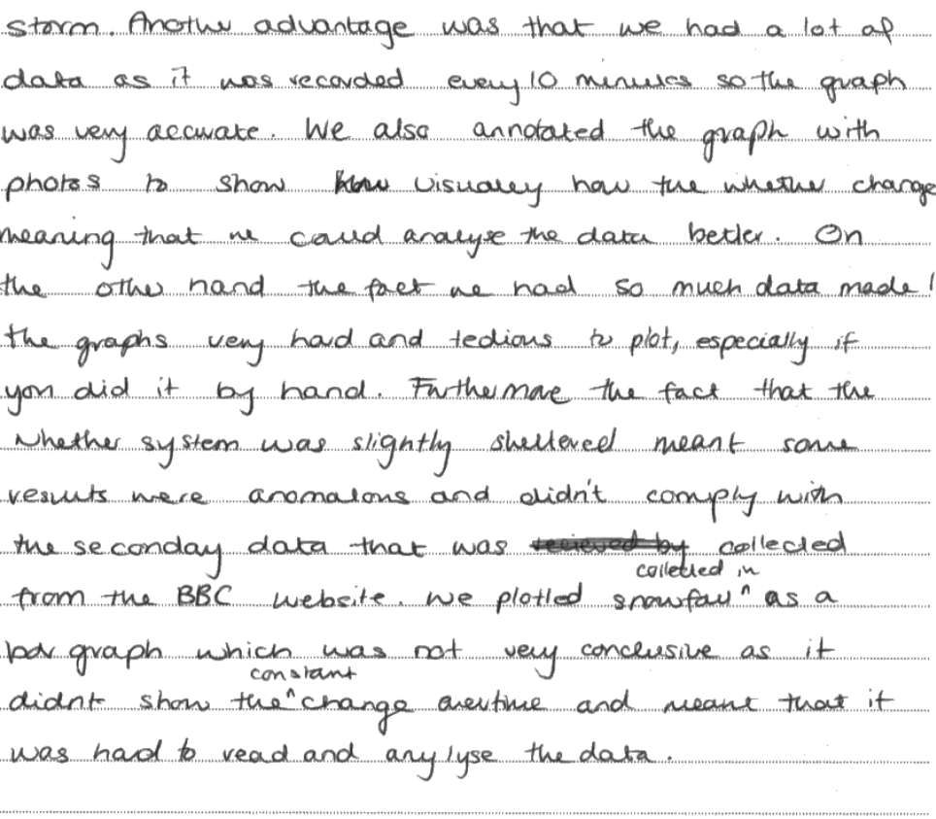
Examiner Comment: a clearly written response, that shows technical detail and mastery of the fieldwork. Candidate knows exactly what they did, how and why it was useful, and what they could improve or reflect on. The evaluation is very strong – look at terms like “slightly sheltered” or “anomalous … compared to secondary data” and “not very conclusive”
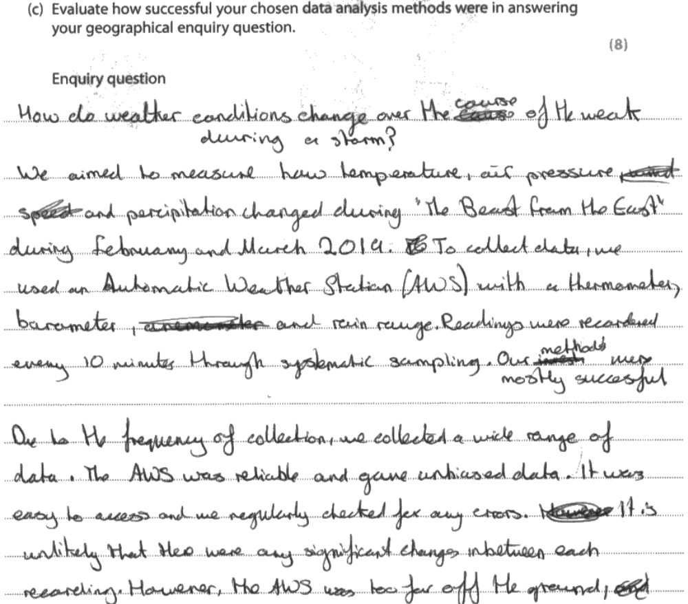
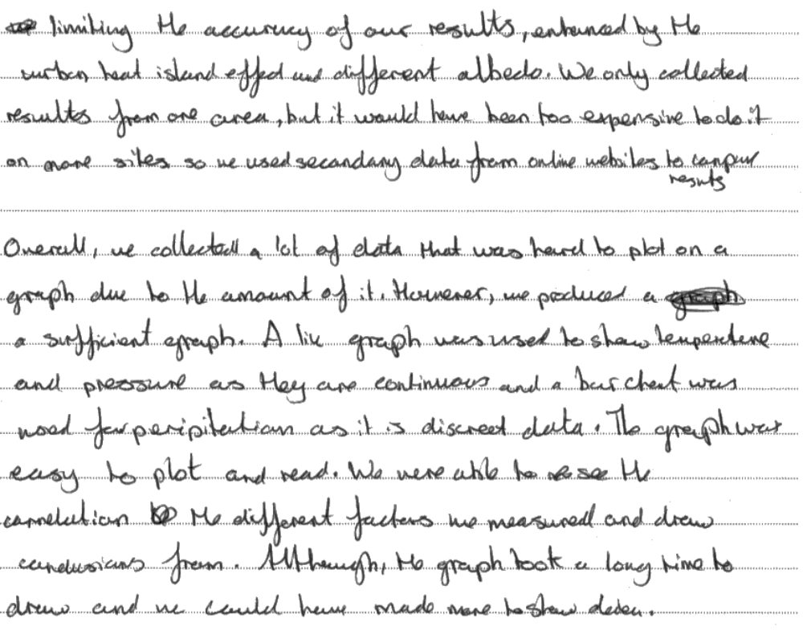
Examiner comment: Again, a fluent and well planned response. Clearly links specific knowledge of the fieldwork to precise details, and is able to discuss good and bad components, leading to a sensible evaluation. Full marks.

Paper 2: Economic Activity and Energy

Economic Activity & Energy: Specification
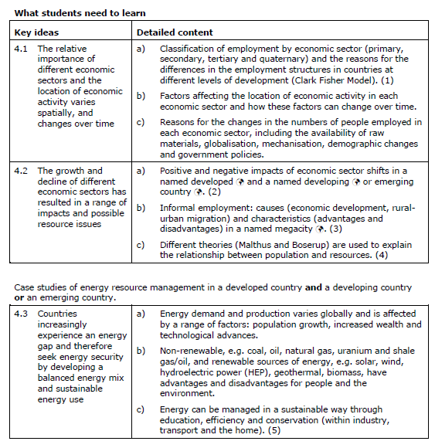

Glossary of Terms: Economic Activity & Energy
Alternative energy: renewable sources of energy, such as solar and wind power, that offer an alternative to the use of fossil fuels.
De-industrialisation: the decline of manufacturing in the economy of a region or country
Demand: the volume of goods and services which people are willing to buy
Economic development: the growth of a country or region's economy
Economic sector: a major division of the economy based on the type of economic activity. The economies of all countries are made up of three sectors; most HICs have a fourth sector
Energy consumption: the amount of energy used by individuals, groups or countries.
Energy efficiency: making the most of energy sources in order to cut down on waste and reduce consumption
Energy gap: a gap created because the loss of energy caused by phasing out the use of fossil fuels is greater than the amount of energy that is being developed from new, low-carbon sources.
Energy: heat and motive power. The former provided by the Sun and by burning coal, oil and timber (primary); the latter provided by electricity, gas, steam and nuclear power (secondary).
Foreign direct investment: in which a company or government becomes involved in the economy of another country.
Fossil fuel: carbon fuels such as coal, oil and natural gas that cannot be remade, because it will take tens of millions of years for them to form again.
High-tech industry: economic activities that rely on advanced scientific research and produce new, innovative and technologically-advanced products, such as microchips, new medical drugs and new materials.
Industrial phase: the middle of three phases in the history of manufacturing, when it is an important sector of a country's economy.
Informal employment: types of work that are not officially recognised and are taken up by people working for themselves on the streets of LIC cities
Informal sector: forms of employment that are not recognised, such as people working for themselves and in the so-called 'black economy'.
Information technology: the use of computers and software to manage and process information
Manufacturing: the processing of materials, usually by mechanical means, into partly finished or finished products.
Microcredit: small loans offered to poor people to encourage them to set up their own small businesses
Microlending: the process of making microcredit loans
Newly industrialised country (NIC): a country that enjoyed economic growth in the 1970s and 1980s. Examples include Taiwan, Singapore and South Korea; sometimes referred to as the Asian Tigers.
Non-renewable energy: energy produced from resources that cannot be replaced once they are used. Examples include the fossil fuels of coal, oil and natural gas.
Output: something that is produced by, and leaves an open system, for example the crops and livestock produced by a farm system.
Physical infrastructure: the services, such as transport, telecommunications, water and sewage disposal, that are vital to people and businesses.
Post-industrial phase: in the last phases in the history of manufacturing when factories close and move to new locations in less developed countries
Pre-industrial phase: The first of three phases in the history of manufacturing when it contributes little to the economy of a country
Primary energy: energy that is derived from renewable sources, such as the Sun and wind, and directly from the burning of fossil fuels.
Primary sector: economic activities concerned with the working of natural resources - agriculture, fishing, mining and quarrying.
Production chain: a sequence of stages in which companies exploit resources, transform them into goods or commodities and, then, distribute them to consumers. It is the pathway along which a good travels from producers to consumers.
Quaternary sector: economic activities that provide highly skilled services such as collecting and processing information, research and development.
Renewable energy: sources of energy which cannot be exhausted, such as the Sun, wind and running water.
Resources: things which satisfy human needs; they may be natural (climate, soil, vegetation) and human (labour, skills, capital).
Science park: an area of land specifically set aside for high-tech industries and companies involved in research and development; usually located near the urban fringe and often close to a university.
Secondary energy: energy derived from the processing of primary energy; examples include the generation of electricity by burning fossil fuels and petrol and diesel derived from crude oil.
Secondary sector: economic activities concerned with making things, such as cars, buildings, and electricity.
Sectoral shift: changes in the relative importance of a country's economic sectors.
Supply: the availability of goods and services.
Technology: tools, systems, processes and structures invented by people which allow them to control and exploit their environment.
Teleworking: working from a home in the countryside, using modern communications.
Tertiary sector: activities that provide a wide range of services and enable goods to be traded.
Underemployment: occurs where people have a job but it does not keep them fully occupied or provide enough money to live on. This often persuades them to try to make some more money in the informal sector.

Economic Activity & Energy: Revision Materials
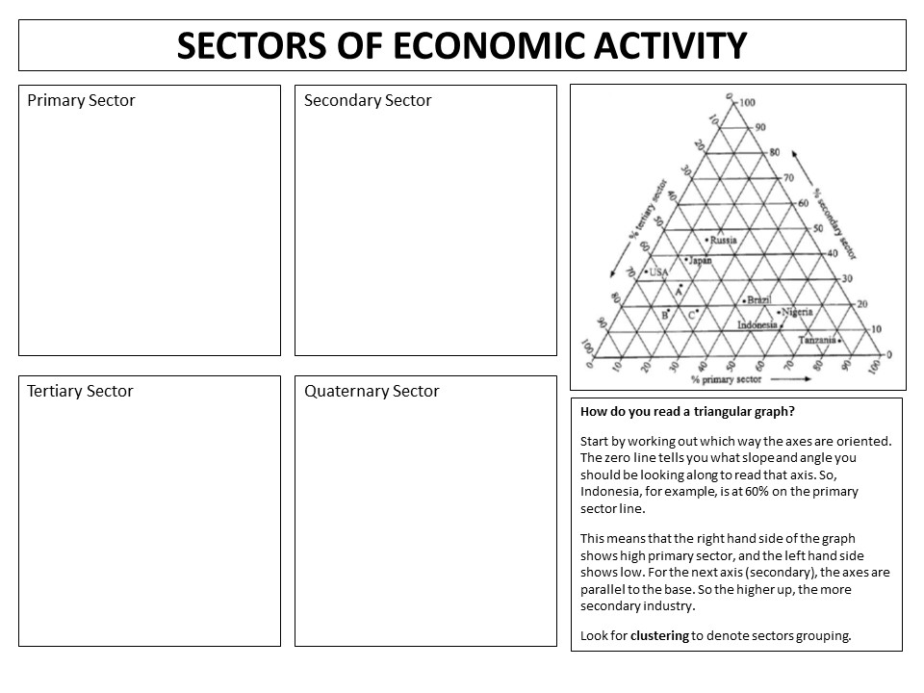
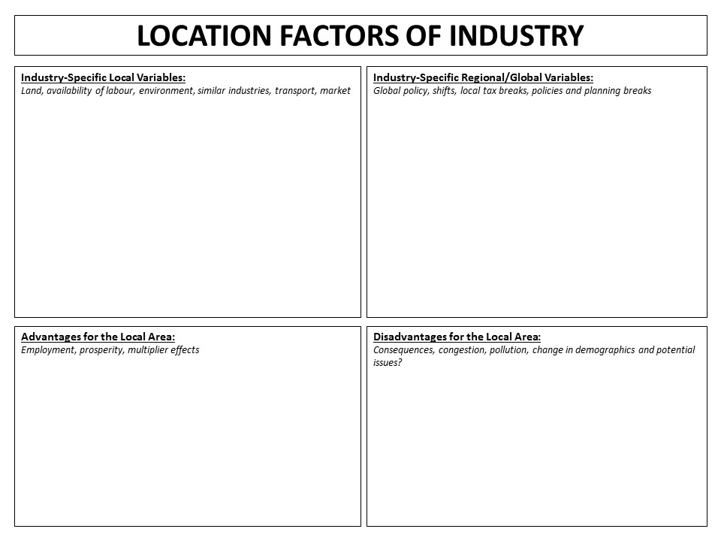
THE CLARK FISHER MODEL OF INDUSTRIAL DEVELOPMENT

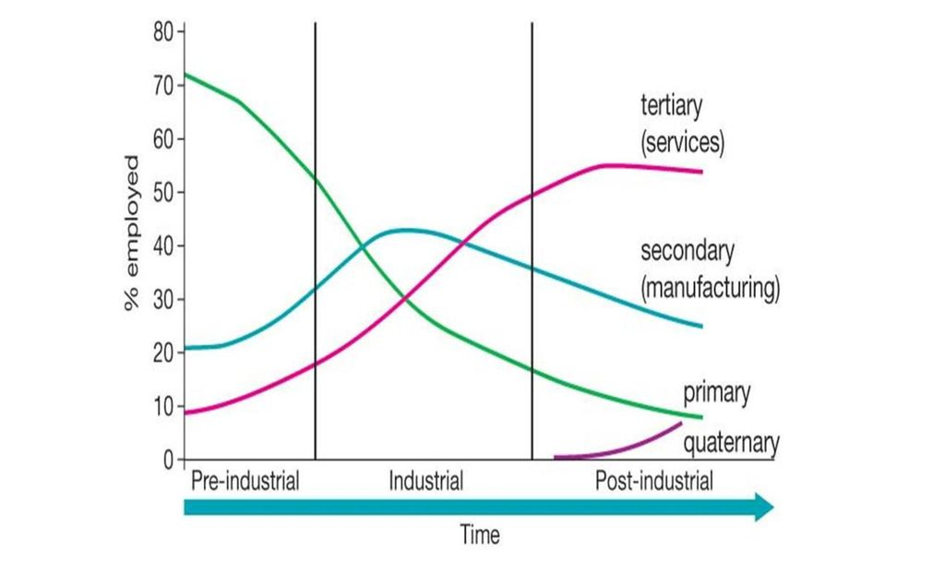
Annotate to show role of: raw materials, mechanisation, urbanisation, demographic changes, government policies and globalisation
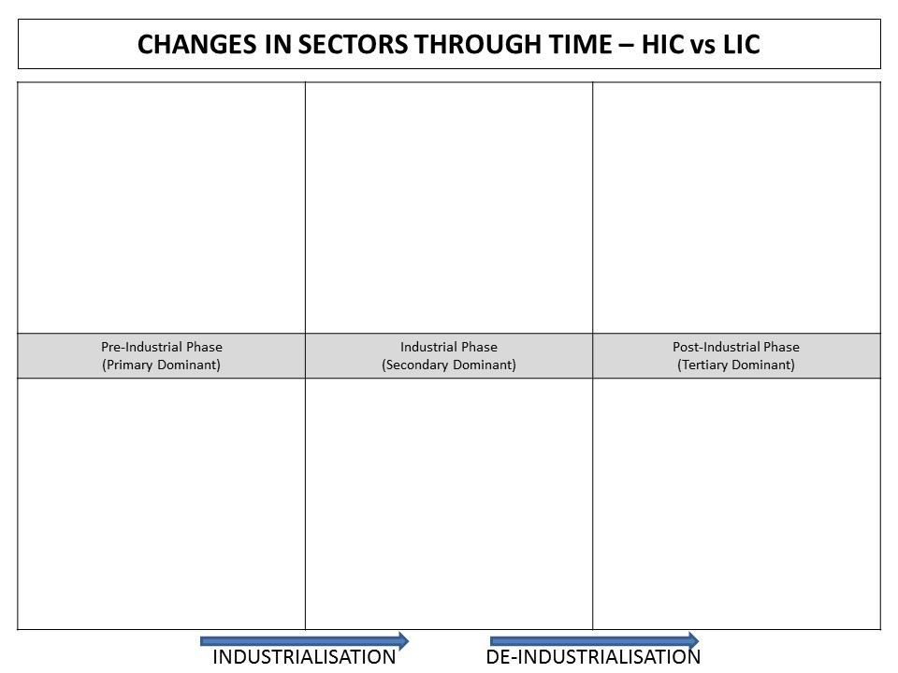
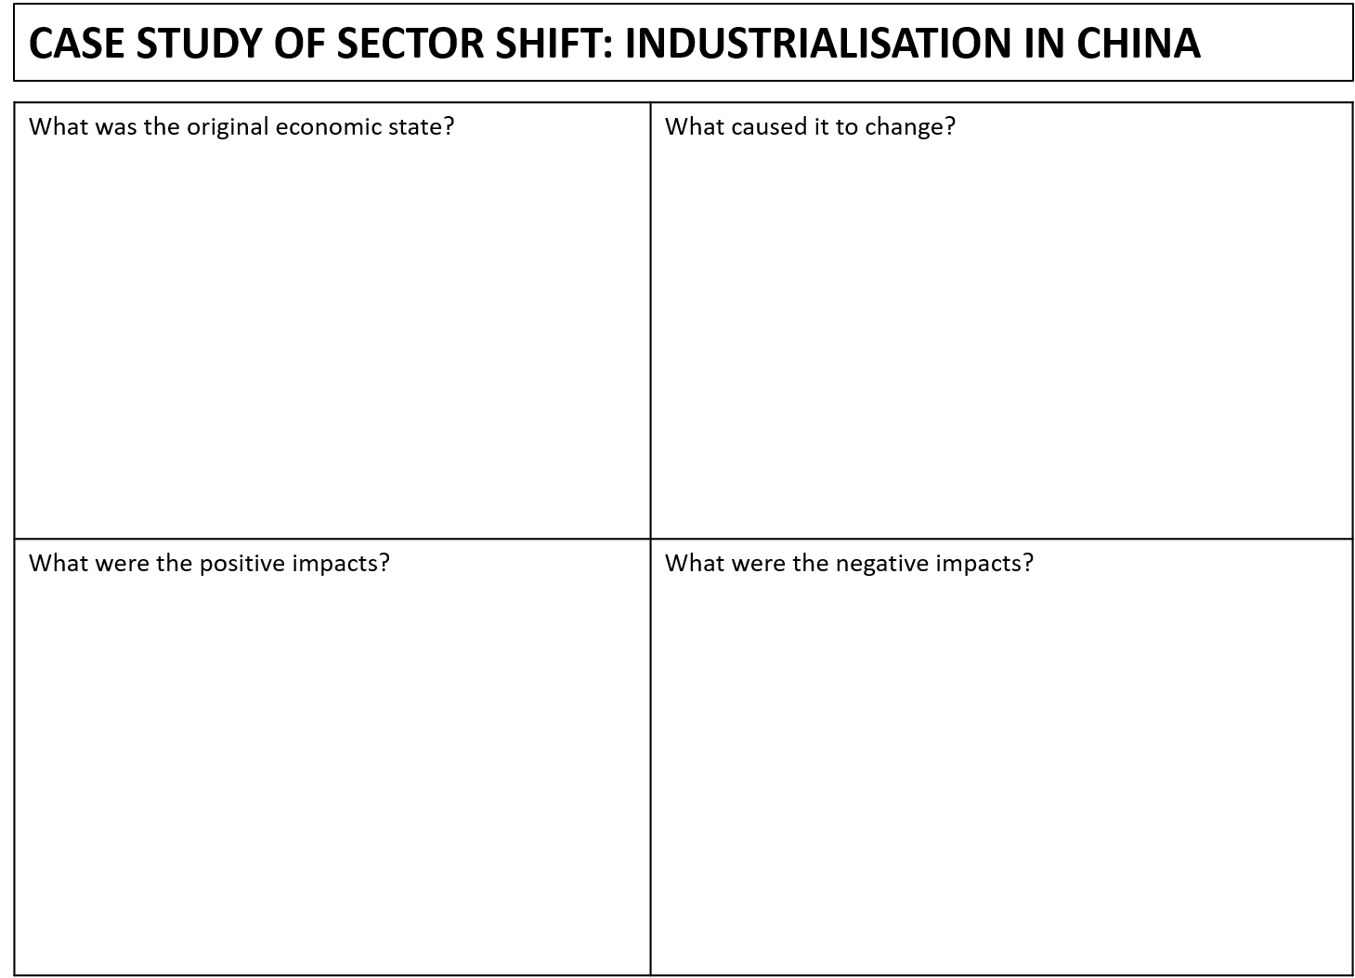
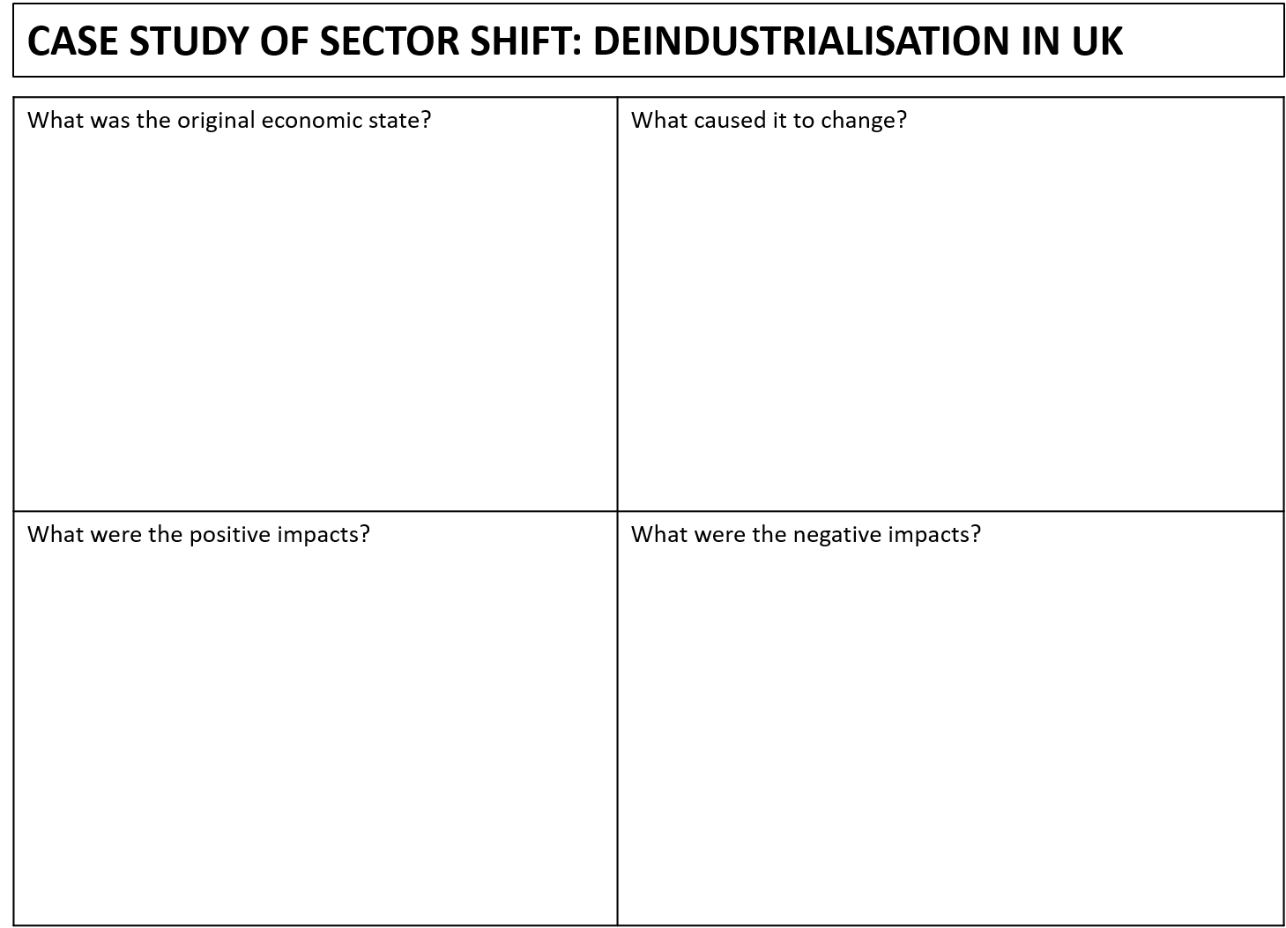
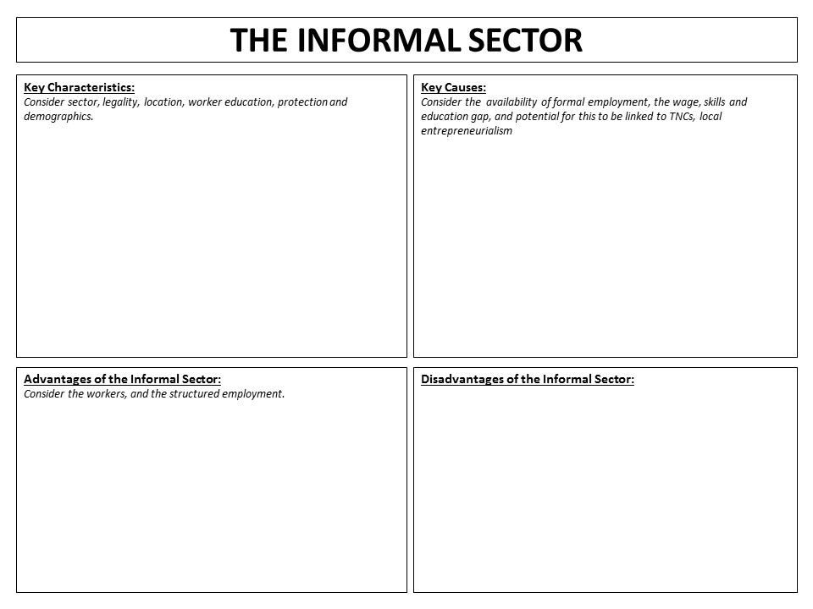
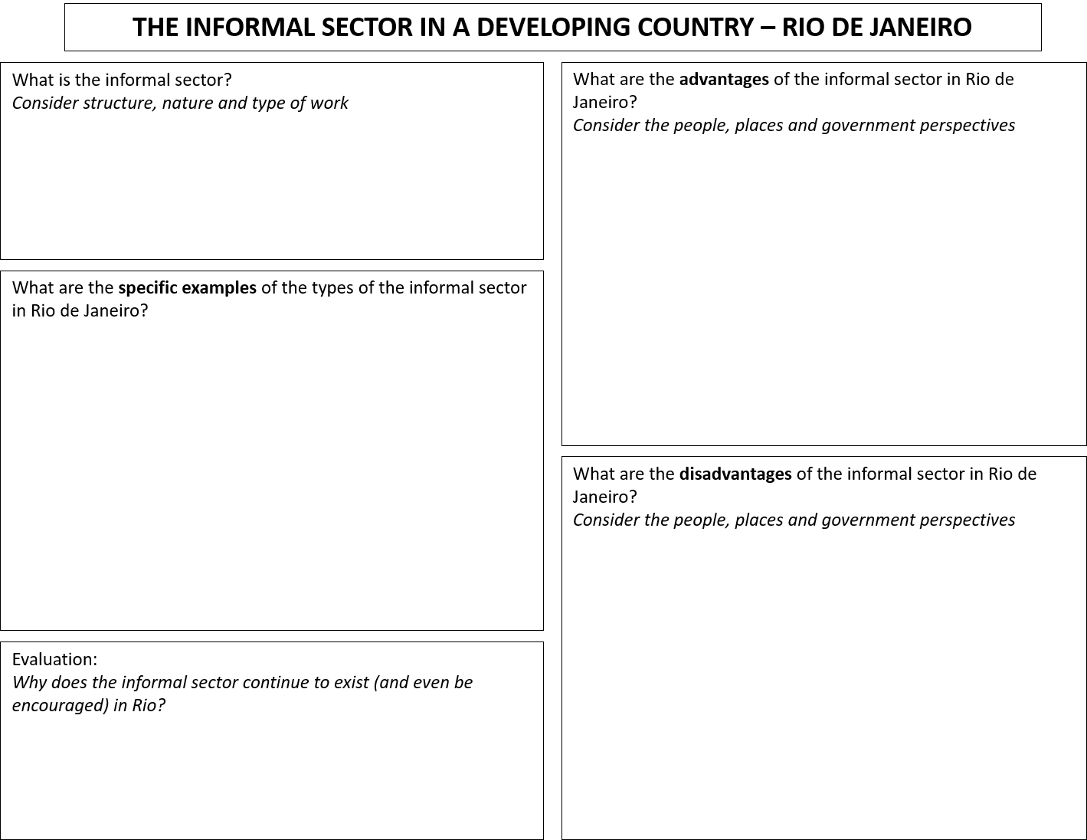
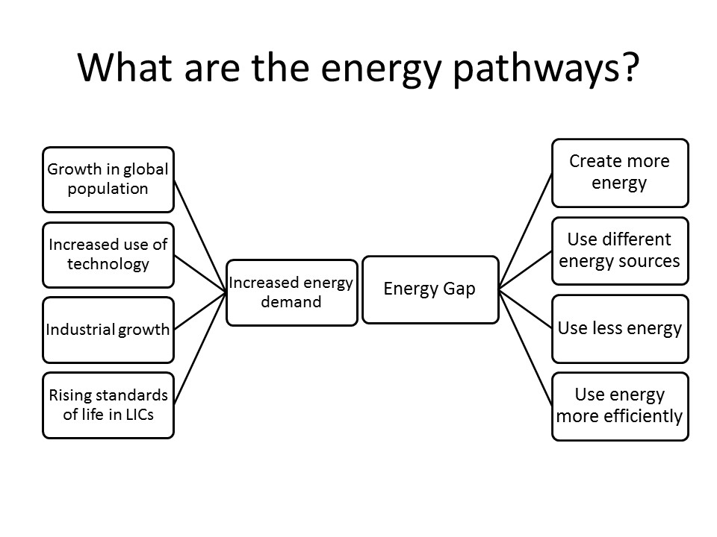
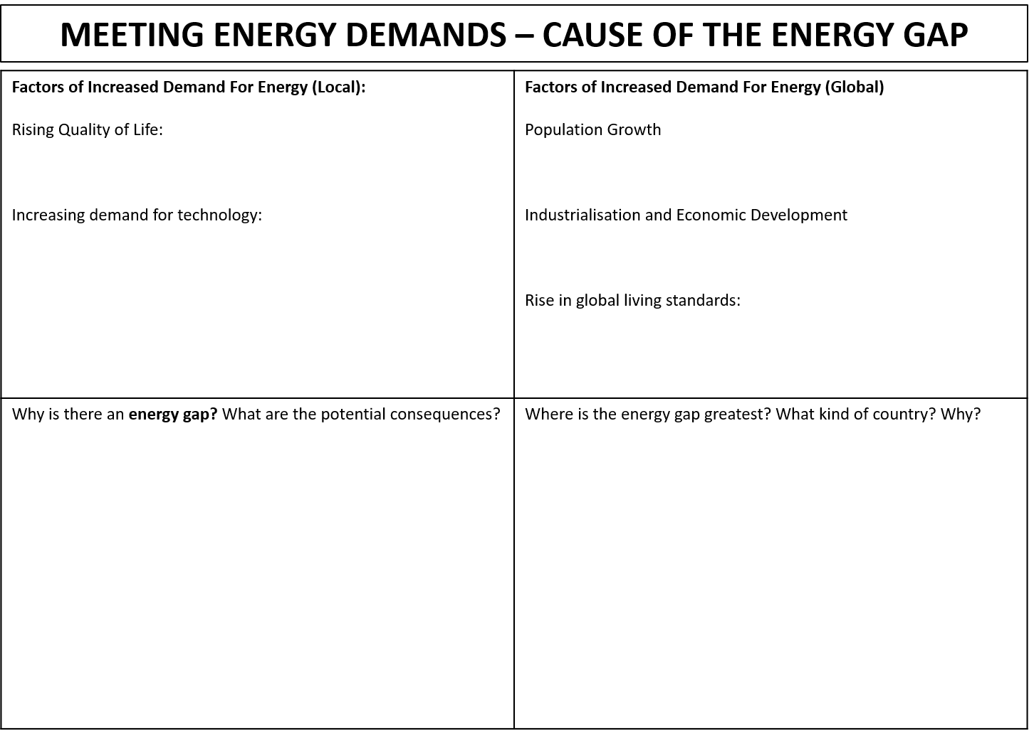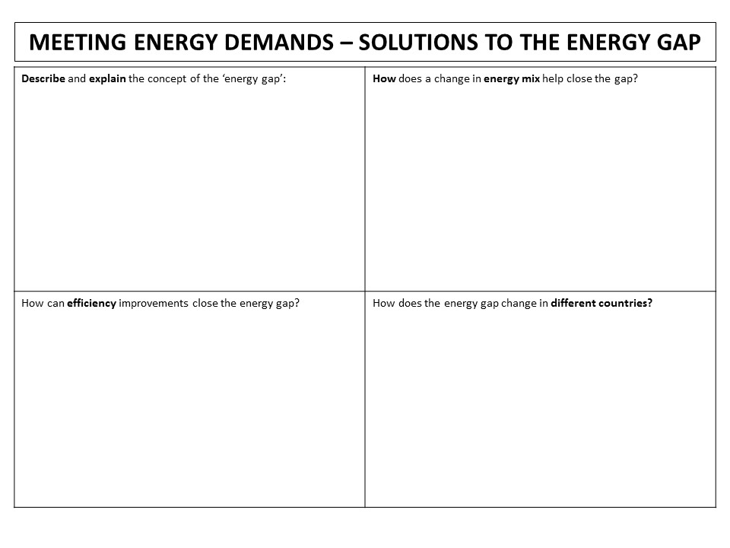
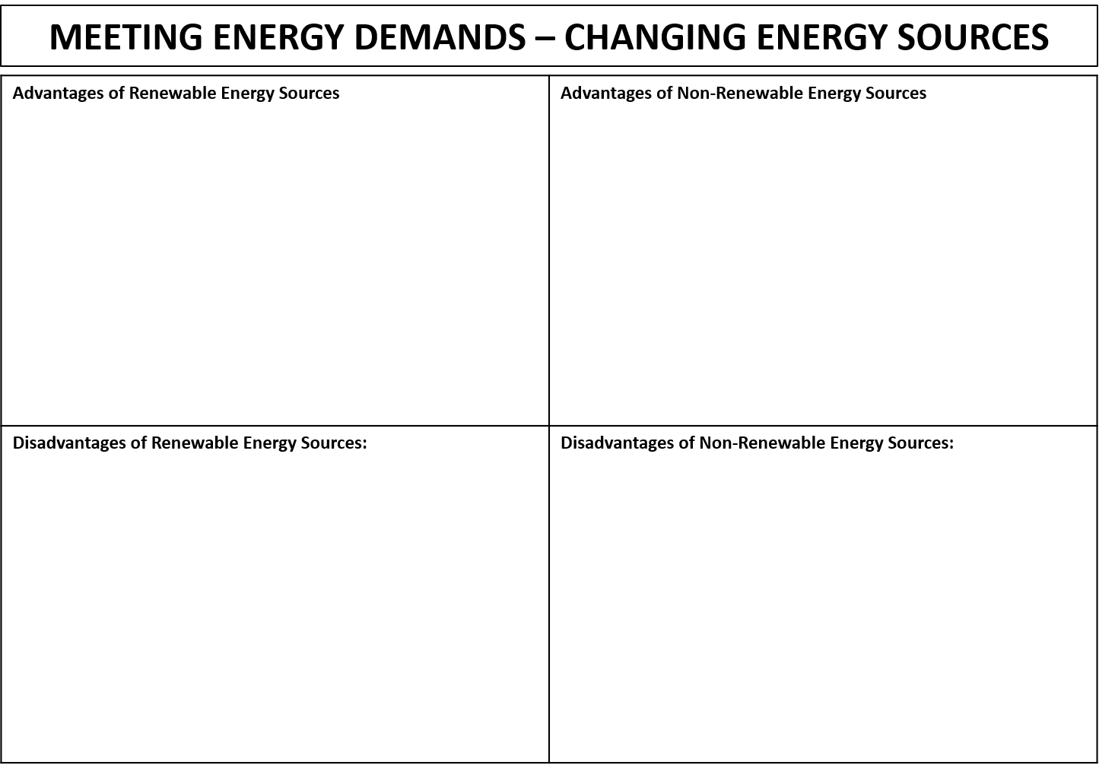
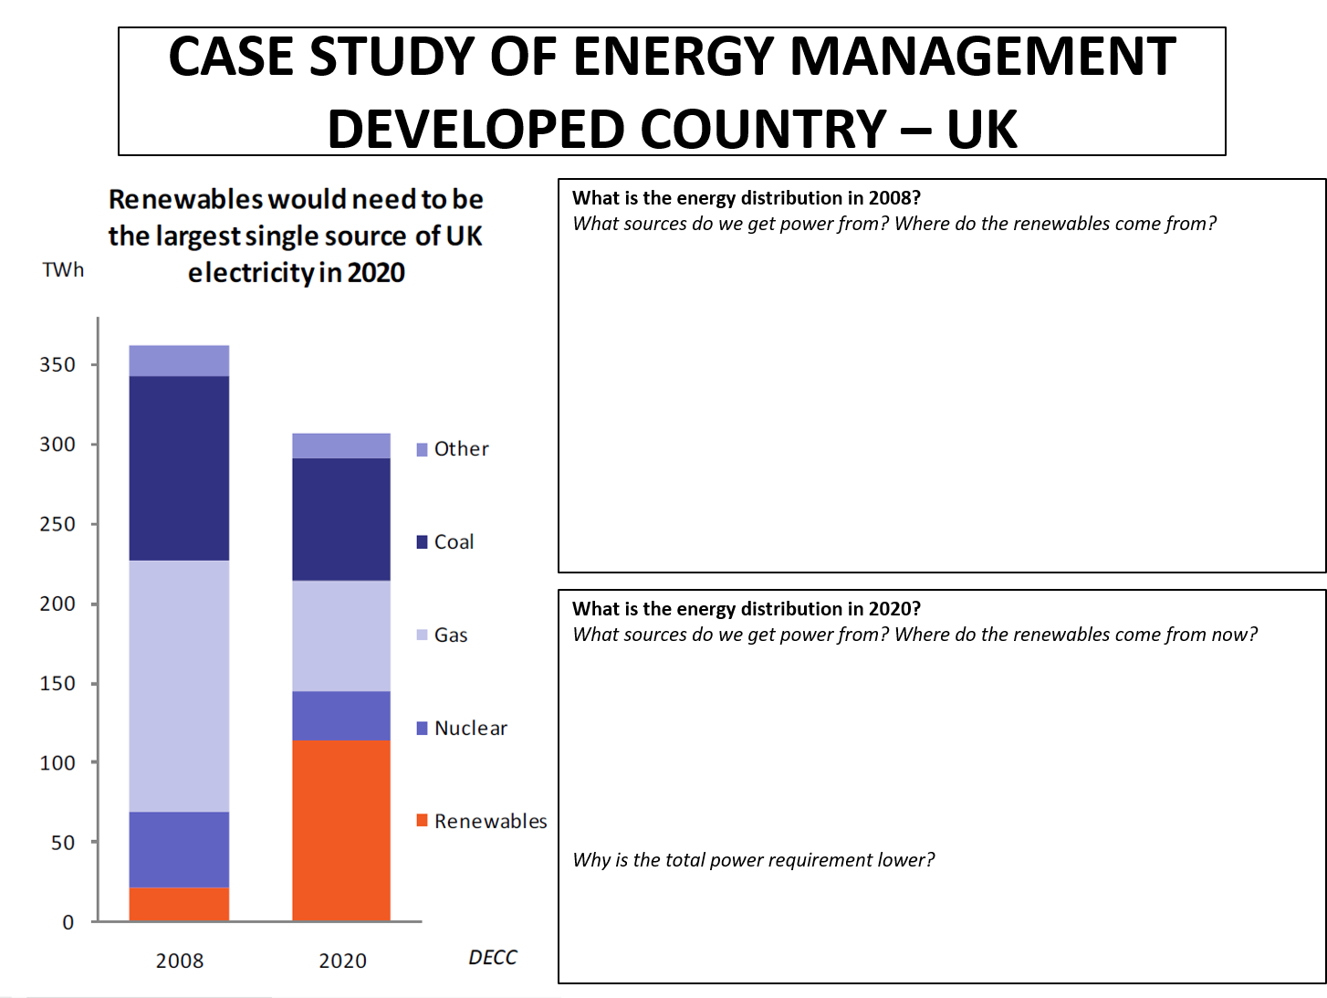
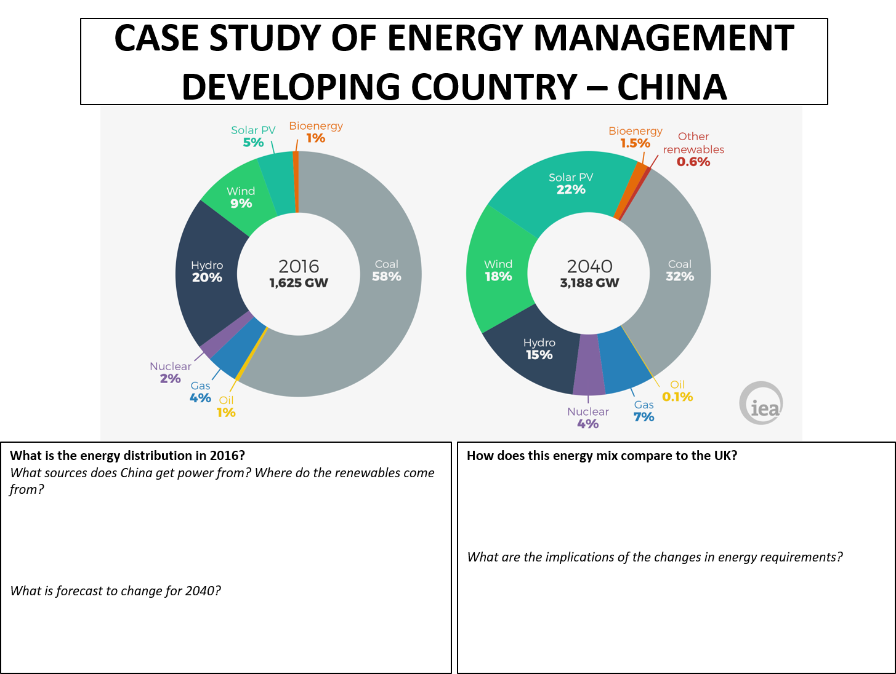

Economic Activity & Energy: Practice Questions
EAE1: Name an industry located close to its sources of raw materials. (1 mark)
EAE1: Suggest why this is a good location for producing electricity (1 mark) [Image of solar panels in a field]
EAE1: What is non-renewable energy (1 mark)
EAE1: What is renewable energy? (1 mark)
EAE1: Which economic sector does car and van production belong to? (1 mark)
EAE1: Which employment sector includes agriculture? (1 mark)
EAE1: Which source is used to generate energy both onshore and offshore? (1 mark)
EAE2: For one source of energy, suggest why it cannot be used to generate energy everywhere (2 marks)
EAE2: Give one advantage and one disadvantage of using renewable sources of energy (2 marks)
EAE2: State two characteristics of a TNC (2 marks)
EAE2: What is meant by ‘high tech’ industry? (2 marks)
EAE2: What is meant by informal employment? (2 marks)
EAE2: What is meant by the ‘global shift in manufacturing’? (3 marks)
EAE2: What is meant by the term “economic sector”? (2 marks)
EAE2: What is meant by the term deindustrialisation? (2 marks)
EAE2: What is meant by the term de-industrialisation? (2 marks)
EAE2: What is meant by the term high-tech industry? (2 marks)
EAE2: What is meant by the term world markets? (2 marks)
EAE3: Describe one effect that the change in the secondary sector between 1991 and 2010 has had on a named area of an HIC. (3 marks)
EAE3: Describe the advantages of an industry being located close to its sources of raw materials. (3 marks)
EAE3: How do primary and secondary sectors differ? (3 marks)
EAE3: Many TNCS have set up factories in LICs. Why would they do this? (3 marks)
EAE3: State three characteristics of informal employment. (3 marks)
EAE3: Suggest three reasons why a location [reference to photo source] was chosen for a high-tech industrial estate (3)
EAE3: What are the advantages for an LIC to host a TNC (3 marks)
EAE3: What are the disadvantages of informal employment (3 marks)
EAE3: What is meant by ‘deindustrialisation’? (3 marks)
EAE3: What is the ‘development pathway’? (3 marks)
EAE3: What is the energy gap (3 marks)
EAE3: Why do high-tech industries choose certain locations? (3 marks)
EAE3: Why is the tertiary sector relatively insignificant in LICs? (3 marks)
EAE4: Describe how the relative importance of economic sectors changes with levels of development (4 marks)
EAE4: Give reasons for the importance of the primary sector and informal employment in most LICs. (4 marks)
EAE4: Outline two causes of deindustrialisation (4 marks)
EAE4: Outline two causes of de-industrialisation (4 marks)
EAE4: Outline two causes of informal employment (4 marks)
EAE4: Outline two factors responsible for the growth of tertiary and quaternary activities (4 marks)
EAE4: Suggest reasons for governments encouraging investment by transnationals in their country. (4 marks)
EAE4: What are the key features of a post-industrial country? (4 marks)
EAE4: What are the reasons for the expansion of the tertiary sector in HICs? (4 marks)
EAE6: [With reference to map of Derby] Suggest why Toyota chose this location for a car production factory (6 marks)
EAE6: Explain how the economic sectors of a named HIC differ from those of a named LIC (6 marks)
EAE6: Explain how the relative importance of each of the economic sectors changes as countries develop. Reference to named countries may help your answer. (6 marks)
EAE6: Explain why some countries have an energy gap (6 marks)
EAE6: Explain why the global demand for energy is rising (6 marks)

Economic Activity & Energy: Source Question Examples
Using Figure 1, analyse the reasons why countries choose to have a range of energy sources (8 marks)
Using Figure 1, discuss the reasons for and against renewable sources of energy (8 marks)
Using Figure 2, analyse how energy use changes with levels of development (8 marks)
Using Figure 3, and your own knowledge, analyse the reasons for past and predicted changes in energy demand (8 marks)
Using Figure 4, analyse the extent of the global shift in manufacturing between 2005-2001 (8 marks)

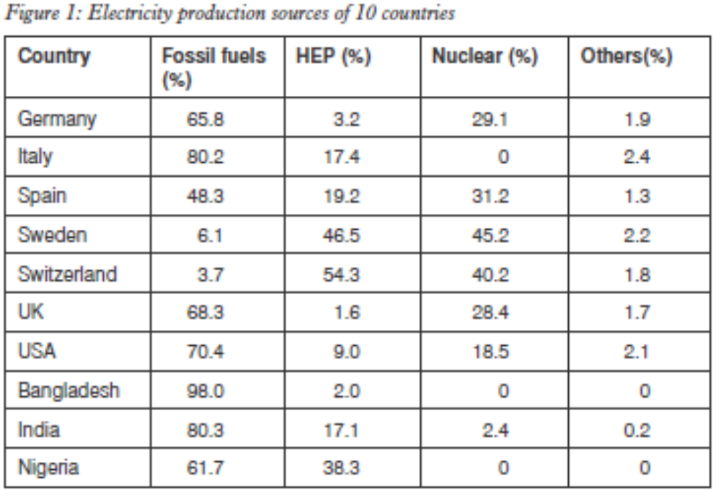
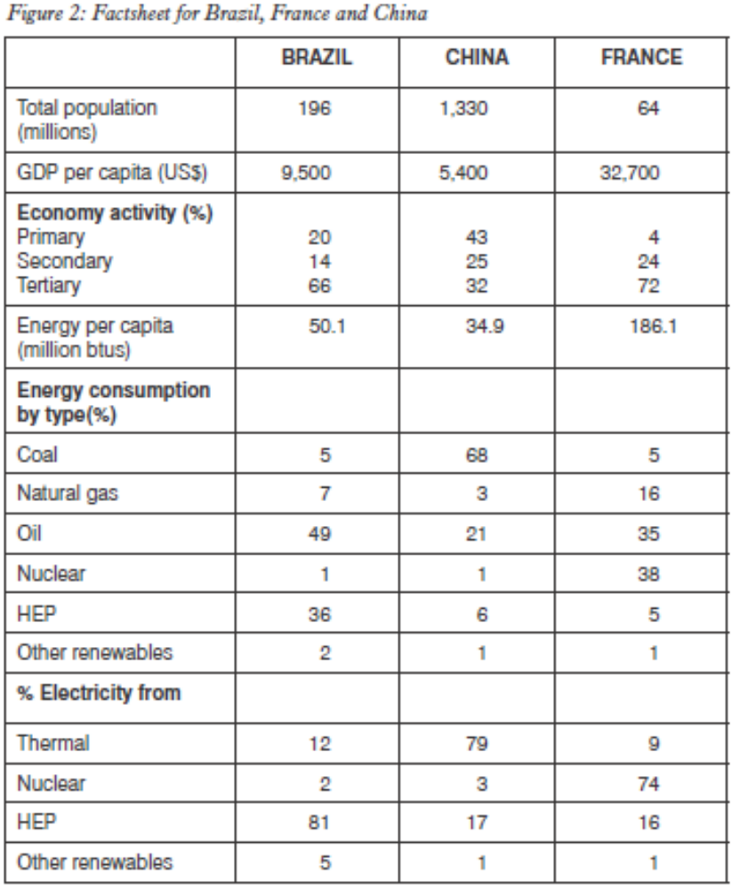
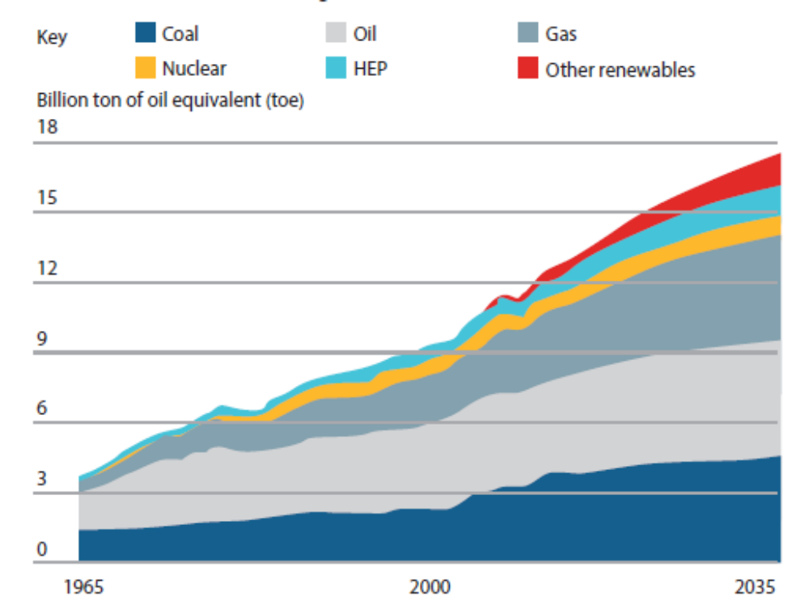
Figure 3: Past and predicted changes in energy demand, 1965-2035

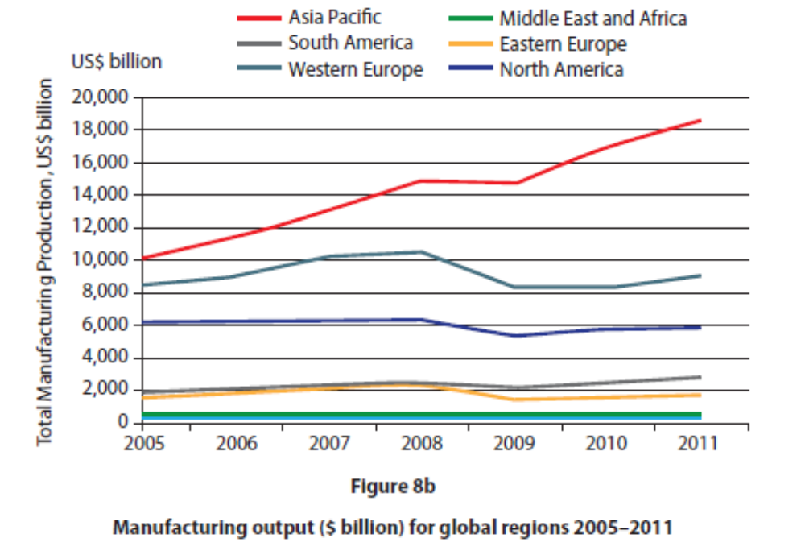
Figure 4: Manufacturing output ($ billion) for global regions, 2005-2011

Economic Activity & Energy: Model Answers

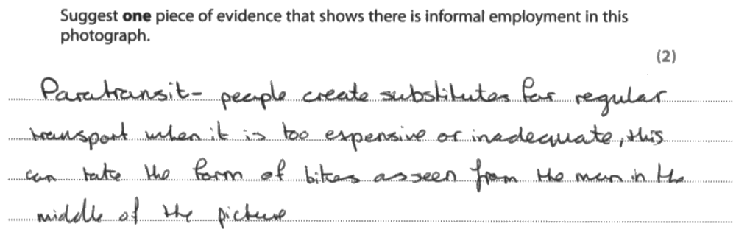

Examiner comment: in the early, two mark questions, the quality of top candidates stands out early on. Look at the technical language and precision of analysis!

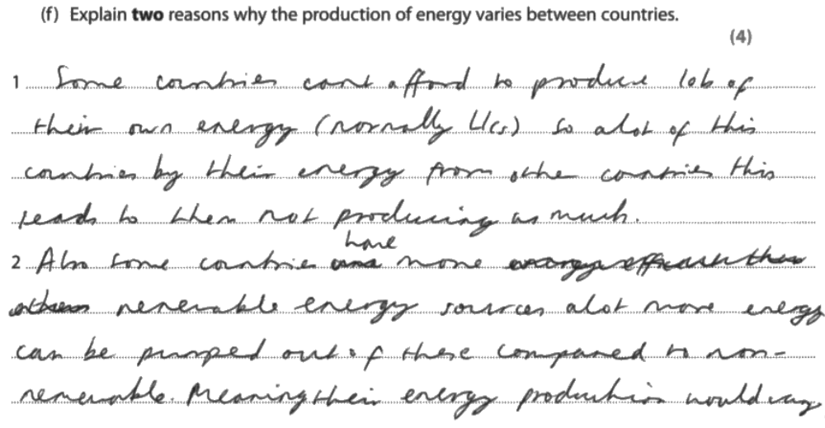
Examiner comment: clear, details and logical progression from point to development for the second mark in each reason.

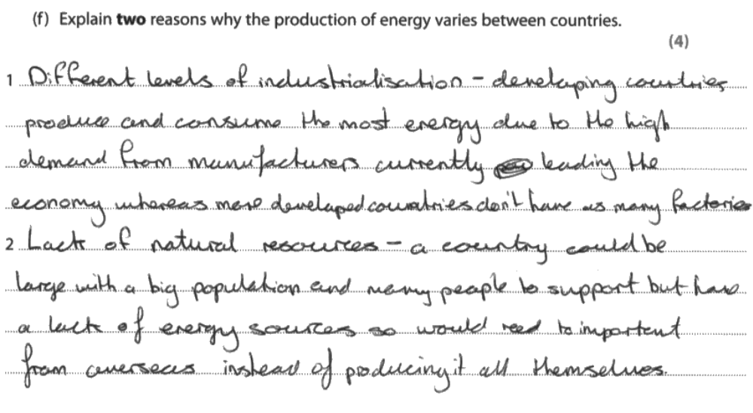

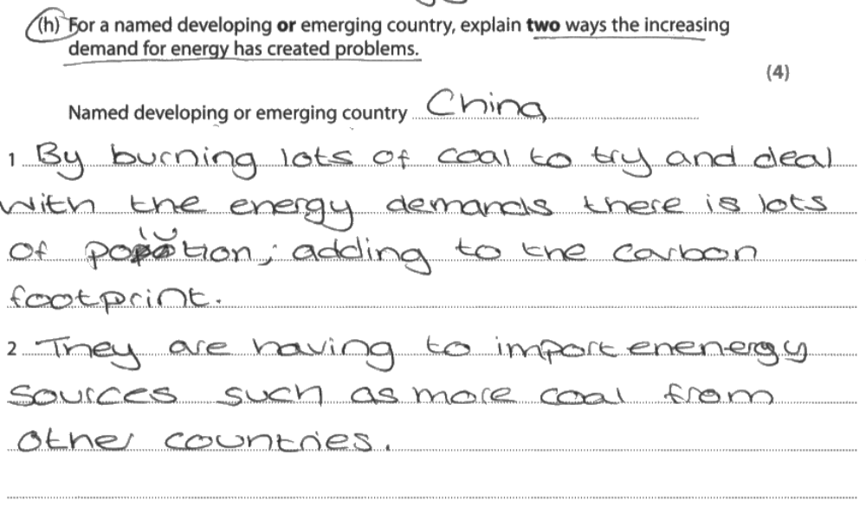
Examiner Comment: here, you can see two different examples of 2x2 marking for four mark questions. Again, there’s a clear development from point to extension, showing value for the second mark in the two mark reasoning. Make it easy for the examiner to decide to give you both marks!

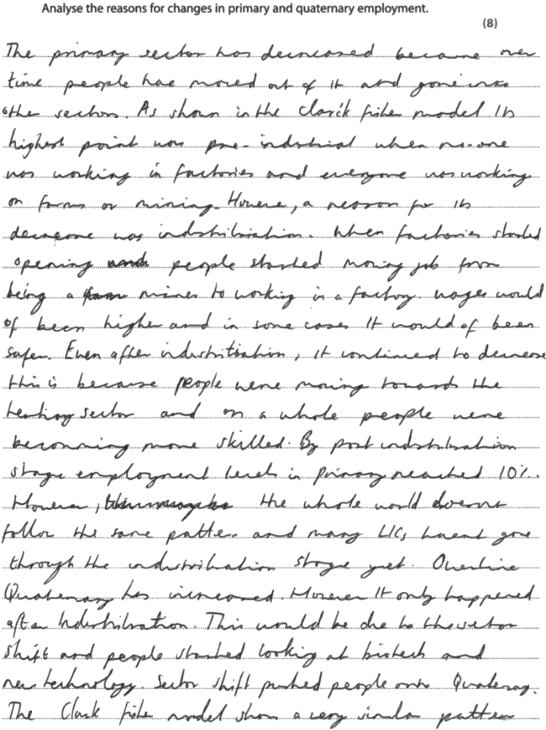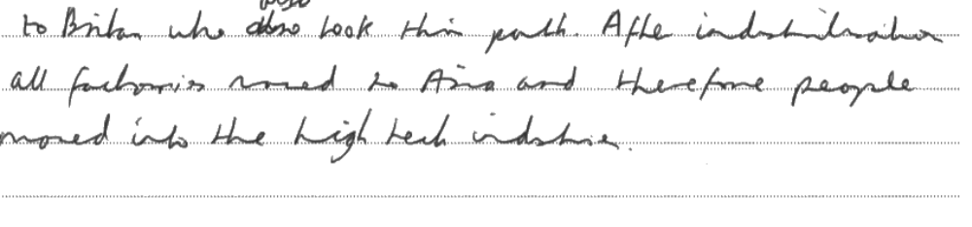
Examiner Comment: this is a sophisticated response for eight marks. Data is used to show clear links to the Figures, and then the explanations are exceptionally clear and logical. The quality of analysis is excellent.

Paper 2: Urban Environments

Urban: Specification

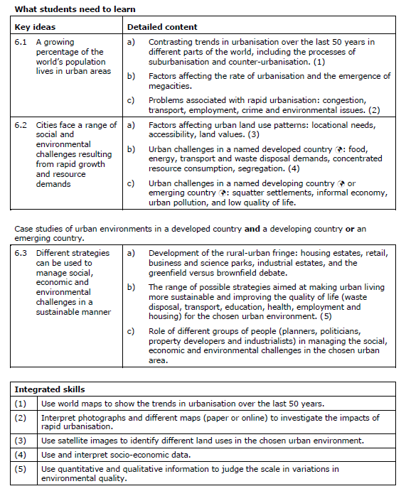

Glossary of Terms: Urban Environments
Accessibility: the ease with which one location can be reached from another; the degree to which people are able to obtain goods and services, such as housing and healthcare.
Agglomeration: the concentration of people, buildings and activities at a specific location.
Brownfield site: land that has been previously used, abandoned and now awaits a new use.
Business park: an area of land set aside for offices and high-tech companies
Central business districts (CBD): the commercial centre of a town and city in which shops, offices and other services are concentrated.
Communications: the exchange of information and 'remote' contact between people
Commuting: the daily movement of people from their homes to their place of work
Congestion: acute overcrowding caused by high densities of traffic, business and people.
Conurbation: a large urban area formed by the growing together of once separate towns
Counterurbanisation: the movement of people and employment from major cities to smaller cities and towns, as well as to rural areas.
Deprivation: when the standard of living and quality of life fall below a minimum level
Edge city: a part of the suburbs which has become more city-like through the agglomeration of offices, shops and factories.
Environmental quality: the degree to which an area is free from air, water, noise and visual pollution.
Ethnic group: a group of people united by a common characteristic such as race, language or religion.
Gated community: an area of wealthy housing protected by a perimeter wall or fence, with controlled entrances for residents and their visitors.
Gentrification: the movement of middle-class people back into rundown, inner-city areas, resulting in the improvement of their housing, built environment and image.
Greenfield site: land that has not been used for urban development
High-class residential area: an area inhabited by wealthy people
Inaccessibility: the difficulty of reaching places due to remoteness, terrain and lack of transport.
Industrial estate: land specifically set aside for factories and service industries.
Infrastructure: the transport networks and the water, sewage and communication systems that are vital to people and their settlements and businesses.
Inner-city ring: the old part of a town or city immediately outside the historic nucleus
Land use: any use made by people of the Earth's land surface
Land value: the market price of a piece of land; what people or businesses are prepared to pay for owning and occupying it
Low-class residential area: a part of a settlement where housing conditions are poor and lived in by the poorest members of society.
Megacity: a city or urban area with a population larger than 10 million
Middle class: a term loosely used to describe well-off people who do non-manual work, often in the professions.
Millionaire city: a city or urban area with a population larger than 1 million
Out-of-town retailing: large areas mainly occupied by shops and located on or near the urban fringe
Paratransit: an alternative mode of flexible passenger transport that does not follow fixed routes or timetables. Typically mini-buses are used. Such services in LICs are frequently operated as part of the informal sector.
Peak land-value intersection: the location within an urban area where land values are highest. It usually coincides where major transport routes converge on the centre
Periphery: an area remote or isolated from its core and generally lagging in terms of development and influence
Pollution: the presence of chemicals, dirt or other substances which have harmful or poisonous effects on aspects of the environment, such as rivers and the air.
Rebranding: see Urban rebranding
Redevelopment: the demolition of old buildings to make way for new ones
Regeneration: see Urban regeneration
Re-imaging: see Urban re-imaging
Rural dilution: the impact of urban people moving to and residing in rural areas
Service provision: making available a range of commercial, professional and social services, from shops and legal advice to schools and medical treatment.
Services: are the non-material equivalent of goods. They mainly involve specially trained people, such as doctors, dentists, solicitors, hoteliers and hairdressers, doing things for other people as a way of making a living.
Settlement: any form of human habitation from a single dwelling to a megacity.
Shanty town: an area of slum housing built of salvaged materials and located either on the city edge or within the city on hazardous ground, previously avoided by urban development.
Social deprivation: when the well-being and quality of life of people falls below a minimum level.
Social segregation: the clustering together of people with similar characteristics (class, ethnicity, wealth) into separate residential areas.
Socio-economic group: a group of people sharing the same characteristics, such as income level, type of employment and class.
Stakeholder: a person, group of people or organisation that has direct or indirect interest in a particular business or situation, and are able to influence what happens.
Squatter community: see Shanty town.
Suburban ring: the outskirts of a town and city produced by suburbanisation and in which residence is the major land use.
Suburbanisation: the outward spread of the urban area, often at lower densities compared with the older parts of a town or city.
Superstore: a huge retailing outlet or supermarket, usually located on or close to the urban fringe.
Traffic congestion: see Congestion.
Urban fringe: the outer edge of the built-up area of a town or city.
Urban land market: the buying and selling of land and buildings in a town or city.
Urban managers: people who make important decisions affecting urban areas, such as planners, politicians and developers.
Urban rebranding: the regeneration and re-imaging of old urban areas, often involving an economic revival based on leisure and recreation.
Urban regeneration: the investment of capital in the revival of old, urban areas by either improving what is there or clearing it away and rebuilding.
Urban re-imaging: changing the image of an urban area and the way people view it.
Urbanisation of suburbs: the process whereby the suburban ring becomes more urban as a result of increasing building densities, building on vacant plots and introducing non-residential land uses.
Urbanisation: growth in the percentage of a population living and working in urban areas.

Urban: Revision Materials

THE URBANISATION PATHWAY
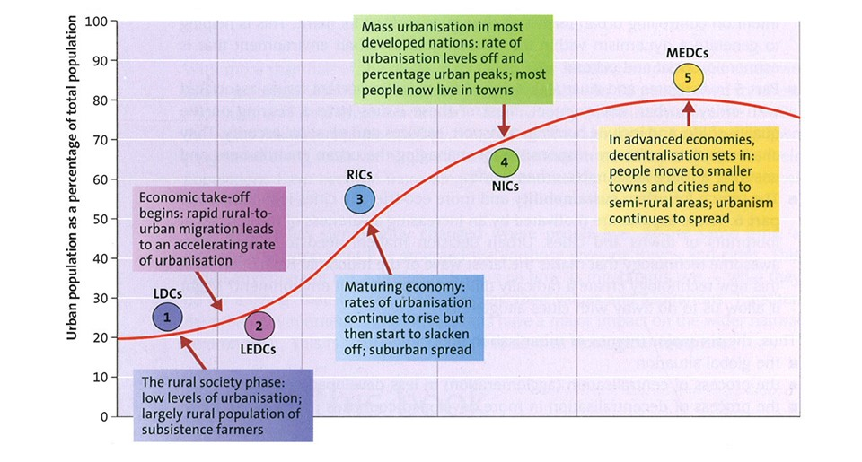
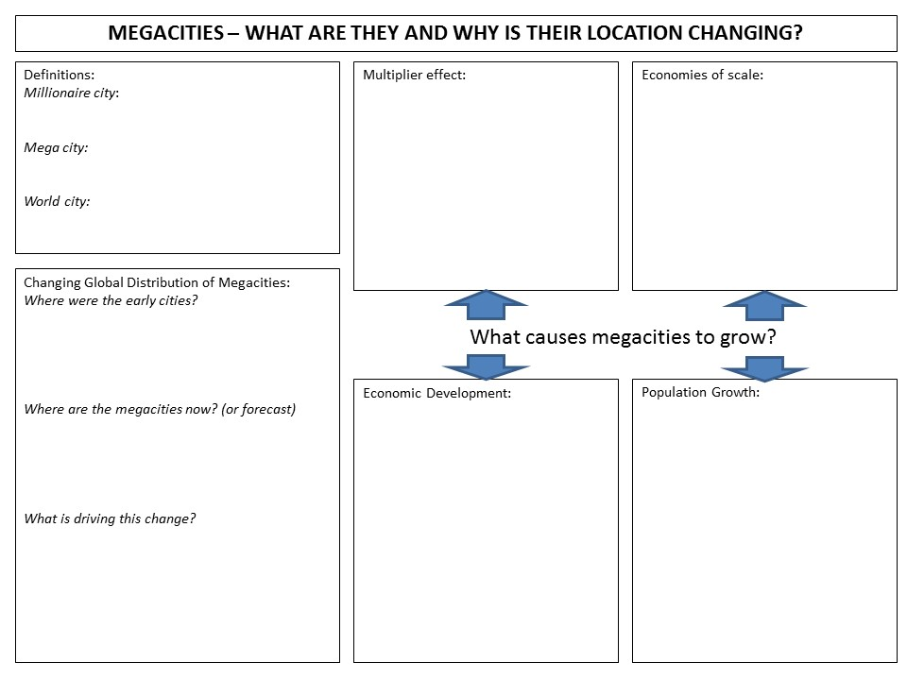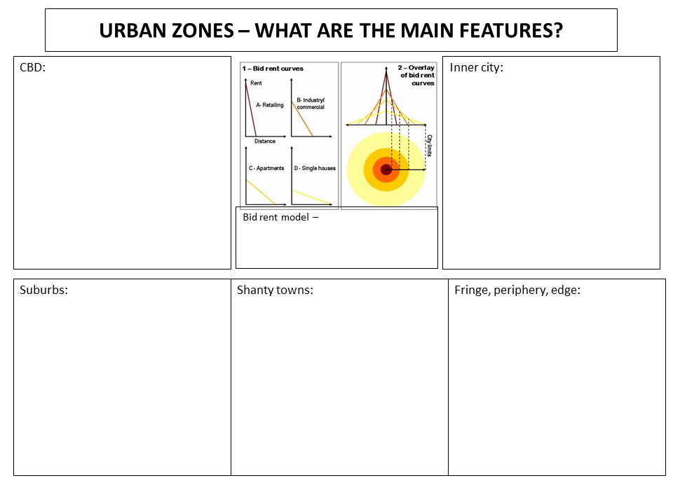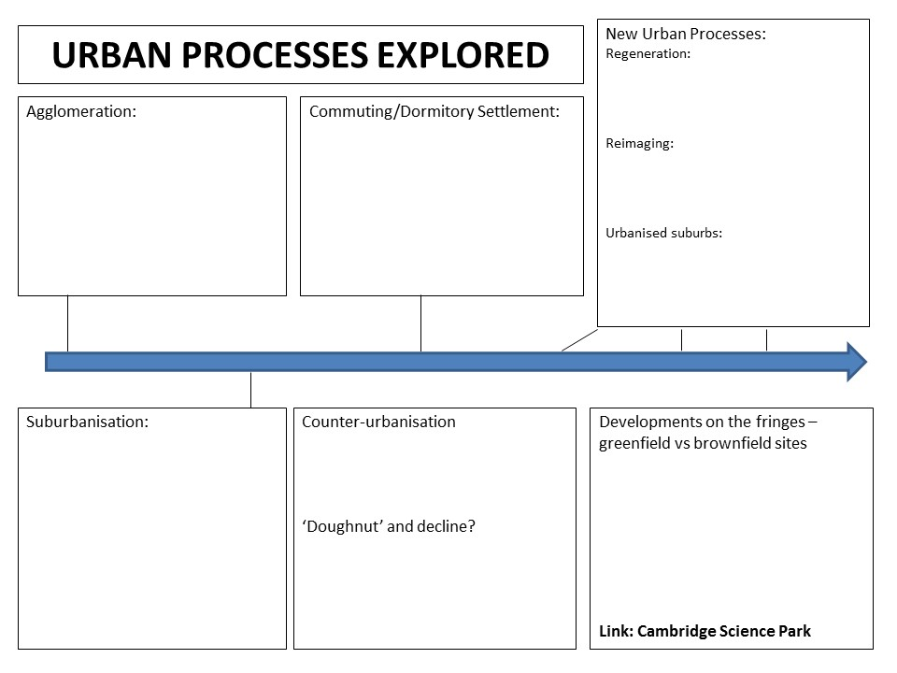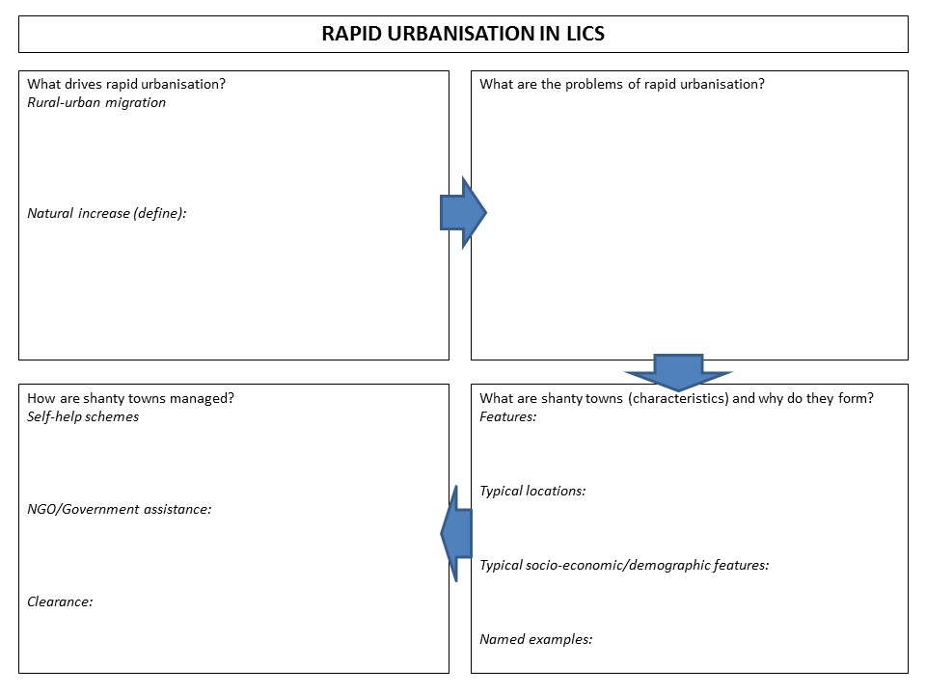
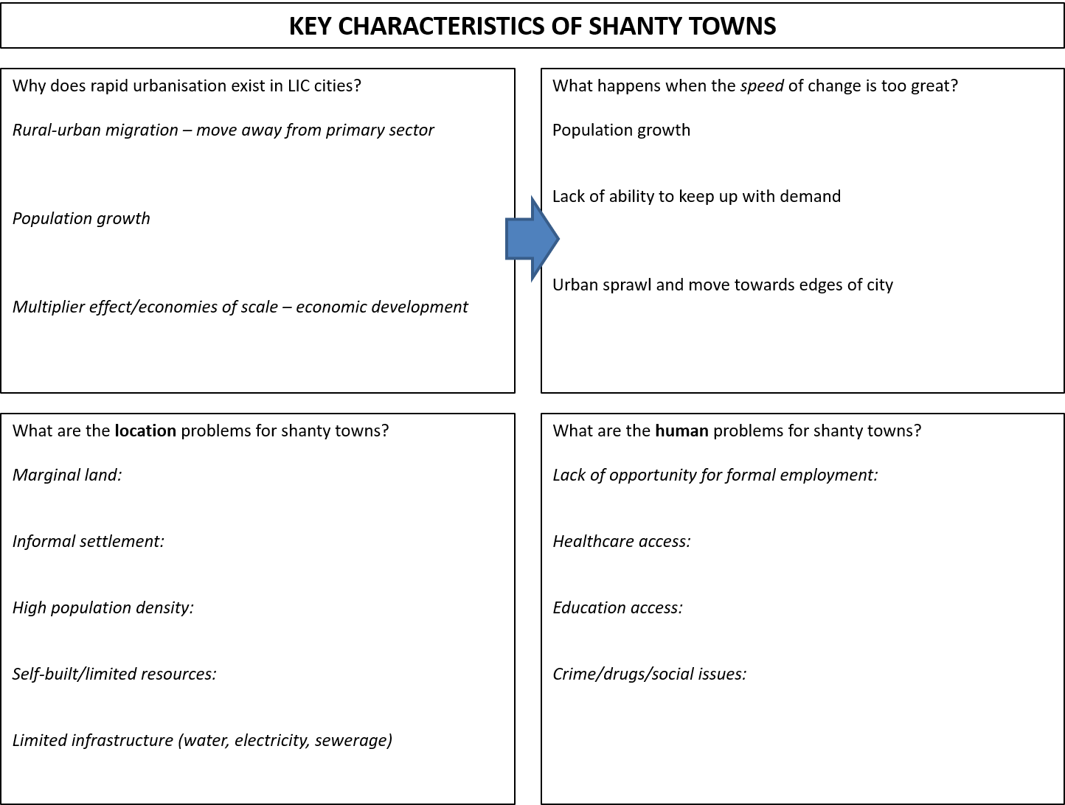
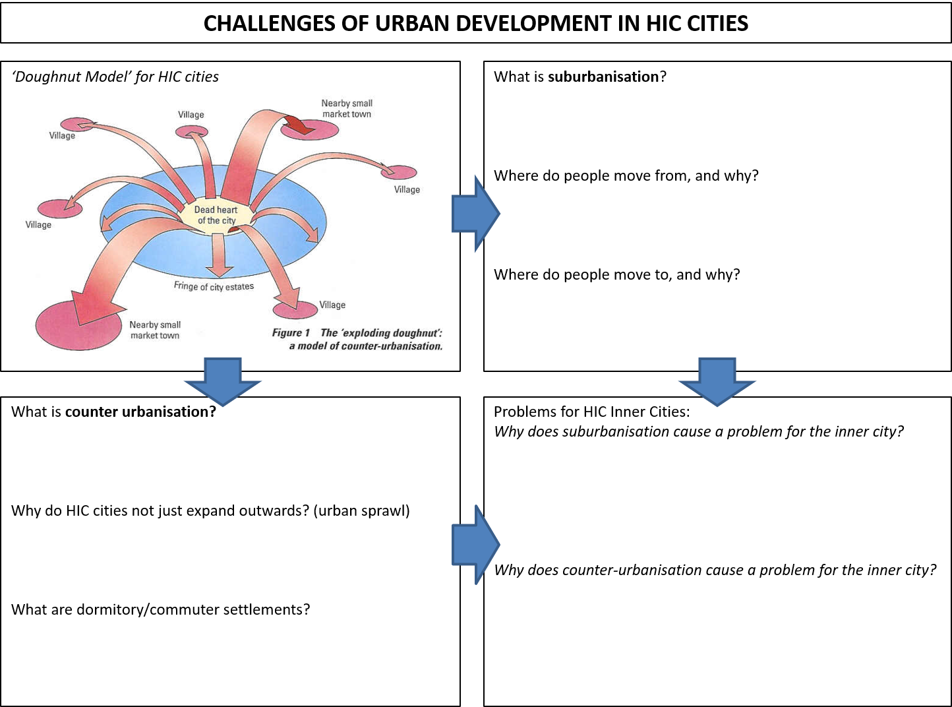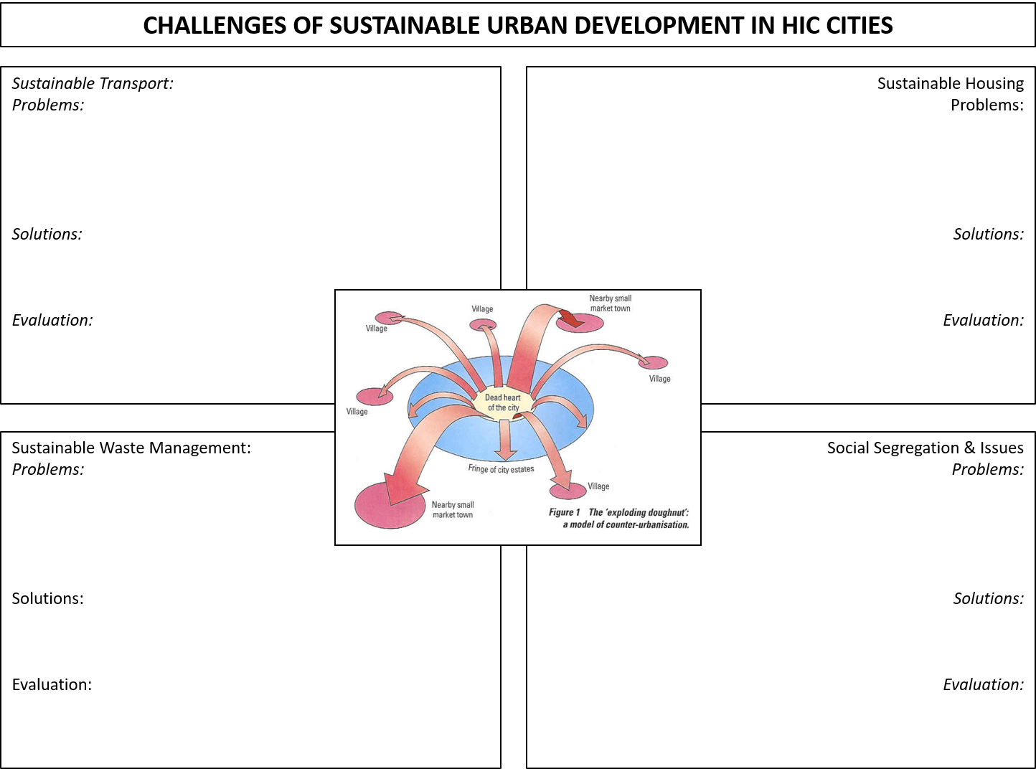
HIC CITIES – GREEN FIELD VERSUS BROWN FIELD DEVELOPMENT

What is a green field site?  Examples: | What is a brown field site?  Examples:

Greenfield Site |  | Brownfield Site
Advantages | Disadvantages | Advantages | Disadvantages

What might influence your decision?

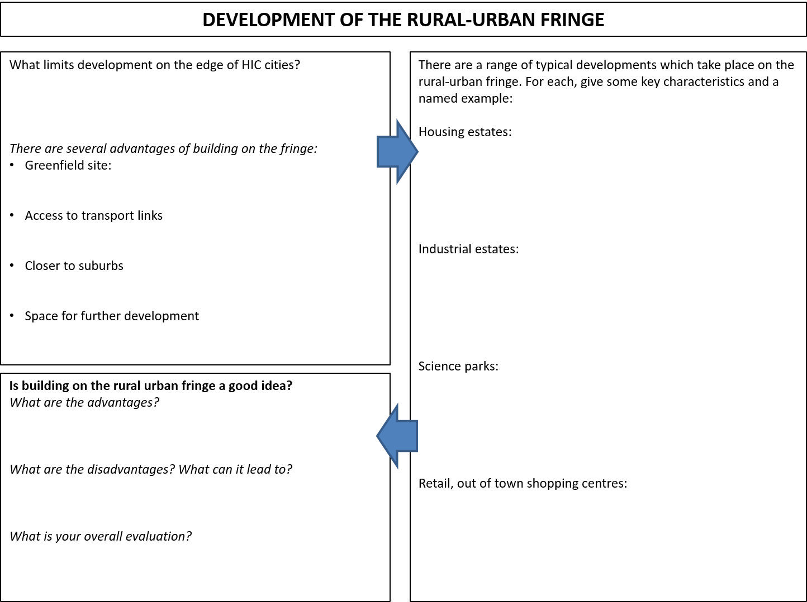
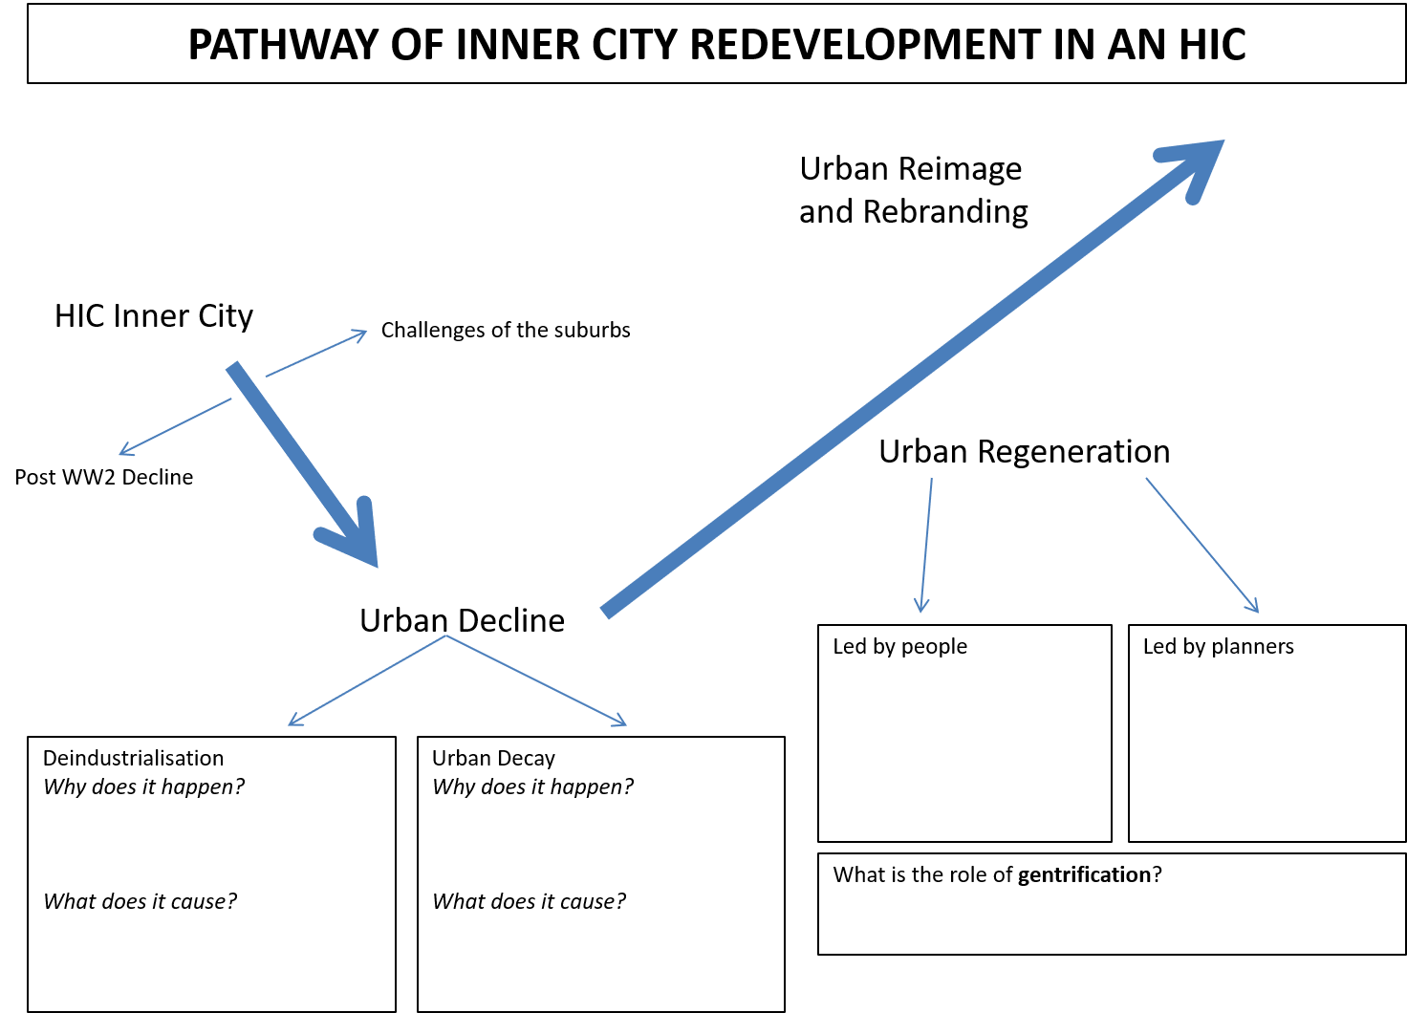
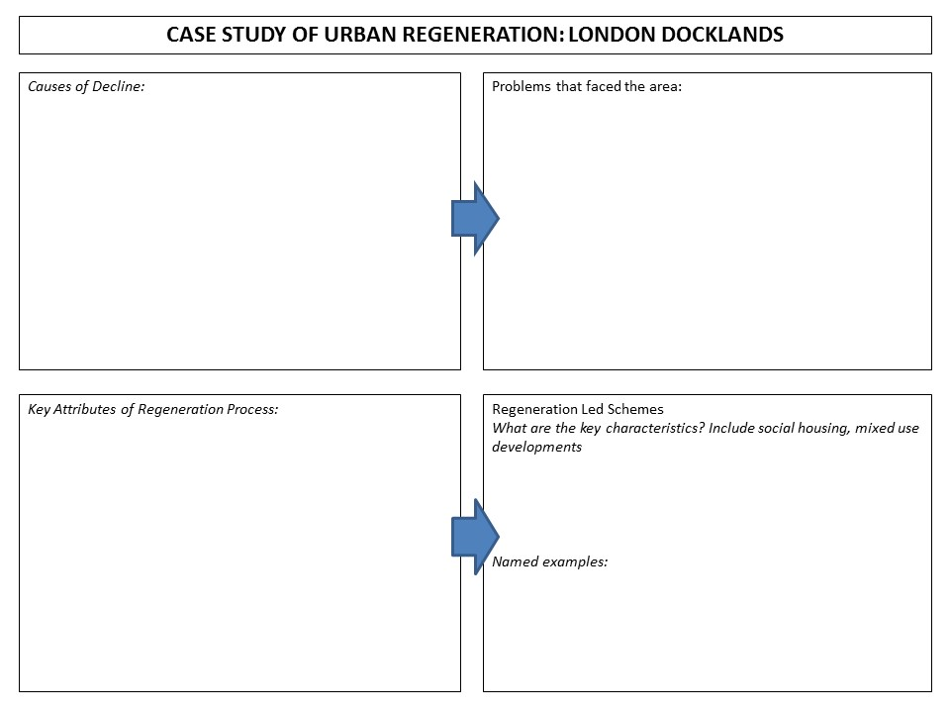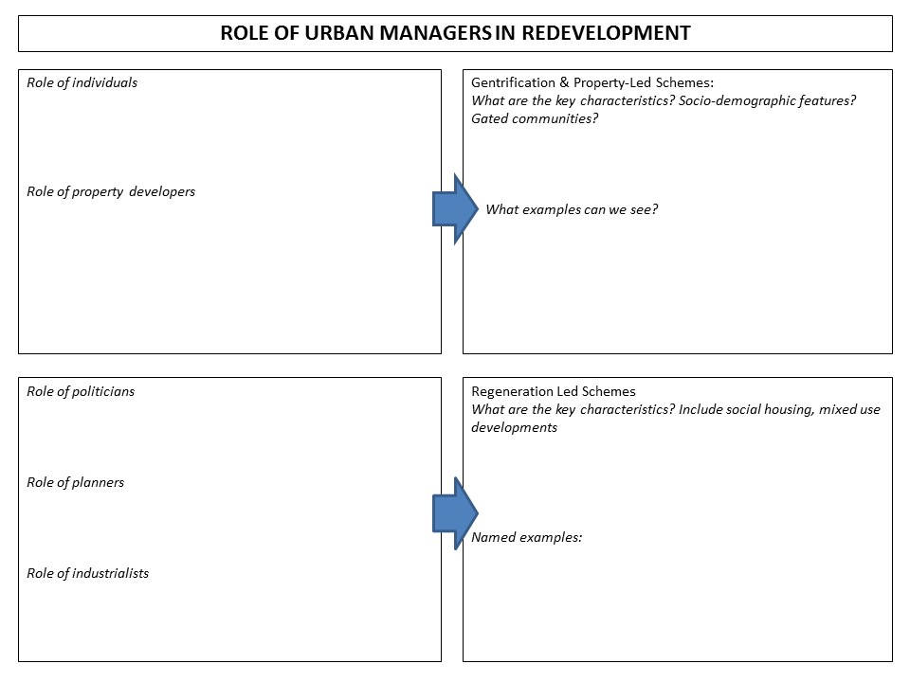

Urban: Practice Questions
UE1: Identify one feature of modern housing shown in the image [picture of housing in Nairobi] (1 mark)
UE1: Identify one piece of evidence that suggests the area around the power station [reference to source material] is being regenerated (1 mark)
UE1: What is it called when a government or NGO provides free building materials for residents to improve their squatter settlements? (1 mark)
UE1: What term is used to describe the area surrounding a CBD? (1 mark)
UE1: What is the minimum population of a megacity? (1 mark)
UE1: What term is used to describe the world’s largest cities? (1 mark)
UE1: Which area of the city has highest quality of life (1 mark)
UE1: Which one of the following best describes urban regeneration? [Multiple Choice: A: building a new town, B: adding air conditioning to old offices; C: improving an urban area through investment, D: building on a greenfield site]
UE1; What term is used to describe a growing proportion of people living in towns and cities? (1 mark)
UE2: Compare how the percentages of urban population in LIC and HIC changed between 1960-2010 (2 marks) [refers to data]
UE2: Identify the evidence [from Figure] that China has experienced rapid urbanisation (2 marks)
UE2: Identify two characteristics of the squatter settlement shown in the image [Source] (2 marks)
UE2: State two relationship between land use and land value as shown in [Source] (2 marks)
UE2: Suggest two reasons why the regeneration zone in [Source] might be a suitable location for residential development (2 marks)
UE2: What is meant by the term ‘urbanisation’? (2 marks)
UE2: What is meant by the term greenfield site? (2 marks)
UE2: What is meant by the term land value? (2 marks)
UE2: What is meant by the term mega-city? (2 marks)
UE2: What is meant by urbanisation? (2 marks)
UE3: 60% of the Mumbai population live in shanty towns. Describe three key characteristics of shanty town settlements (3 marks)
UE3: Describe one scheme which may help to improve the inner city of HIC cities.(3 marks)
UE3: Describe the changes in land use taking place on the edge of the city. (3 marks)
UE3: Describe the characteristics of the rural urban fringe (3 marks)
UE3: Describe three features of a typical CBD (3 marks)
UE3: Distinguish between brownfield and greenfield sites (3 marks)
UE3: Explain the difference between a greenfield site and a brownfield site. (3 marks)
UE3: State three causes of urbanisation (3 marks)
UE3: State three problems associated with rapid urbanisation other than shanty towns (3 marks)
UE3: Suggest how the use of brownfield sites may help reduce development pressures on the edges of HIC cities. (3 marks)
UE3: Suggest reasons for the rapid growth of urban area in LICs (3 marks)
UE3: Suggest why some shanty towns have been cleared (3 marks)
UE3: What are the key features of suburbanisation? (3 marks)
UE3: What is a megacity? (3 marks)
UE3: What is gentrification? (3 marks)
UE4: Describe the changes occurring in some shanty towns, which can improve conditions for residents (4 marks)
UE4: Describe the problem of shanty towns in LICs (4 marks)
UE4: Explain why shanty towns are an important feature of urban growth in many LICs (4 marks)
UE4: Give reasons for the changes taking place on the edge of many HIC cities such as Oxford. (4 marks)
UE4: Outline two factors encouraging the emergence of mega-cities. (4 marks)
UE4: Outline two factors that affect the rate of urbanisation (4 marks)
UE4: Outline two reasons why greenfield sites are attractive to modern business (4 marks)
UE4: Outline two reasons why land values vary within urban areas (4 marks)
UE4: Suggest reasons for the differences in types of squatter settlement (4 marks)
UE4: What are the arguments in favour of brownfield sites? (4 marks)
UE4: What are the characteristics of ‘urban decay’? (4 marks)
UE4: What are the reasons for the decline of the inner city in HICs? (4 marks)
UE4: What features of the city change with distance from the city centre? (4 marks)
UE4: Why are developers interested in using greenfield sites (4 marks)
UE4: With reference to HICs, describe how inner-city areas outside the CBD are changing. (4 marks)
UE5: Suggest reasons for the growth of mega cities. (5 marks)
UE5: What are shanty towns? (5 marks)
UE5: What is ‘rebranding’, and how does it work? (5 marks)
UE5: Why are cities in LICs growing faster than those in HICs? (5 marks)
UE6: Explain the changes taking place on the edges of HIC cities. Reference to examples may help your answer (6 marks)
UE6: Explain the characteristics of areas of social deprivation and poverty in HIC cities (6 marks)
UE6: Explain the improvements taking place in shanty towns in LIC cities (6 marks)
UE6: What are the main causes of rapid urbanisation in LICs? (6 marks)

Urban: Source Question Examples
Using Figure 1 and Figure 2, and your own knowledge, analyse the main problems of shanty towns for cities in LICs (8 marks)
Using Figure 3, and your own knowledge, analyse the main causes for the rapid growth of megacities (8 marks)
Using Figure 4-5 and your own knowledge, analyse to what extent governments are able to improve the conditions of shanty towns for residents (8 marks)
Using Figure 6, and your own knowledge, analyse the changing global distribution of global megacities (8 marks)

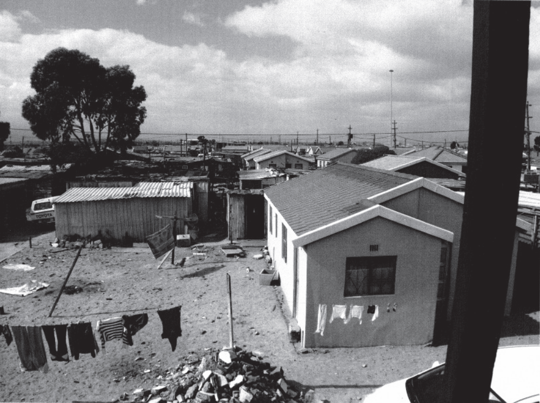
Figure 1: Squatter Settlement in Cape Town, South Africa

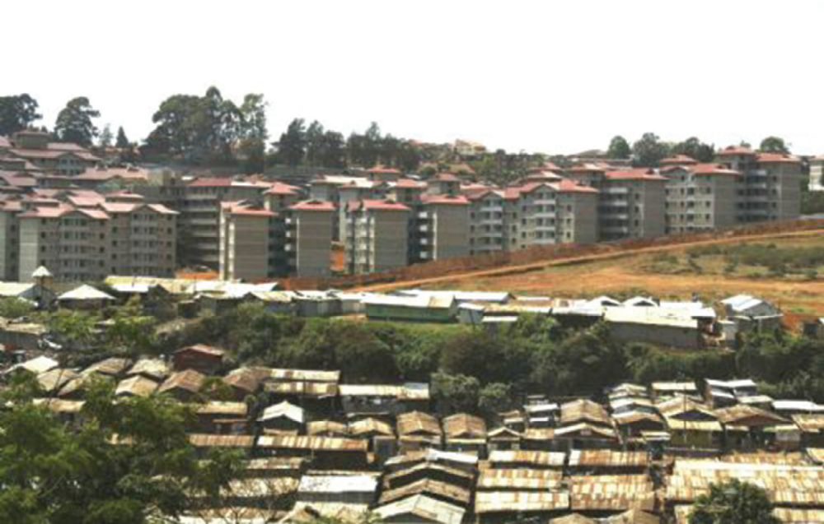
Figure 2: Squatter Settlement in Nairobi, Kenya

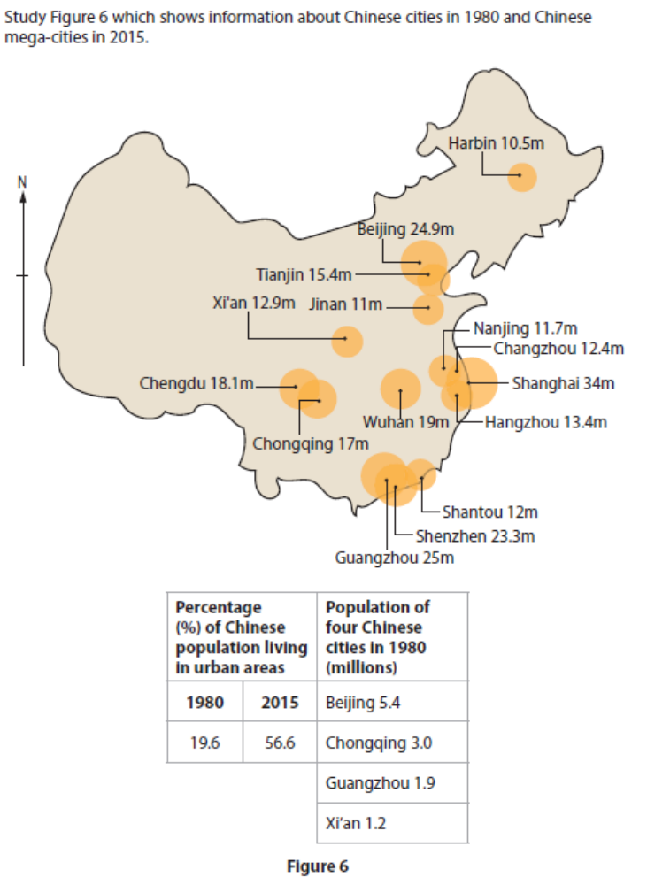
Figure 3: Selected Chinese cities in 1980, and Chinese mega-cities in 2015

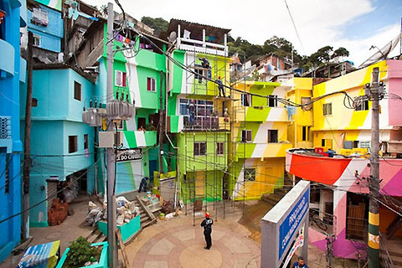

Figure 4: Buildings in one of the favelas of Rio de Janeiro

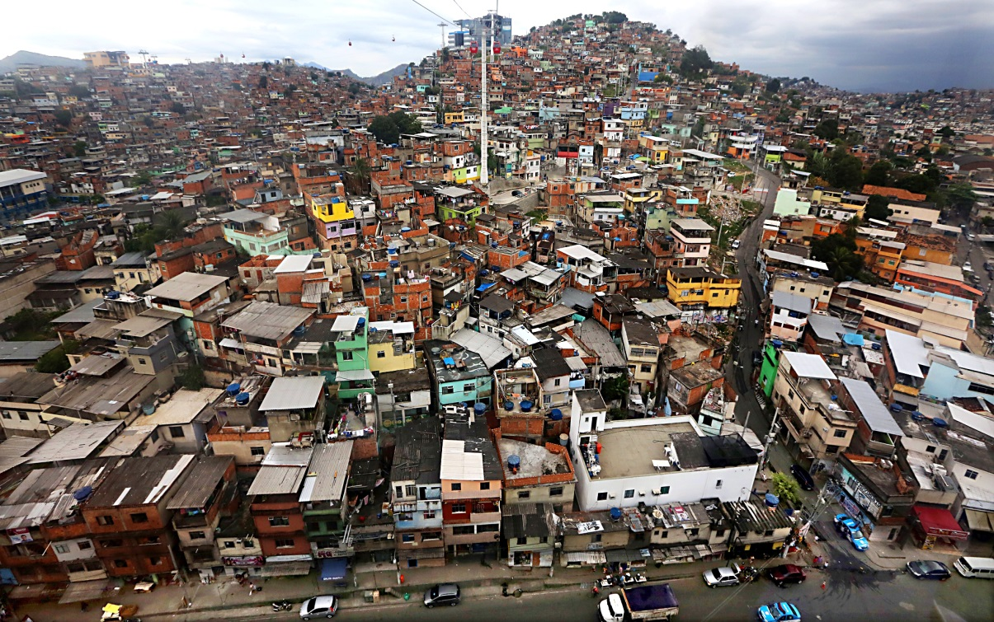

Figure 5: A cable car installation in Medellin, Columbia, above one of the shanty towns in the city.
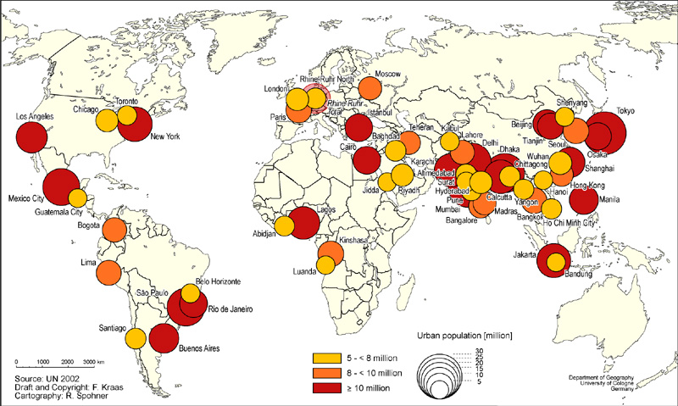
Figure 6: Map of the world’s largest cities in 2015

Urban: Model Answers

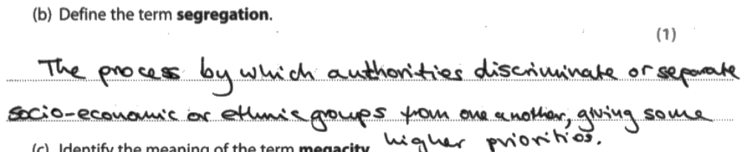

Examiner Comment: look at the specific technical detail for a one marker. This is a strong candidate!

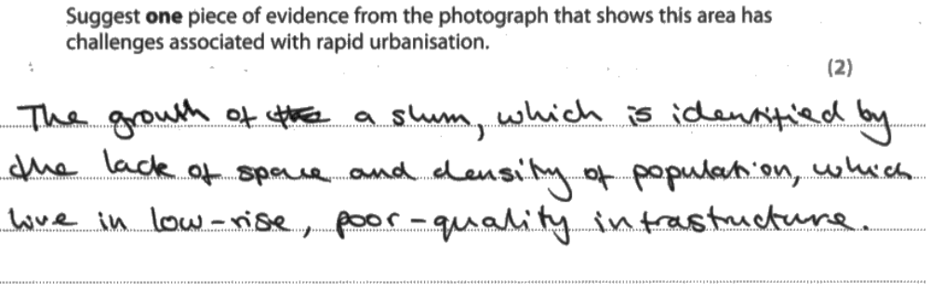
Examiner Comment: sequence and clear explanation, moving from the first mark to the second mark seamlessly
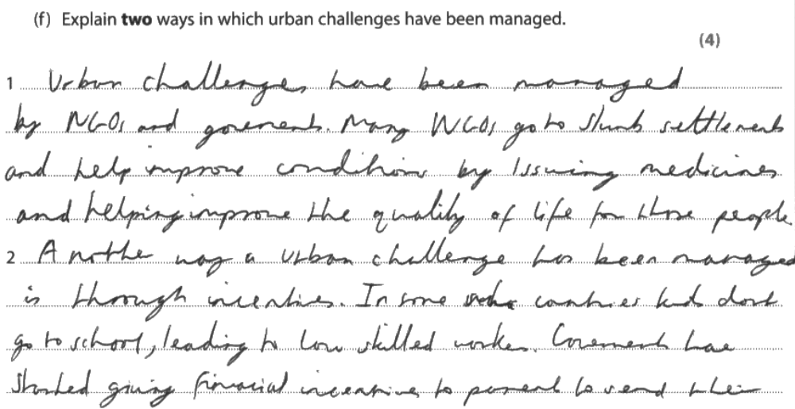
Examiner Comment: worth looking at this in terms of the theoretical structures. This candidate doesn’t refer to specific examples – question doesn’t ask for it – but is able to talk in such clear language that full marks are awarded. Compare this response against the next two which do the same question, and see the different ways to 4 marks!

Examiner Comments: here, there are clear references to specific placed ideas (land rights to slum dwellers), but without explicitly naming examples. The clarity of the idea is what gets the full marks.

Examiner Comments: in this example, specific names are used, but the clarity of ‘top down’ versus ‘bottom up’ is interesting! What can you learn from this? Three examples, very different – all getting full marks because of their detail and clarity of explanation.

Examiner Comment: despite going over the lines, this is a fluent and well written example which clearly refers to sources and shows high level judgement. Worthy of 8 marks.

Examiner Comment: what’s lovely about this response is the clarity of judgement that shines out. Clearly separated paragraphs show “most important” to “less important”, and the conclusion brings it all together. Each paragraph refers explicitly to a source, and shows real analysis and linking skill.

Paper 2: Fieldwork Questions

Principles of Fieldwork

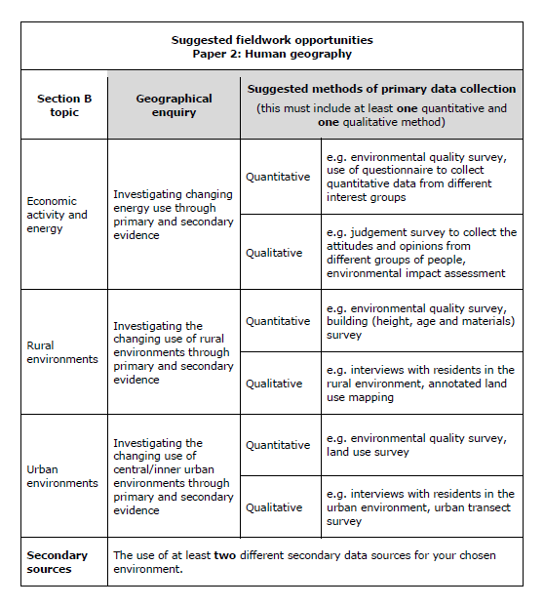
You should:
- Know the defined fieldwork opportunities and suggested research questions listed here. This is easy marks in the exam.
- Know what is likely to be asked for each option – if you have an idea of what the typical fieldwork will look like, your responses need less ‘on the spot’ thinking, and can refer more appropriately to technical and theoretical knowledge.
- Have some practical and reasonable suggestions for safety through all fieldwork. There is no point suggesting outlandish and inappropriate risks – keep it to something that an examiner can easily give credit to.
Be prepared to analyse data fully – remember to look for overall conclusions, patterns and trends.
ECONOMIC ACTIVITY FIELDWORK – People’s views on use of renewable energy
What do we want to know?
- What would we expect to happen? Why? [Theory/Context]

- What do we want to find out? [Aim]

- What specific questions do we want to answer? [Research Question]

How do we find our information? [Methods]
- What kind of data do we want to collect? (Primary/Secondary/Quantitative/Qualitative)
Primary: Secondary:

Quantitative: Qualitative:

- How do we collect data? (Equipment, Techniques)

- How do we know where/how much to measure? (Sampling)

- How do we stay safe? (Risk Assessment)

What did we find out? [Results & Conclusions]
- Presentation of results

- Statement of conclusions/key findings

- Statement of any anomalies or unexplained results

Did we do it right? [Evaluation]
- Did we collect enough data in terms of places visited or people asked? How do we know?

- Did we collect data for long enough in time? How do we know?

- Did we use the most effective techniques of data collection? How do we know?

- How could we improve our study in any of these areas?

Glossary of Terms: Fieldwork
Accurate data is as close to the real data as possible. It represents the target population precisely and shows the real world as it is. Accuracy is usually improved by better techniques and sampling techniques.
Aim: an aim is a big and broad idea, which covers lots of smaller research questions. For example, in physical geography, an aim might be “to investigate beach processes”, or “to investigate the CBD of Catford” in human geography. These are big ideas, and give rise to lots of smaller research questions and hypotheses that you can test.
Bias: an interpretation or approach which suits a particular set of facts. This is a negative idea, and we want to create unbiased approaches wherever possible.
Environmental Quality Survey: standard template designed to give a quantitative assessment of the quality of environmental standards. This needs to be customised and standardised to give you a reliable approach.
Fair: a technique that can be produced without personal interpretation and reflects the real world.
GOAD map: is an old name for detailed town centre plans. Used as base maps for urban studies.
Hypothesis: a hypothesis (plural: hypotheses) is a testable question, that you should be able to answer “yes” or “no” to at the end of your fieldwork using statistical evidence. For example: “does longshore drift occur on the beach at Swanage?”, or “does land use follow the Burgess model in Catford?”. Think about what type of data this might need to collect. This is different to a research question.
Primary data is collected personally by an investigator or their team.
Qualitative data provides people’s opinions and perceptions. This needs to be described and interpreted by the investigator, and brought together to understand it.
Quantitative data provides numerical information that can easily be shown on graphs and charts.
Questionnaire: a range of questions, asked as a template, to establish people’s opinions. Designing a questionnaire needs careful consideration of aim, research needs and data collection. Practically completing a questionnaire needs careful planning of a sampling strategy and risk assessment.
Random sampling involves using a random number generator (calculator/phone) to produce a completely unbiased choice. The generator identifies the interval (e.g. how many people to wait before your next questionnaire or how many metres before your next measurement).
Reliable data is the output of the scientific method. It is repeatable, based on a clear and evidence driven approach, and you can get similar results again and again by doing the same technique. Reliability is usually improved by repetition and taking averages to show consistency.
Research Question: a research question offers a more evaluative question that has no single answer. For example: “has the regeneration of Catford been successful?”. There is no single piece of data you can collect to prove that: it’s about opinion and evaluation of results! What data does it need?
Risk assessment is a core part of fieldwork. You need to identify realistic problems, and consider potential solutions. You should normally think about personal risks, environmental risks and specific risks for the area of study (e.g. coastal, urban).
Sample: a representative section from a target population. May be drawn using different techniques
Secondary data has been collected by someone else. It can be official (e.g. a government census, a satellite map of an area, the weather records for an area) or comparative (someone else’s questionnaire data, another group’s comparison study). The key is that you have not collected it yourself.
Stratified sampling involves having a clear knowledge of your target population, and then sampling according to that pre-determined ratio. So for example if you’re asking a questionnaire, and you know 70% of the people you want to talk to are female, you’d make sure 70% of your sample are female too.
Systematic sampling involves having a clear and pre-planned interval for your samples. You may decide you’ll measure every 100m, or ask every third person. A transect is a specific type of systematic sampling technique.
Target population: the whole context for a fieldwork study. A sample will draw some elements from this whole context as part of a sampling technique.
Transect: a linear sampling technique, that takes a cross section across a target population space to produce a fair representation. They are excellent for showing change over space (e.g. distance from the CBD, or coastal beach profile), and follow a pre-existing line or approach.

Fieldwork Practice Questions
FW1: Figure (map of urban area with buildings being drawn in) shows data being recorded during an urban fieldwork investigation. Suggest one possible aim of this investigation (1 mark)
FW1: Here is a questionnaire about renewable energy use and sources. Suggest one possible aim of this investigation (1 mark)
FW1: Identify one advantage of putting data near a map of where it was collected (1 mark)
FW1: Suggest a possible aim of an EAE investigation [source showing factors for industrial location] (1 mark)
FW2: [Source] shows a photograph of services and factories on an industrial estate. Suggest two possible geographical aims for an investigation of this industrial estate (2 marks)
FW2: Describe one advantage of using the type of diagram you have drawn in Figure [line graph] (2 marks)
FW2: Describe one health and safety risk to be aware of when carrying out this type of fieldwork investigation (2 marks)
FW3: Explain how ICT could be used in this investigation (3 marks)
FW3: Outline a sampling strategy you could use when collecting data about environmental quality (3 marks)
FW3: Outline how one named simple statistical technique could help you analyse data (3 marks)
FW3: Outline how you would attempt to ensure that the data collected (by questionnaire) was as accurate as possible (3 marks)
FW3: Outline how you would attempt to make sure the data collected [urban transect] was as accurate as possible (3 marks)
FW3: State three health and safety risks that should be assessed before collecting fieldwork data on an industrial estate (3 marks)
FW4: Comment on other information you might need in an investigation on the future use of energy sources (4 marks)
FW4: Comment on other information you might need in an investigation about changes in buildings and land use in an urban area (4 marks)
FW4: Describe how [town centre plan] might be used in an environmental quality investigation? (4 marks)
FW4: Describe two possible risk assessments that need to be made with this type of fieldwork [questionnaire data] (4 marks)
FW4: Describe two possible risk assessments that need to be made with this type of fieldwork [urban transect] (4 marks)
FW4: Describe two sources of secondary information that might have been useful as part of the pre-fieldwork and planning stage (4 marks)
FW4: Draw a diagram to represent the data for [chosen site] (4 marks)
FW4: Fig 10 shows data collected in the urban fieldwork investigation, along a transect extending outwards from the town centre. Draw a labelled graph showing building height at sites 2, 4, 6, 8, and 10 (4 marks). Justify your choice of data presentation technique (3 marks)
FW4: Fig 9 shows responses given by 100 people to the questionnaire. Draw a labelled graph to present the ‘use more’ total among under 30s for each of the five energy sources. (4 marks). Justify your choice of data presentation in this Figure (3 marks)
FW4: Outline two sources of secondary data that could be researched before collecting fieldwork data for this investigation (4 marks)
FW4: Suggest an appropriate method that could be used to collect data on people’s views (4 marks)
FW4: Suggest how you might evaluate the accuracy of conclusions reached in an investigation such as this (4 marks)
FW4: Suggest how you might evaluate the conclusion reached in an investigation (4 marks)
FW4: Suggest the type of information you would need to collect for the aim of your study (4 marks)
FW4: Suggest two ways ICT might have been used in this investigation (4 marks)
FW4: Suggest what factors students might consider in undertaking a risk assessment at either a factory or services location (4 marks)
FW4: What additional information may be collected to improve the investigation? (4 marks)
FW5: Outline what you need to consider when evaluating the fieldwork process and conclusions of a geographical investigation (5 marks)
FW6: Describe the fieldwork you would need to carry out in order to map the pattern of land use in a town or city (6 marks)
FW6: What conclusions about environmental quality can be reached from analysis of data (6 marks)
FW6: What conclusions about people’s views can be reached from an analysis of [Figure]? (6 marks)
FW6: What conclusions about the future use of energy sources can be reached from analysing the questionnaire responses in the Figure (6 marks)
FW6: What conclusions can be reached about building and land use changes along the transect from analysis of your data (6 marks)
FW6: What conclusions can be reached about people’s views on the use of renewable and non-renewable energy? (6 marks)
FW8: Describe the equipment and field techniques you might use when collecting information for an investigation [on industrial location] (8 marks)
FW8: Describe the use of equipment and the field techniques that might have been used when collecting information in a survey of location needs for industry or services (8 marks)

Human Fieldwork: Model Answers

Examiner comment: know your fieldwork. Specific detail, and clarity of explanation helps this candidate earn an easy first five marks on the fieldwork section – that’s a quarter of the marks!
Examiner comment: Look at the technical language use here. Clear reference to “Environmental Quality Survey” and “likert scale” show exceptional understanding of how the techniques are worked, and the candidate develops points easily for four marks
Examiner comment: an unusual question, but the candidate has thought this one through. What is critical? Let’s explain the transect across the CBD, and show even space for a systematic sample. The drawing isn’t brilliant, geographically accurate or a perfect map – but every box is ticked for the examiner, so it gets full marks.
Examiner Comment: a clearly developed 2 x 2 marks – point, developed. Four marks.

Examiner Comments: this is a complex question, and there are two excellent examples of how to successfully evaluate “a student’s” fieldwork rather than your own. Look at what it’s aiming to achieve, and what bits of it you can praise and recognise as positive. Then you can use the sources to evaluate and suggest improvements. There should be a balance between them: you can see how each candidate has plotted their way through the sources to do that! Both examples are very different, but scored full marks

Paper 2: Globalisation & Migration

Globalisation & Migration: Specification
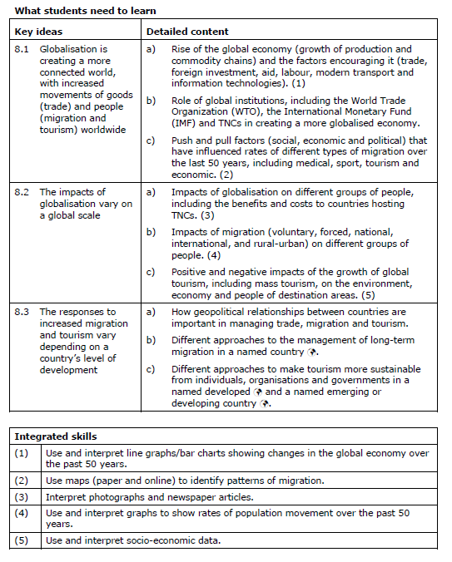

Glossary of Terms: Globalisation & Migration
Asylum seeker: a person who tries to enter a country by claiming to be a victim of persecution or hardship.
Birth rate: the number of births per 1000 people in a year; a measure of fertility
Commodity chain: see Production chain
Comparative advantage: the idea that areas will produce those things which they are best suited to produce
Consumption: the using up of things, particularly resources.
Depopulation: a decline in the number of people living in a particular area.
Development: economic and social progress that leads to an improvement in the standard of living and quality of life for an increasing proportion of the population
Economic globalisation: the increasing integration of national markets for goods and services into a single global market
Economic migrant: a person seeking work in another country
Ecotourism: a form of tourism that tries to minimise its environmental impacts by using local resources and labour and by keeping profits within the local area
Emigration: the migration of people out of a country
Forced migration: a type of migration where push factors prevail and people have little or no choice
Global economy: the evolving economic system that increasingly links the countries of the world; it involves the worldwide exploitation of resources and the production and marketing of goods and services.
Global shift: the movement of manufacturing from HICs to cheaper production locations in LICs
Global village: a term used to convey the idea that people all around the world are being drawn closer together into a single global community
Globalisation: the process, led by TNCs whereby the world's countries are all becoming part of one vast global economy.
Goods: made items, products and materials.
Gross domestic product (GDP): the total value of goods and services produced by the economy of a country during a year
Immigration: the movement of people into a country
Infant mortality rate: the number of deaths of children under the age of one year, per 1000 live births.
In-migration: the movement of people into an area
Interdependence: a situation in which countries rely on each other as part of the global economy
Internal migration: migration within a country; also known as 'domestic migration'
Internally-displaced person (IDP): a person who for various reasons, such as civil war or a natural hazard, has been forced to migrate within their country.
International migration: the movement of people between countries
Labour: people who work and produce goods and provide services
Location factor: something which affects where a particular activity is found
Mass tourism: popular, large-scale tourism of the type pioneered in Southern Europe, the Caribbean, and North America in the 1960s and 1970s.
Migration: the long-term movement of people from one place to another
Natural change: a change in the size of a population resulting from the difference between birth rates and death rates
Net migration: the balance between the number of people entering and the number leaving a country or region
Out-migration: the movement of people away from an area
Outsourcing: a process whereby rich countries look to poorer ones to produce their food and other commodities, as well as help with services, such as by call centre.
Package holiday: a holiday in which travel and accommodation are put together by a tour operator and sold as a relatively cheap package
Population density: the number of people per unit area (i.e. per km²)
Population growth rate: the speed with which a population is growing; usually calculated as the increase in a year expressed as a percentage of total population at the beginning of the year
Population growth: an increase in the size of a population due to natural increase, net in-migration or both.
Population pressure: when the number of people in an area begins to approach the carrying capacity and places a strain on available resources
Push-pull factors: the things that encourage people to migrate from one area to another. The negatives in the area of departure (push) are balanced against the positives of the destination (pull)
Returnee: a refugee or asylum seeker returning to their home country either voluntarily or by deportation
Refugee: a person whose reasons for migrating are due to fear of persecution or death and who now resides in another country
Tourism: any leisure time or recreational activity which involves at least one night’s absence from the normal place of residence.
Trade: the movement of goods from producers to consumers, most often between countries.
Transnational corporation (TNC): a large company operating in a number of countries and often involved in a variety of economic activities.

Globalisation & Migration: Revision Materials
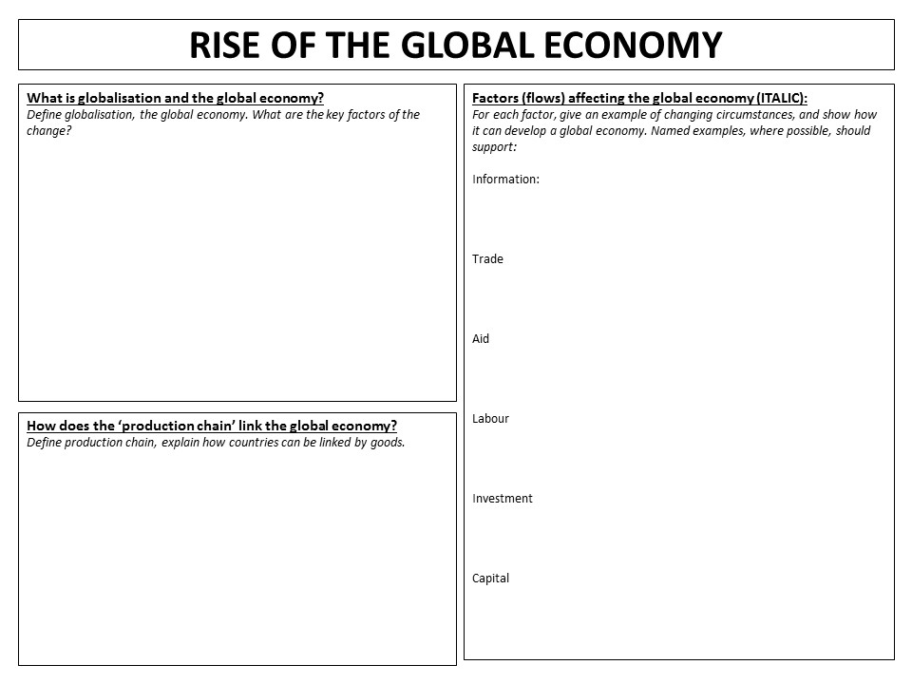
ROLE OF INSTITUTIONS IN THE RISE OF THE GLOBAL ECONOMY
Who are they? | What do they do? | How do they shape globalisation? | Importance to globalisation?
Transnational corporations (TNCs)
World Bank
International Monetary Fund
World Trade Organisation (WTO)
Trade blocs e.g. European Union
United Nations
Non-Governmental Organisation (NGO) Charities (e.g. Red Cross)

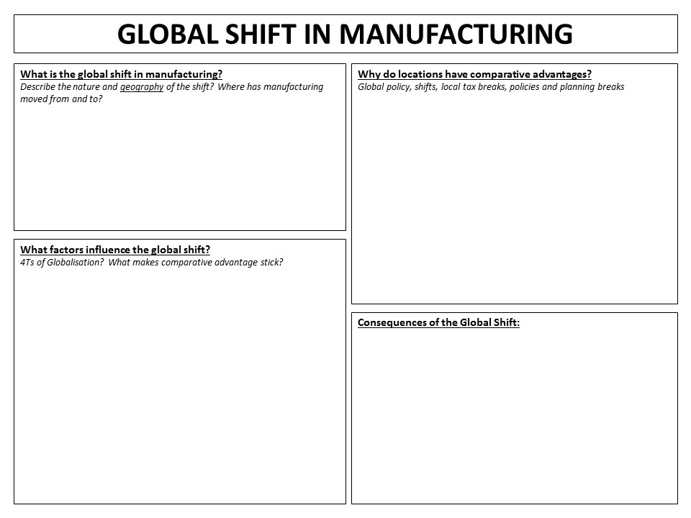
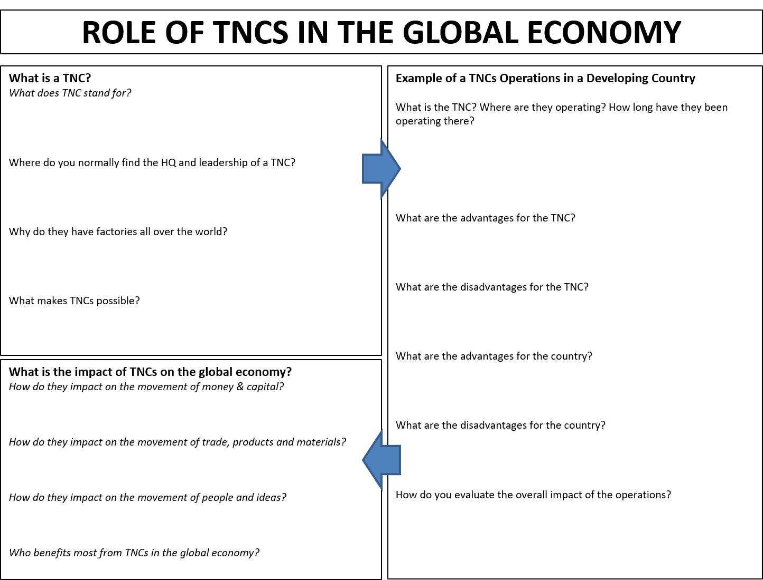
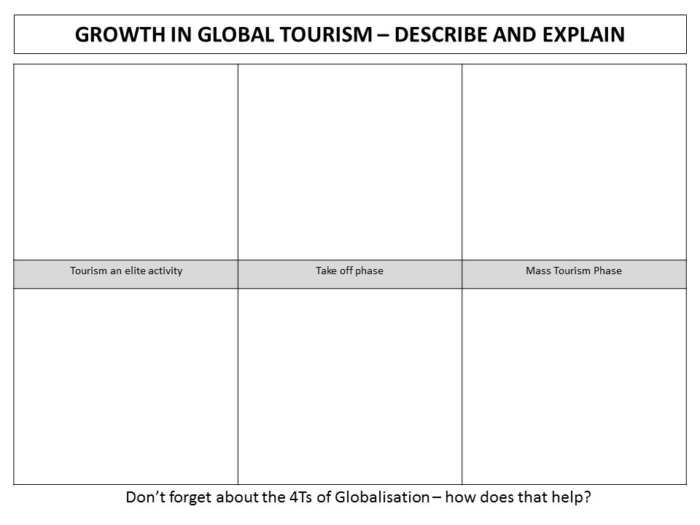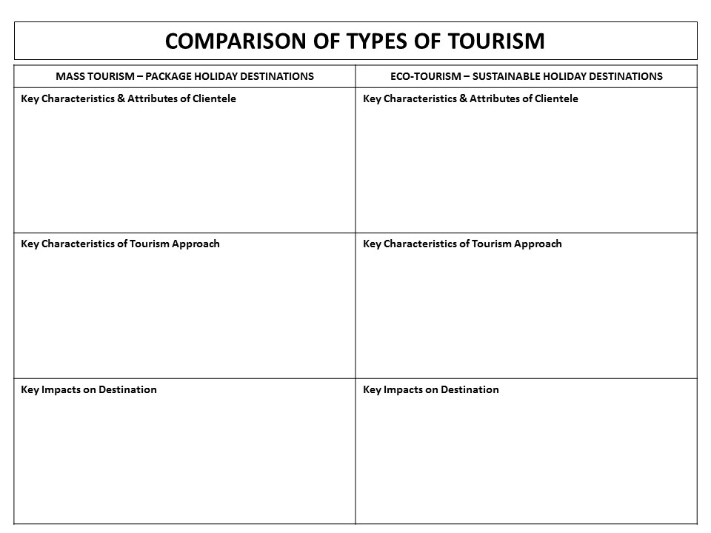
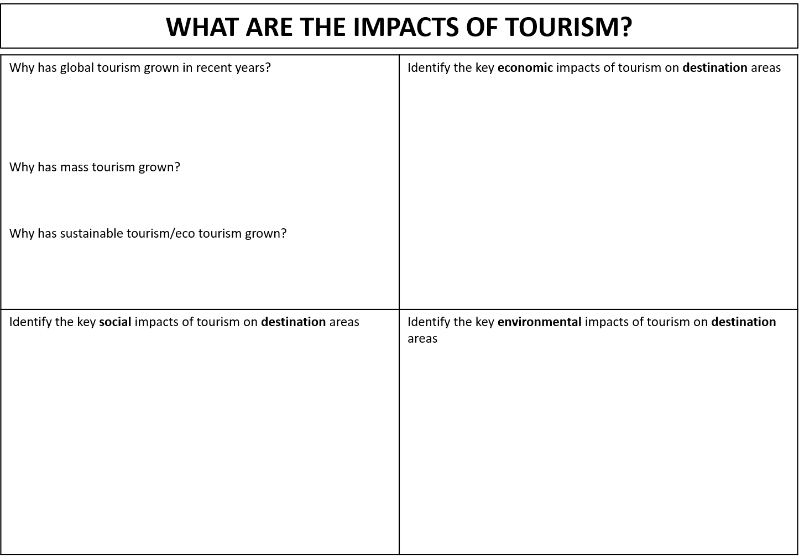
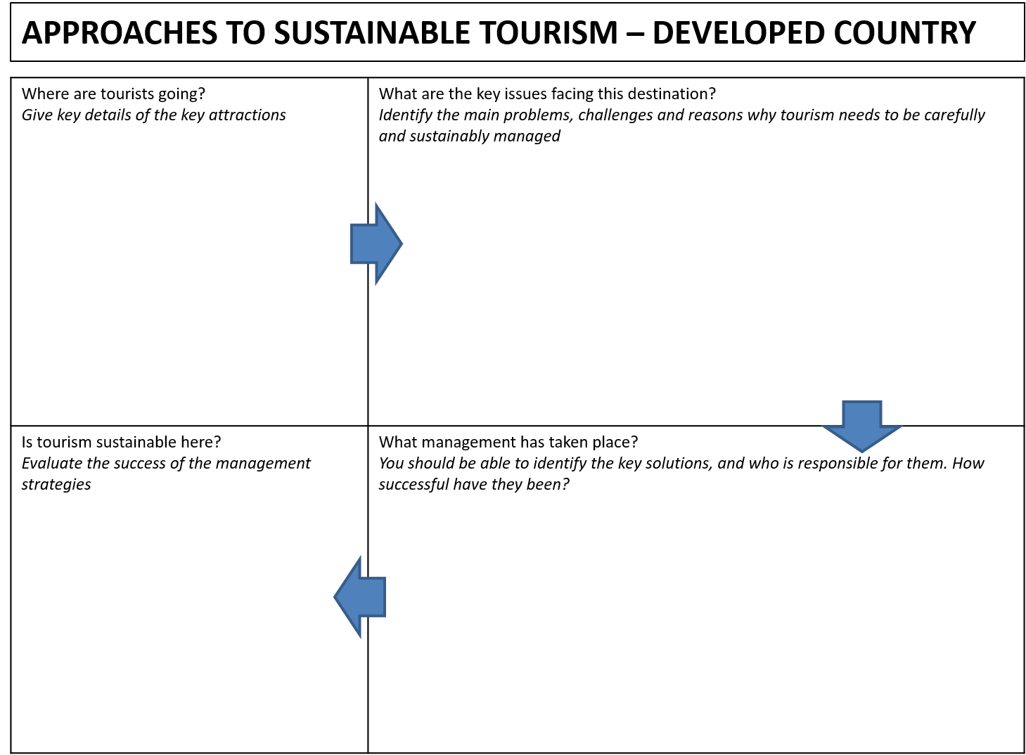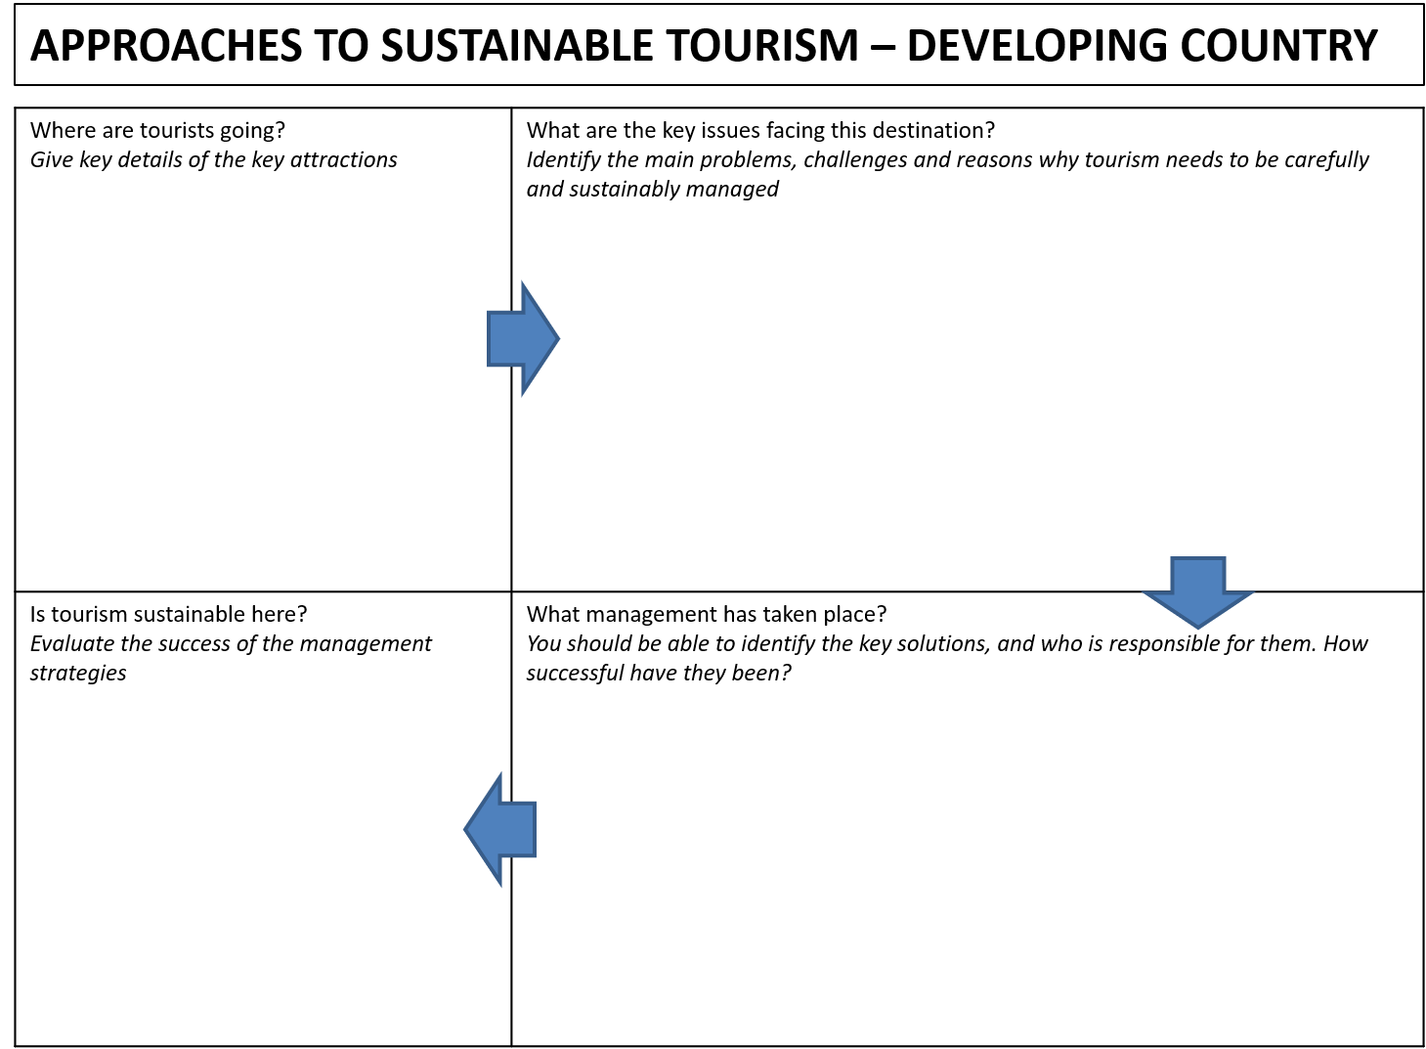
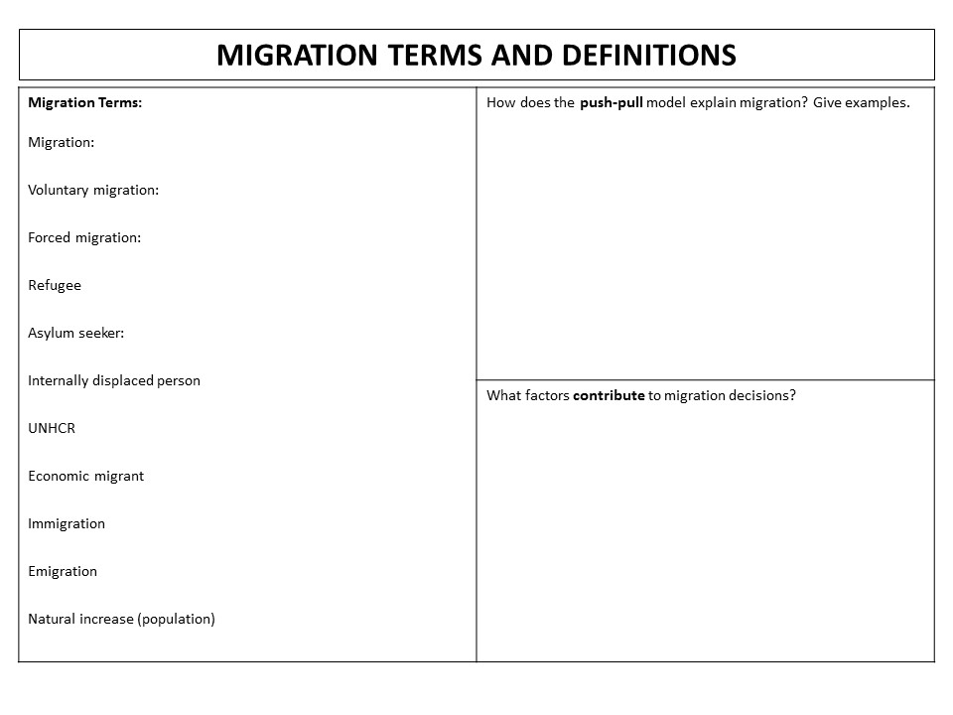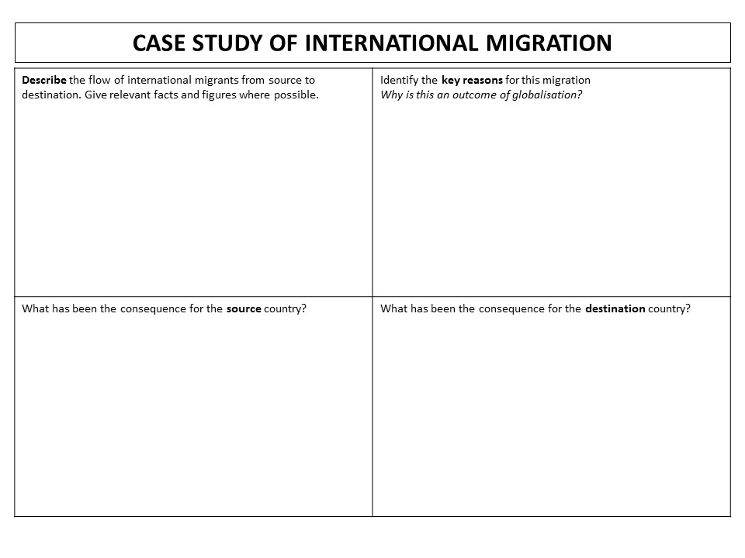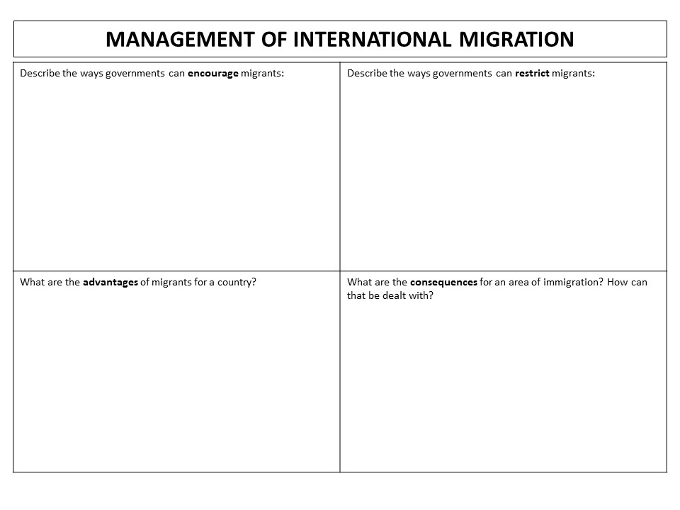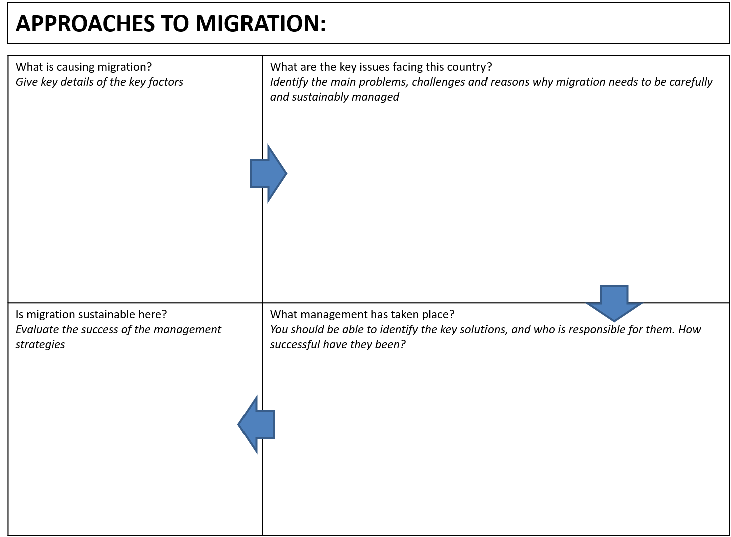

Globalisation & Migration: Practice Questions
GM1: What is meant by the term international migration (1 mark)
GM1: What is the evidence that HICs are the main destinations for international migrants? (1 mark)
GM1: What term describes global companies like Carrefour? (1 mark)
GM1: What term describes the difference between immigration and emigration (Multiple Choice: positive net migration, negative net migration, net migration, voluntary migration) (1 mark)
GM2: Suggest one reason why Carrefour’s recent growth has taken place mainly in Latin America and Asia (2 marks)
GM2: There is a land border between the USA and Mexico. What does [source] suggest about movement across this border? (2 marks)
GM2: What is a package holiday? (2 marks)
GM2: What is a refugee? (2 marks)
GM2: What is ecotourism? (2 marks)
GM2: What is international migration? (2 marks)
GM2: What is meant by the term net migration? (2 marks)
GM2: What is meant by the term ecotourism? (2 marks)
GM2: What is meant by the term forced migration? (2 marks)
GM2: What is meant by the term production chain? (2 marks)
GM2: What is the global shift in manufacturing? (2 marks)
GM2: What is the relationship between a country’s net migration and its’ level of economic development (2 marks)
GM3: Give three examples of voluntary migration? (3 marks)
GM3: Suggest why some international migrants settle in NICs and LICs (3 marks)
GM3: What is ‘sustainable’ tourism? (3 marks)
GM3: What is globalisation? (3 marks)
GM4: Describe the characteristics of one named ecotourism project? (4 marks)
GM4: Describe the nature of the global shift in manufacturing (4 marks)
GM4: Describe the push-pull model of migration (4 marks)
GM4: Outline two push factors that give rise to forced migration (4 marks)
GM4: Outline two reasons for controlling international migration flows (4 marks)
GM4: Outline two reasons for the global shift in manufacturing (4 marks)
GM4: Outline two reasons for the growth of global tourism (4 marks)
GM4: Outline two reasons for the growth of production chains (4 marks)
GM4: Study Fig 14 which gives information about migration in to Australia in 2010. Describe one push and one pull factor that results in positive net migration in some HICs, such as Australia (4 marks)
GM4: Suggest two reasons why governments might try to manage migration (4 marks)
GM4: What factors have made the shift in manufacturing possible? (4 marks)
GM4: Why are package holidays a popular product of globalisation? (4 marks)
GM4: Why is ecotourism “different”? (4 marks)
GM5: What are the benefits of hosting migrants? (5 mark)
GM5: What flows are involved in the growth of the global economy? (5 marks)
GM5: Why do some people oppose immigration policies? (5 marks)
GM5: Why has the global shift in manufacturing occurred (5 marks)
GM5: Why has tourism increased globally? (5 marks)
GM6: [Figure] shows a commodity chain for the clothing industry. Explain why globalisation has encouraged the growth of commodity chains such as the one shown in [Figure] (6 marks)
GM6: [Source] is a photograph of sustainable tourism in the Galapagos Islands. Explain the reasons for making tourism more sustainable (6 marks)
GM6: Describe the impacts that mass tourism can have on package holiday destinations, such as Benidorm (6 marks)
GM6: Explain the growth of global tourism (6 marks)
GM6: Explain why countries, such as Australia, need to manage international migration flows. (6 marks)

Globalisation & Migration: Source Question Examples:
Using Figure 1, and your own knowledge, analyse the role of TNCs in the global economy (12 marks)
Using Figure 2-4, and your own knowledge, analyse the extent to which migration can be successfully managed (12 marks)
Using Figure 2-3 and your own knowledge, discuss the ways in which refugees are good examples of migrants (12 marks)
Using Figure 4, and your own knowledge, discuss the extent to which tourism is a global economy (12 marks)

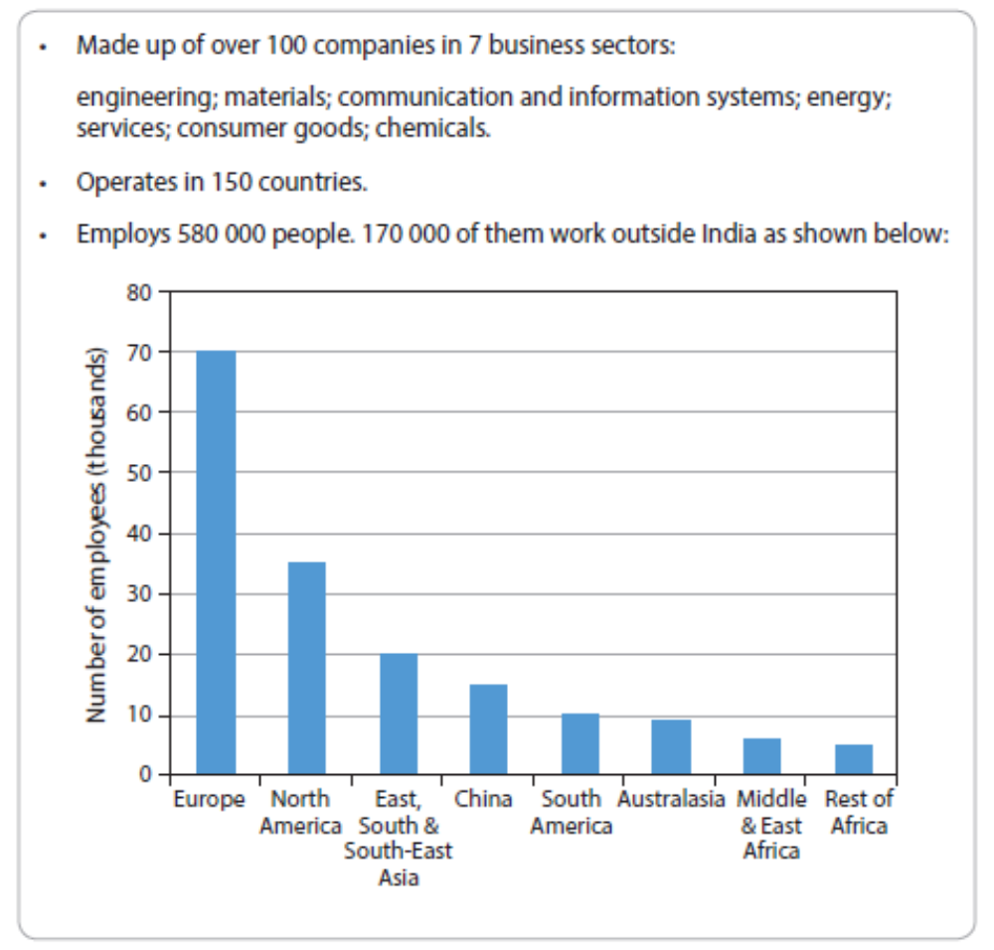
Figure 1: Information about India’s largest corporation
Figure 2: Destination of Global Refugees, 2005-2015
Figure 3: Global net migration in 2016: gains, losses and neutral

Figure 4: Visitor numbers (millions) to 20 global destination cities, 2015

Globalisation & Migration: Model Answers

Examiner comment: clear explanation of developed point – shows 2 x 2 marking and reference to data.
Examiner comment: another example of excellent 2 x 2 writing. Get used to developing your ideas for second mark!
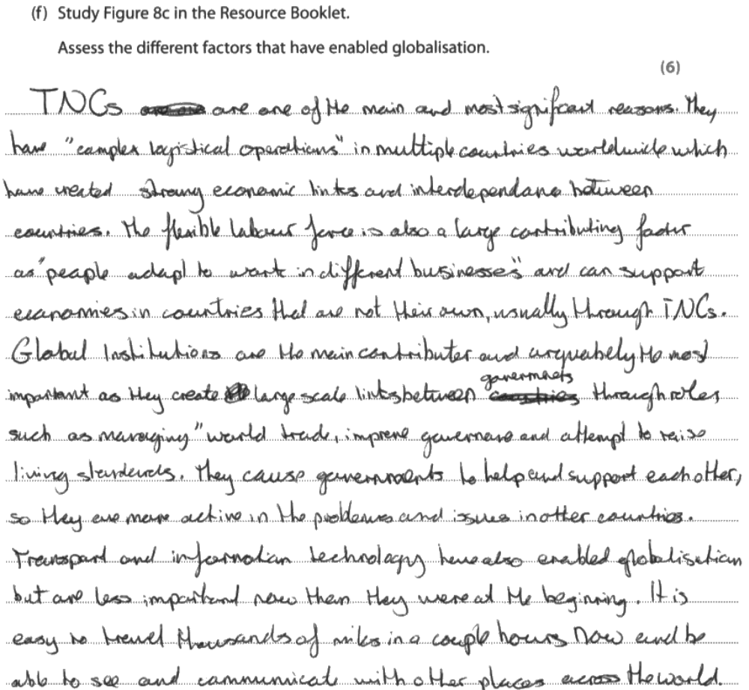

Examiner Comment: There’s so much to like about this response – look at the way the candidate specifically quotes text, and shows judgement about “arguably the most important reason”. The clear use of technical language and fluent explanation is just excellent, and this secures a deserved full six marks.

Examiner Comment: again, a clear use of judgement. See how the candidate starts with “I think is the most important”, which shows clear assessment and focus on the question straight away. The developed ideas and structured response are a skill that should be practiced – if you don’t automatically think in logical steps, then can you practice planning responses?
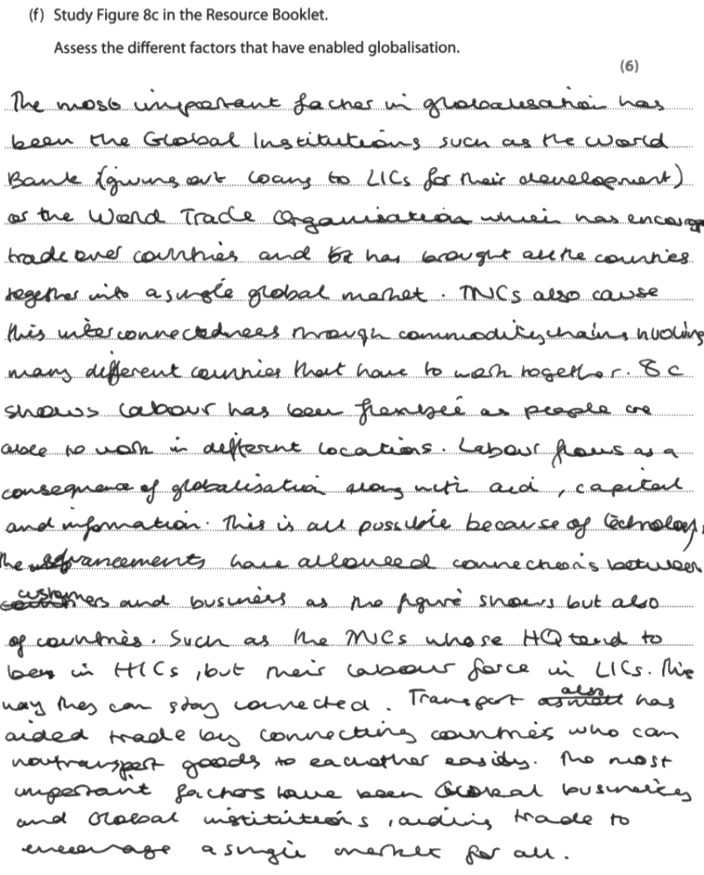
Examiner Comment: a longer response, but the technical language and judgement is no less important. You can see the same themes being discussed, but this candidate has made different judgements about what’s important to them. The examiner doesn’t care – they want to see you analysing and assessing the factors, but there isn’t a “right” order of assessment and “correct” judgement to make!
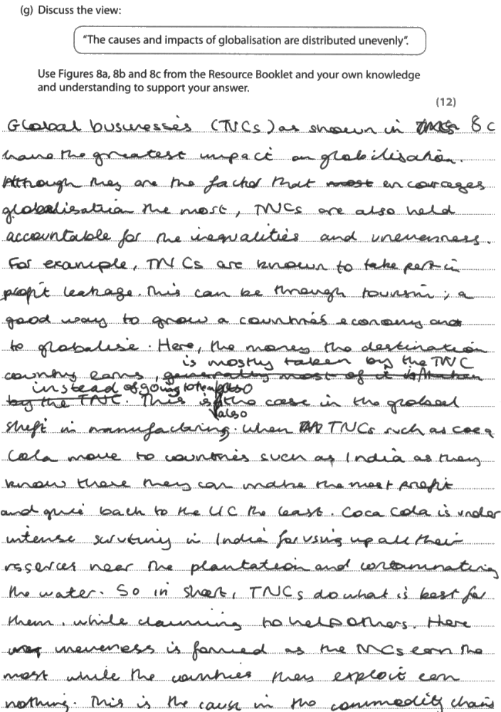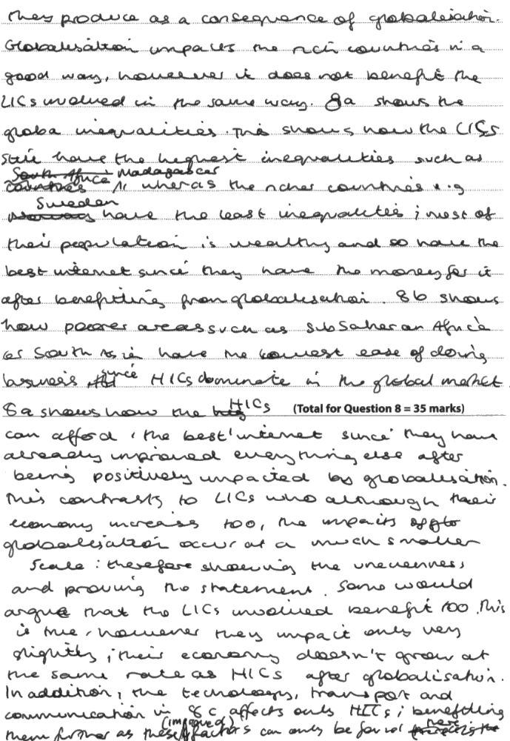

Examiner Comment: the final section of the Globalisation and Migration section is this twelve mark question. Essentially, it’s exactly the same as an eight marker – just a bit longer. You write it in the same way: clear structure, detailed reference to the figures, and a clear and explicit use of evidence for each stage. You can see this candidate making a judged point “greatest impact is…” and then backing it up “for example, TNCs are…”. It might have helped them to have separate paragraphs, but they are already pushed for space, so it’s not critically important. There’s no difference in approach or style to the eight mark questions – just extend the number of sources and write clearly!

Revision and Preparation:
Preparing for exams is not easy. It is a complex and time-consuming process, and requires you to have a well planned focus. You require three key components for exam success – your knowledge, your application and your confidence.
This booklet is designed to help with the first two of those. Contained within here are the structures and frameworks that will support your geography revision sessions with your teachers. We have provided vocabulary lists, content frameworks and all that is necessary to build excellent understanding of processes, case studies and the interactions between different elements of the course. Your work over the next few weeks should fill this booklet with key information, definitions, details and all that is necessary to secure top grades. At every stage, the responsibility lies with you to maximise your understanding – if you don’t ask, we can’t help you.
We have also provided materials to help with your application – including all the past questions ever written; and some model long answers that support the extension revision session that staff will be running. Use them wisely, and get plenty of practice.
Your work and practice should be smart. Don’t waste time with unnecessary ‘reassuring’ activities that ultimately don’t help you. You may want to revise by topic, or by approach to questions – the diagram overleaf gives you an idea of what fits where.
Buy a kitchen timer. Practice against the clock, regularly. Test yourself rigorously. There’s no point getting good at writing a ten minute response to a two mark question – you won’t have that kind of time in the exam. Time management is key – don’t waste it in revision, and you won’t waste it under exam conditions either.
All of this work will build your experience. To that, you must add your well-being – look after yourself, and ensure that you are rested, healthy and ready to work well. The Geography exam is challenging – be in good physical condition to tackle it.
Prepare well, and meet the challenge of the paper!
